What is a nitrogen generator and why should I buy one?

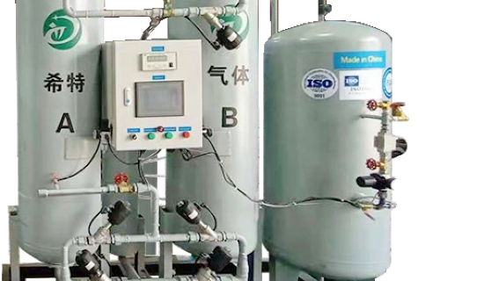
For many businesses， nitrogen is deeply integrated into the workday. Industries ranging from food processing to mining regularly use this resource， and its supply is critical to the core of operations. Unfortunately， traditional nitrogen acquisition requires the procurement， delivery， installation and removal of high-pressure cylinders. The tanks are inefficient， and a late delivery or low supply can bring production to a halt. Not only is this process more expensive than it needs to be， but it also creates more opportunities for workplace injuries.
Nitrogen generators， on the other hand， offer a better alternative. If your company is a regular user of nitrogen generators， consider installing your own to enjoy the wide range of benefits they offer.
On-Site Nitrogen Generators
What is a nitrogen generator?
Before exploring the many benefits of on-site nitrogen production， it's important to know what a nitrogen generator is and how it works. These machines perform a process called pressure swing adsorption (PSA) and membrane technology to extract nitrogen from the air and compress it.
Nitrogen generators provide a continuous stream of pure nitrogen to your production floor and avoid any need to wait for tank deliveries or be subject to supplier pricing. While the resource provided is essentially the same， the nitrogen generator produces nitrogen instead of transporting it in cylinders.
Uses of nitrogen generators
Nitrogen has many applications in a variety of industries. Any industry that currently uses nitrogen tanks， cylinders， dewars， or liquid delivery can benefit from an in-house nitrogen production system. Depending on your industry， nitrogen generators can be seamlessly integrated into your production process in a variety of ways.
One of the most common industries where nitrogen is used is food and beverage production. Nitrogen helps preserve the food in the package and extend its shelf life. This is doubly important for bulk foods that may be stored for longer periods of time， and for foods that do not include preservatives in the ingredient list.

