Application of common industrial gases and separation methods， separation principles

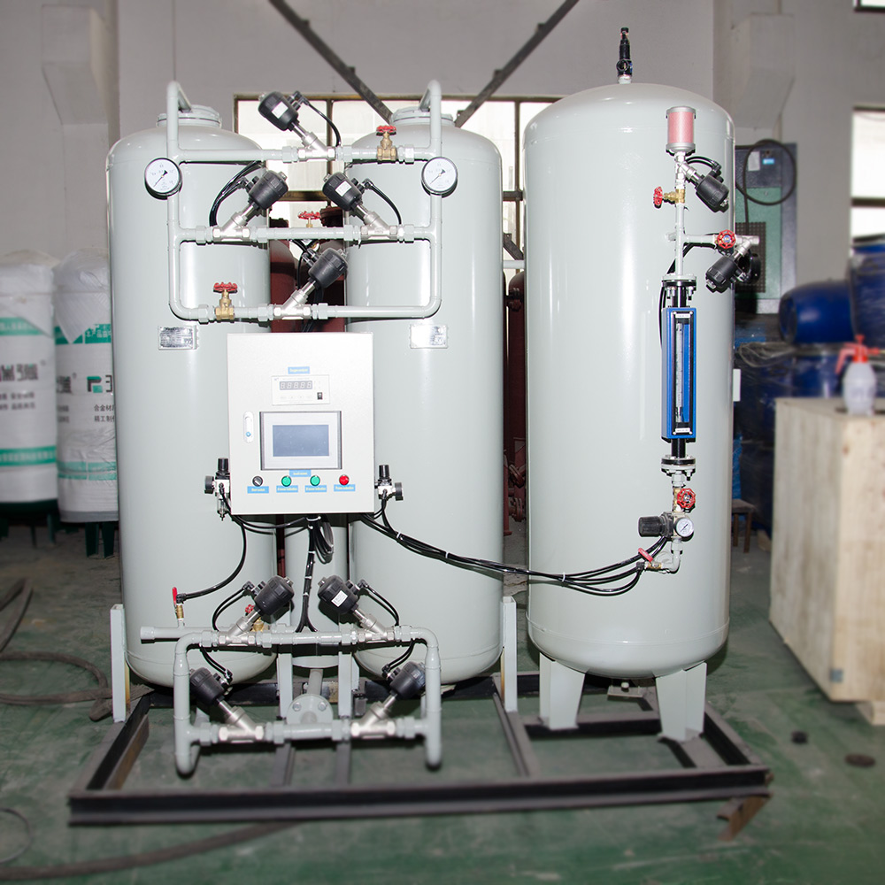
Industrial gases are oxygen， nitrogen， argon， neon， helium， krypton， xenon， hydrogen， carbon dioxide， acetylene and natural gas. As these gases have inherent physical and chemical properties， they occupy a pivotal position in the national economy， and have been promoted and applied at a very fast pace， penetrating into almost every industry. As an important basic material of modern industry， gas products have a wide range of applications. In metallurgy， iron and steel， petroleum， chemical industry， machinery， electronics， glass， ceramics， building materials， construction， food processing， medicine and health care sectors， a large number of commonly used gases or special gases are used.
Industrial gases used in many traditional industries are: steelmaking， ironmaking， non-ferrous metal smelting， fertiliser production， ethylene， propylene， polychlorinated ethylene， man-made fibres， synthetic fibres， silicone rubber products， cables and synthetic leather and other petrochemical industries， mechanical industrial production of welding， metal heat treatment， helium cuttings， etc.， float glass production and so on. Due to the rapid development of these traditional industries in recent years， the usage of industrial gases has also reached a peak.
Industrial gases are used in the following industries: coal mine fire extinguishing， oil extraction， coal gasification and coal liquefaction， glass melting furnaces， cement kilns， refractory production kilns， brick kilns and other industrial kilns， food freezing， food packaging， beer preservation， optics， defence industry production of fuels， the production of superconducting materials， electronics， semiconductors， fibre optic production， agriculture， animal husbandry， fisheries， waste water treatment， bleaching， pulp， waste incineration， crushing， and so on. Pulp， waste incineration， crushing waste tyres and other environmental protection industries， construction， meteorology， culture， heritage protection， sports， public security crime solving， cold knife in the healthcare industry， oxygen absorption for critically ill patients， hyperbaric oxygen metallurgy， cryogenic refrigeration of the human body's apparatus tubes， anaesthesia technology， and oxygen bars.
Industrial gas applications are being tested in the industry: solid nitrogen production， fuel cell production， magnetic material production， ultrafine processing， natural gas power generation， compressed natural gas vehicles， hydrogen car production.
Industries with a high consumption of industrial gases， such as iron and steel， fertiliser， chemical， glass and chemical fibre industries， have built their own gas production facilities and implemented a self-producing and self-selling business policy， while some industries with a low consumption of industrial gases mainly rely on the market to purchase industrial gases.

