Nitrogen generator for tire thermal cracking， 99.9% purity， 5KG/CM2 working pressure， 1000m3/h output

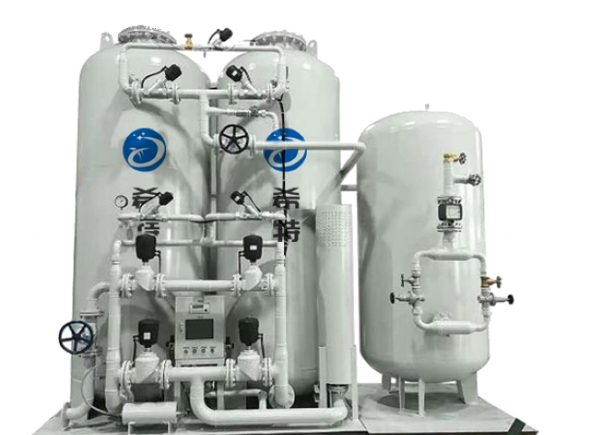
Suzhou XITE installed a 1000 m3/h nitrogen generator for thermal cracking of tires with 99.9% purity and 5 KG/CM2 operating pressure.
The environmental and safety problems of these plants were caused by fire hazards， emissions of fine carbon particles and odor disturbances as well as the need to burn excess high temperature gas. To solve these problems， nitrogen is added to the reactor according to the process requirements and XITE has supplied nitrogen generators to many customers of tire thermal cracking plants.
Pyrolysis is a thermal degradation process that produces oil， pyrolysis gas (hot gas)， carbon black carbon and steel from tires and rubber products in the absence of oxygen.
During the pyrolysis process， the self-generated hot gases and tires， which are used as fuel， are manually fed into the pyrolyzer， and at the end of the process， the steel and carbon are manually removed. This resulted in large carbon spills， exposure of workers to fine carbon particles， and working in an unsuitable environment for the pyrolyzer. Some explosions have also been reported in some facilities due to frequent opening of the reactor in high temperature conditions.
The environmental and safety problems in these plants are caused by fire hazards， emissions of fine carbon particles and odor disturbances and the need to burn excess pyrolysis gases.
To solve these problems， nitrogen is added to the reactor according to the process requirements and XITE has supplied nitrogen generators to many tire thermal cracking plants.

