Global Aquaculture Market Forecast to 2028

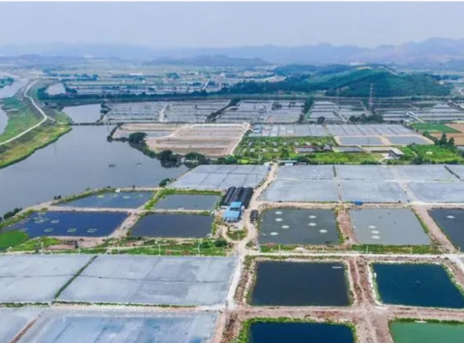
Employing more than 41 million people worldwide， aquaculture is growing at an unprecedented rate since 2018. Farming fish， algae， crabs， mollusks， crustaceans and other organisms requires little investment， little labor， and not much monitoring. Among the cheapest and now healthiest sources of animal protein， demand for seafood and related products continues to be on an upward trajectory.

Will this trend continue? How will innovation disrupt this industry? What is the role of governments in driving this sector forward?
In our global aquaculture market forecast， we answer many of these questions
The fish segment of the aquaculture market accounts for the largest market share by 2020. This figure is expected to grow in the coming years and register the highest CAGR over the forecast period.
Aquaculture is considered to meet the growing demand for fish and will continue to meet the market demand as the population continues to grow， incomes increase， and urbanization takes place.
Fish and seafood species will continue to be an important source of nutrition for the economically disadvantaged， as they are the cheapest form of animal protein.
With population growth and health concerns， demand for naturally occurring sources of protein is increasing in developed regions like North America. This concern has led to a shift in consumption of fish products， thus increasing the demand for fish. Fish and fish products meet the protein needs of middle-income groups， while safeguarding the protein consumption needs of the poor.
Government initiatives have been promoting the adoption of aquaculture globally.
Presumably， the use of fish oil in industry will boost the demand for aquaculture.
The increased production of fish and other aquatic animals in China and China is directly related to the growth of the aquaculture market. China has the highest production of aquaculture products in the world.
The growing demand for fish and aquatic species will contribute to the growth of e-commerce and allow farmers to flourish. This development in aquaculture and the scope for growth in this sector could attract investment for related businesses and further boost the domestic and global aquaculture industry.

