Nitrogen generator for beer and beverage use

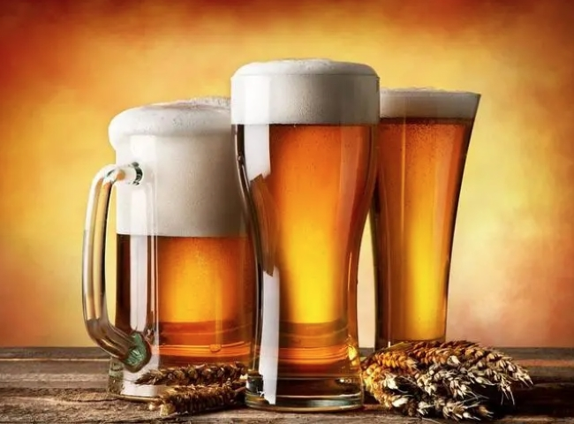
Our dedicated nitrogen generator lines for the beer and beverage industry are designed for restaurants and bars to create a consistent， on-demand supply of ultra-pure nitrogen in beer and coffee operations. These models use state-of-the-art technology to reduce operating costs and produce premium beverage grade nitrogen to maintain the quality of product expected by brewers. The industry's smallest footprint and most efficient PSA technology make them the perfect solution for nitrogen injection in pre-nitrogenated or kegged beers.
Nitrogen is also used extensively in beer brewing， wine making and bottle manufacturing processes. Blowing on bottles， inerting BRIGHT tanks for brewing， or providing nitrogen blankets for bottled or kegged beverages will reduce the amount of oxygen in the atmosphere and eliminate the concern of oxygen coming into contact with the product. Nitrogen will also keep the beverage line clean， dry and inert.
Our nitrogen generators are available in the following models
Equipment capacity range - 5 to 1000 Nm3/Hr.
Nitrogen purity - up to 99.9998%.
Equilibrium oxygen content - 5 to 0.5%.
Dew point range - 20 to -40 degrees Celsius
Discharge pressure - 5 to 25 kg/cm2

