Protecting power plant equipment with nitrogen inert gas

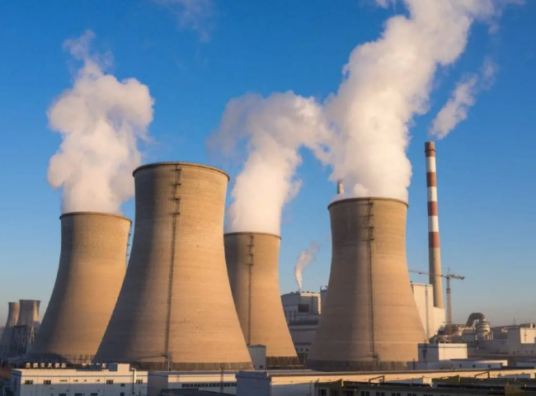
Over the past decade， several hundred power plants have emerged or are in various stages of implementation and will be operational in the next 3-4 years. While most of these power plants have been built by major Chinese government entities such as NTPC and state electricity boards， many of these plants have also been implemented by private companies that have been granted licenses by the Chinese government to build and operate these plants.
A major reason for many of these power plants is the tight supply of fuel materials (e.g.， coal and natural gas). In the event of fuel supply challenges， many power plants are forced to idle their plants or shut down completely for days or weeks at a time.
During these extended idle or shutdown periods， many power plant equipment such as boilers， turbines， power cycle piping， fuel supply piping and other major BOP equipment must be "preserved" to avoid significant problems such as corrosion due to air contact.
For these preservation activities， many power plants use dry nitrogen. If idle periods or shutdowns are periodic and infrequent， power plants can rely on the purchase of nitrogen in cylinders to meet these intermittent needs early on.
However， due to recent severe fuel supply challenges， the frequency of these shutdowns has increased and the cost of the nitrogen purchase itself has risen considerably. Many power plants are now seriously considering implementing on-site nitrogen generators to avoid reliance on nitrogen cylinder suppliers. By purchasing and implementing smaller nitrogen generators， power plants are becoming self-sufficient and are able to utilize this nitrogen directly where it is needed.
Nitrogen generators such as those offered by XITE are simple to operate units that require only dry compressed air as the feed gas source. The nitrogen is produced directly from compressed air and delivered in a pressure range of 8-12barg.
The nitrogen produced by the XITE gas generator is very dry with a dew point below (-) 40 C. This dry gas is ideal in power plants because the dry gas prevents corrosion.
We now explain the technical aspects of equipment preservation and demonstrate them with a short example.
When it is necessary to purge and preserve with nitrogen， any equipment that is currently in a normal atmosphere， needs to have the following requirements:- 1.
1. purge the entire volume， at least 6 times， displacing the air and replacing it with nitrogen.
2. Pressurize the equipment. A minimum pressure is required， even 300 mm wg (0.003 kg/cm2g) is sufficient in most cases. Smaller maintenance pressures will mean lower leakage rates through shaft/s and other non-gas-tight joints.
Take a 600 MW generator as an example. It has an internal volume of 90 meters. Therefore， it requires 6 x 90 = 540 nm of nitrogen for the initial purge. You can close all openings， flanges， etc.， and feed air from the low flange on one side and release air/nitrogen from the flange on the diagonal opposite side (with a partially closed valve， which will also help maintain back pressure). Using a 5m3/h capacity nitrogen generator will complete the initial purge in 540/5 = 108 hours (really， there is no rush!) . Typically for such a device， the leak rate will not exceed 0.2% of the space volume while maintaining a pressure of 300 mmHg， i.e. 90 x 0.002 = 1.8 m3/h. This example goes on to show that a 5 m3/h nitrogen generator can handle even three 600 MW generator banks.
-
We offer two different types of nitrogen generators.

Membrane nitrogen generators - for products with up to 99.9% purity
Compared to other technologies， membrane nitrogen generators offer many benefits， such as low maintenance and very low production costs. Since nitrogen purity requirements never exceed 99%， membrane nitrogen generators are ideal for power plants.
PSA Nitrogen Generators - for purity above 99.9%
PSA nitrogen generators are powerful systems for the production of nitrogen with a purity of 99.9% or more. PSA is a very mature technology and XITE is the largest manufacturer of PSA nitrogen generators in China， supplying over 1200 generators worldwide.

