Adding Nitrogen to Steel to Achieve Higher Strength - Nitrogen Absorption in Steelmaking
Nitrogen in steel

Nitrogen exists in steel in two forms， namely (i) as interstitial nitrogen in atomic form， or as unstable and readily soluble nitrides such as Fe4N， and (ii) as stable nitrides. In the atomic form， it is referred to as active or free nitrogen in steel. In microalloyed steels， such as high-strength low-alloy (HSLA) steels， some or all of the interstitial nitrogen combines with alloying elements (V， Ti or AI) to form stable nitrides in the steel. Both forms of nitrogen have a significant impact on the properties of the steel.

Nitrogen as an alloying element in iron-based alloys has been intensively studied in the last decades since the beginning of this century. However， to date， nitrogen steels have not been widely used. The relatively few industrial applications are due to customer skepticism about the brittleness caused by nitrogen in ferritic steels， some technical problems involved in introducing nitrogen into steels， and insufficient knowledge of the physical properties of the effects of nitrogen in iron and its alloys.

For many years， the role of nitrogen in steel has been almost ignored. Steel produced by the Bessemer converter， where air is blown through the molten steel， contains large amounts of nitrogen. The effect of nitrogen on steel became apparent with the introduction of oxygen steelmaking， which led to various major investigations of the role of carbon and nitrogen in steel in the 1950s and 1960s.

Nitrogen is present in all commercial steels. Because the amount of nitrogen is usually small and its analysis is complex and expensive， its presence is usually ignored even in the specifications for steels given in standards. However， whether present as a residual element or deliberately added as an alloying element， the influence of nitrogen in steel is significant. Together with carbon， it is responsible for the discontinuous yield point that characterizes the stress-strain curve of mild steels. The dislocation pegging that leads to this yield point also contributes to the characteristic fatigue limit of these steels.

Nitrogen is often considered an undesirable impurity that contributes to the brittleness of steels. Nitrogen has long been considered to be in the same category as certain undesirable residual elements in steels that are often detrimental to the performance of the steel. It was believed that steels with high nitrogen content were subject to strain aging and that their plasticity deteriorated over time. Recently， it has been noted that nitrogen has a significant effect on mechanical properties， phase stability， corrosion behavior and oxidation resistance. Nitrogen can also react with titanium and aluminum in liquid steel to produce nitride inclusions， which can damage the surface of the steel and reduce the quality of the final product. When nitrogen diffuses into the surface of the steel， it produces significant (interstitial solid solution) strengthening similar to that observed during surface hardening (nitriding). In combination with aluminum， it produces fine grains.

Uptake of nitrogen during steelmaking

The nitrogen content of steel can come from several sources. The main source of nitrogen depends on the steelmaking process. Several sources of nitrogen present in the steelmaking process include hot metal， scrap， pig iron， DRI/HBI， lime， coke/coal， ferroalloys， impurity nitrogen in oxygen， and nitrogen as a stirring gas. Nitrogen uptake from the atmosphere occurs at all stages of steelmaking. Typical nitrogen levels in some nitrogen sources are shown in Table 1.

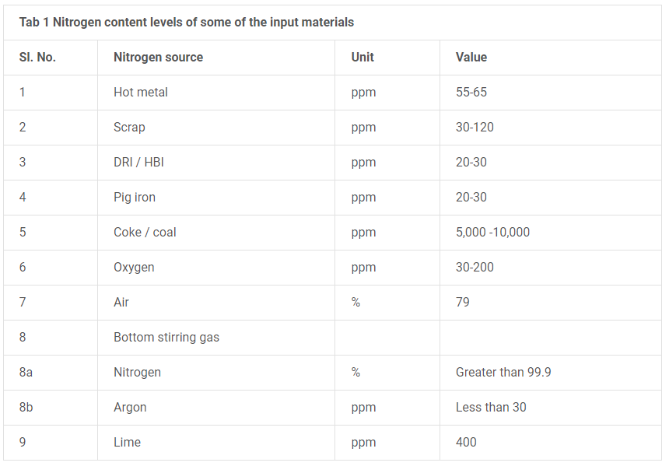
Factors affecting the nitrogen content of steel are: (i) the composition of the melt; (ii) the partial pressure of nitrogen in the gas in contact with the melt， or the nitrogen potential of the slag; (iii) the time of atmospheric contact with the steel; (iv) the temperature of the steel; and (v) the nitrogen additives.

All steels contain some nitrogen， which can enter the steel as an impurity or as an intentional alloying additive. The amount of nitrogen in steel usually depends on the residual level produced during the steelmaking process or the amount to be achieved in the case of intentional additions. The residual levels of nitrogen in steel produced by the two main steelmaking processes vary considerably. The basic oxygen steelmaking process typically results in lower residual nitrogen in steel， typically between 30 ppm and 70 ppm， while the electric furnace steelmaking process results in higher residual nitrogen， typically between 70 ppm and 110 ppm. Nitrogen is added to some steels (such as those containing vanadium) to provide enough nitrogen to form nitrides to achieve higher strength. In such steels， the nitrogen content can be increased to 200 ppm or higher.

Nitrogen can be present in the steel as unbound "free" nitrogen (sometimes called lattice nitrogen) or as nitrides or carbon nitrides chemically bound to other elements. Strain aging effects are due to free nitrogen， which is why these effects can be removed from low-nitrogen steels by adding strong nitride formers such as titanium， which binds any free nitrogen and prevents it from migrating to locations around the dislocation. However， this is not a straightforward phenomenon. In coarse-grained low-nitrogen low-carbon steels， new dislocations form at such a rate in the temperature range of 200 degrees C to 300 degrees C that yielding， as evidenced by a drop in stress without a previous rise， occurs repeatedly， but this phenomenon does not occur in steels with similarly high free nitrogen content. This is because in low-nitrogen steels there is not enough nitrogen to immediately lock the newly formed dislocations， whereas in high-nitrogen steels the dislocations are locked and remain locked at the time of formation. This is reflected in the greater work-hardening capacity of high nitrogen steels.

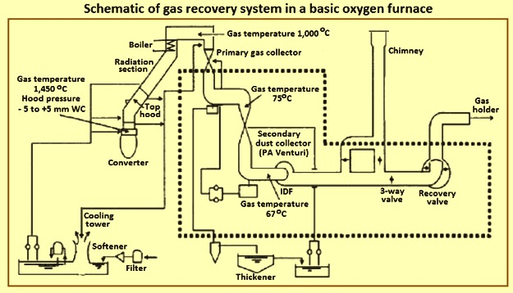
Fig. 1 Solubility of nitrogen in iron

Nitrogen is a strong austenite stabilizer， and the yield and tensile strengths of nitrogen-containing steels increase with increasing nitrogen content， with no adverse effect on ductility. The growth rate of fatigue cracks decreases with increasing nitrogen content， while creep strength increases with the addition of nitrogen.

Nitrogen in liquid steel is present in the form of a solution. During solidification of continuous cast steel， three nitrogen-related phenomena occur. These phenomena are (i) the formation of blow holes， (ii) the precipitation of one or more nitride compounds， and (iii) the solidification of nitrogen in interstitial solid solutions. The maximum solubility of nitrogen in liquid iron is about 450 ppm， which is less than 10 ppm at ambient temperature (Figure 1). The presence of significant amounts of other elements in liquid iron affects the solubility of nitrogen. It is mainly the presence of dissolved sulfur and oxygen that limits the uptake of nitrogen， as they are surface active elements.

Nitrogen and steel properties

Nitrogen can affect the properties of steel in a detrimental or beneficial manner， depending on (i) the presence of other elements in the steel， (ii) the form and amount of nitrogen， and (iii) the required properties of the steel. Typically， most steels require a minimum level of nitrogen. High nitrogen levels can lead to (i) unstable mechanical properties in hot rolled steels， (ii) heat affected zone (HAZ) embrittlement in welded steels， and (iii) poor cold formability. In particular， nitrogen causes strain aging and reduced ductility in cold-rolled and annealed low-carbon aluminum-killed (LCAK) steels.

Effect on steel hardness - Hardness is the resistance of a material to surface indentation. The hardness of steel is linearly related to the nitrogen content. It increases with increasing nitrogen content (Figure 2). The nitrogen absorbed during steelmaking enhances interstitial solid solution and grain refinement， both of which increase hardness. In addition， the figure shows that nitrogen absorbed during steelmaking has a greater effect than nitrogen absorbed during annealing in a nitrogen-rich atmosphere. Nitrogen， like carbon， causes an increase in hardness and yield strength and a corresponding decrease in toughness when dissolved as an interstitial in steel in the temperature range of 100 degrees C to 200 degrees C.

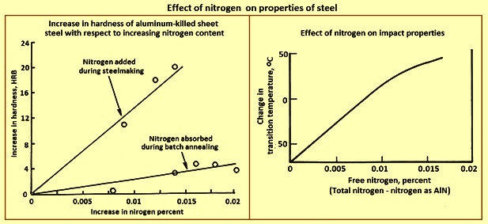
Figure 2 Effect of nitrogen on the properties of steel

Effect on Impact Strength - The ability of steel to withstand impact loads is known as toughness. It is quantified by measuring the energy absorbed by a test piece of known dimensions before it fractures. It can also be analyzed by determining the fracture mechanism upon impact over a range of temperatures. As the temperature decreases， the fracture type changes from fibrous/ductile to crystalline/brittle. This arbitrary temperature is referred to as the "ductile to brittle" transition temperature (DBTT). The lower the transition temperature， the better the impact properties， since damage from ductile fracture is less catastrophic than brittle damage. Figure 2 shows that as the free nitrogen increases， the transition temperature also increases， which means that the toughness decreases. This is due to the strengthening of the solid solution. The presence of small amounts of nitrogen in the form of precipitates has a beneficial effect on impact properties. Nitrides of aluminum， vanadium， niobium and titanium lead to the formation of fine-grained ferrite. The finer grain size reduces the transition temperature and increases the toughness. Therefore， in order to optimize the impact properties， it is necessary to control not only the nitrogen content but also its form.

In Charpy tests， nitrogen increases the "impact transition temperature" (ITT) and high levels of non-combined nitrogen cause a change in fracture energy above room temperature， resulting in a change from ductile to brittle behavior. In pure body-centered iron， nitrogen has been shown to bias onto grain boundaries， and this bias can lead to the development of intergranular embrittlement. This mechanism may occur in steels where the nitrogen is bound by silicon or aluminum in killed steels showing better impact properties than in rimmed or semi-killed steels. It has been shown that the addition of titanium and aluminum to 8% Mn steels reduces DBTT by binding free nitrogen， but also reduces hardness under air and water quenching conditions.

Effect on Mechanical Properties - The effect of nitrogen on mechanical properties is due to (i) interstitial solid solution strengthening by free nitrogen (ii) precipitation strengthening by aluminum and other nitrides， and (iii) grain refinement due to the presence of nitride precipitates. Figure 3 shows that the strength of LCAK steel decreases slightly with increasing nitrogen content and then increases. Conversely， elongation decreases and r value increases with increasing nitrogen content. r value is the average ratio of width to thickness strains for strip tensile samples tested in different directions. It is an inverse measure of formability. Thus， high nitrogen content leads to poor formability of LCAK steels.

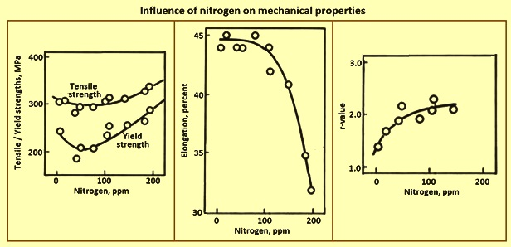
Figure 3 Effect of nitrogen on mechanical properties

Effect on fracture toughness - Nitrogen can play a significant destructive role in the fracture toughness of structural steels. Small changes in nitrogen content can produce significant changes in the fracture mode transition temperature of these steels. These changes are complicated by corresponding changes in precipitated nitrides， associated grain size changes， and interactions between nitrogen and manganese.

Effects on Strain Aging - Strain aging is a yield-related phenomenon caused by nitrogen at temperatures below 150 degrees Celsius and by carbon at temperatures above that. The effectiveness of carbon and nitrogen in producing strain aging is determined by (i) their solubility in ferrite， (ii) their diffusion coefficients， and (iii) the severity of each locked dislocation. The main difference between carbon and nitrogen is that their solubility in the ferrite varies considerably.

After being plastically deformed， the steel undergoes strain aging due to interstitial atoms (mainly nitrogen). After deformation， the nitrogen deviates into dislocations， leading to discontinuous yielding upon further deformation. Strain aging leads not only to an increase in hardness and strength and a decrease in ductility and toughness， but also to "stretcher strain" on the surface of the deformed material.Duckworth and Baird developed a measure of strain aging called the "strain aging index". This is based on an empirical equation to calculate the increase in yield stress when a deformed material is held at room temperature for 10 days. Figure 4 shows that increasing nitrogen leads to a higher stain aging index and therefore a greater susceptibility to surface defects.

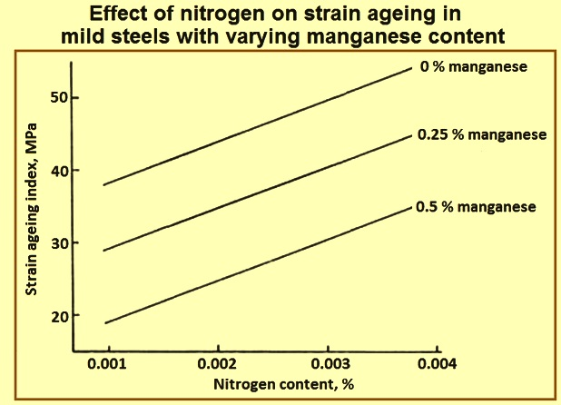
Figure 4 Effect of Nitrogen on Strain Aging Index of Mild Steel

Due to its effect on yield， nitrogen is simply considered an "undesirable residue" in many commercial steel applications due to the phenomenon of strain aging. Strain aging is the reappearance of the yield point of a steel where the previous deformation has exceeded the yield point into the plastic region. The current explanation for this phenomenon was first proposed by Cottrell and Bilby in 1948. They discussed carbon specifically， but noted that these arguments could be applied "with minor modifications" to nitrogen. The gradual diffusion of nitrogen， and to a lesser extent carbon， into preferential positions around new dislocations， which are formed when the steel initially yields， leads to the reappearance of the yielding phenomenon and the associated problems caused when trying to produce smooth cold formed shapes. Typically， this phenomenon only occurs after the steel has been allowed to sit at room temperature for weeks or months， but even a small increase in temperature can greatly accelerate the rate of diffusion and thus shorten this time. As a result， a great deal of work has been done in producing "gapless" steels， such that bulk steels containing less than 20 ppm nitrogen are now a regular product in the automotive industry for stamped body and chassis components.

Due to the high solubility of nitrogen in ferrite， nitrogen is usually more susceptible to strain aging problems than carbon， which precipitates on existing carbides while the nitrogen remains free to migrate to new dislocations. At temperatures above ambient but below about 400 degrees Celsius， the return of the yield point occurs more rapidly and yielding becomes a continuous event known as dynamic strain aging because nitrogen (and some carbon) rapidly migrates to preferred locations around new dislocations as they form. This results in an increase in the tensile strength of the steel， as well as a decrease in ductility and fracture toughness. This was explained by Cottrell and Bilby as the formation of a saturated atmosphere around the new dislocations， requiring only 0.003% of the carbon content (or similar nitrogen content).

However， Gladman noted that the clearance levels associated with strain age hardening and strain age embrittlement far exceeded this level. The suggested explanation is that carbide (and nitride) precipitation occurs on dislocations， producing additional precipitation strengthening effects. Work originally by Baird and MacKenzie， and later by Baird and Jamieson， showed that while nitrogen in pure iron has a high rate of strain hardening (a symptom of dynamic strain aging) below 225 degrees C， this effect persists up to 450 degrees C with the addition of manganese and nitrogen to the iron.

