Treatment of industrial wastewater
Water is used in industry for process needs， cooling， steam generation， dust suppression and many other purposes. Industrial wastewater is the water-like waste produced after water has been used for these purposes. Industrial wastewater is the result of dissolution or suspension of substances other than water in water.
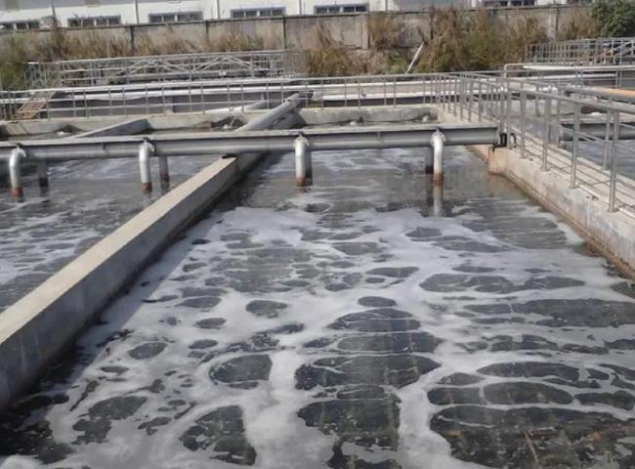
Treatment of industrial wastewater includes the mechanisms and processes used to treat water that has been contaminated in some way as a result of its use in the above activities. The purpose of treatment is to remove dissolved and suspended substances from wastewater so that the treated water can be safely discharged to the environment， or recycled in the same process， or used in a different process.
Components of wastewater
Industrial wastewater contains the following components that require proper treatment.
Suspended solids - These are contaminants that are visible to the naked eye and can generally be filtered out of the water using ordinary filter paper. Although there is no hard and fast definition， suspended solids are often larger than 1-2 microns in size. If water is allowed to sit without disturbing it， suspended solids will settle to the bottom of the container over time.
Dissolved solids - These are contaminants that are invisible to the naked eye and cannot be removed from the water by filtration. Dissolved solids are defined as substances that are generally smaller than 0.45 microns in size. Dissolved solids are normally soluble substances or antisoluble substances. Normally soluble substances are those that become more soluble as the temperature increases. Antisoluble substances are often referred to as "hardness" ions and are usually limited to salts of calcium， magnesium， strontium and barium in water treatment. These substances become less soluble as the temperature increases. These substances form scale on the hot surfaces of boiler or heat exchanger tubes.
Colloidal solids - These are not small enough to be considered dissolved， but also not large enough to be considered suspended solids. Generally， colloidal substances will appear as a mist in the water， and it is impossible to see visible particles with the naked eye. The size range of colloidal substances is typically between ~0.45 and ~2.0 microns. Colloidal solids do not precipitate out of water because they are so small that they are strongly influenced by their ionic surface charge. Colloidal suspensions in water are said to be a stable suspension.
Color - is a type of colloidal suspension. The organic molecules that contribute color to the original surface water are simply macromolecules that fall into the smaller colloidal size range. In water， these macromolecules carry an ionic surface charge that makes them stable and incapable of settling.
Biological Oxygen Demand (BOD) and Chemical Oxygen Demand (COD) - BOD is a measure of the amount of oxygen consumed by bacteria during the breakdown of organic matter. Having a safe level of BOD in the wastewater is critical to producing quality wastewater. If BOD levels are too high， then the water may be at risk of further contamination， interfering with the treatment process and affecting the final product. Several factors can contribute to high BOD levels， such as the presence of nitrate and phosphate in the wastewater， water temperature and other factors. Each of these factors affects plant life in the water， such as algae， which in turn can have an impact on the organisms that help break down water pollutants during the wastewater treatment process. The highest quality wastewater treatment will occur in an environment that supports the life of these bacteria while maintaining a controlled bacterial population so as not to encourage rapid bacterial decomposition， which will produce higher BOD levels. Similar to BOD is COD. COD measures the amount of oxygen consumed by water during decomposition and oxidation， particularly of organic matter and oxidation of inorganic matter or chemicals. cod is a commonly used application for industrial wastewater.
Wastewater Treatment Technologies
Technologies used to treat industrial wastewater are usually classified into four categories， namely (i) chemical technologies， (ii) physical technologies， (iii) biological technologies， and (iv) membrane technologies.
Chemical technologies - The main chemical technologies for industrial wastewater are as follows.
Neutralization - It is the adjustment of the alkalinity and acidity of the wastewater to a neutral value of pH 7.
Precipitation - Precipitation is the addition of chemicals to wastewater to alter the chemical composition of pollutants so that the newly formed compounds precipitate during the precipitation process. Precipitation is commonly used to remove heavy metals from wastewater， which usually precipitate as hydroxides. However， it is necessary to pretreat the wastewater to remove substances that interfere with the precipitation of heavy metals.
Coagulation - is the use of chemicals that cause contaminants to agglomerate and then precipitate during the sedimentation process. Coagulation is used to clarify wastewater containing colloids and suspended solids. Silica or polyelectrolytes help form a material that settles quickly. Wastes containing emulsified oils can be clarified by the coagulation process. This process is very effective in reducing the color of the wastewater， but less effective in reducing COD (chemical oxidation demand).
Adsorption - Adsorption is the use of a chemical that causes certain contaminants to adhere to the surface of that chemical for subsequent removal. Activated carbon or synthetic activated surfaces are used for adsorption.
Ion Exchange - An ion exchange process is typically used to remove undesirable anions and cations from wastewater. Cations are exchanged for hydrogen or sodium and anions are exchanged for hydroxyl ions. Ion exchange resins consist of organic or inorganic network structures with functional groups attached. Most of the ion exchange resins used in wastewater treatment are synthetic resins made from the polymerization of organic compounds.
Physical Technologies - The main physical technologies for industrial wastewater are as follows.
Screening - It is the removal of coarse solids from wastewater through the use of filtration units.
Clarification and Sedimentation - Wastewater clarification and sedimentation is a common and necessary process in industrial wastewater treatment plants. A clarifier consists of a tank or basin in which wastewater is stored for a period of time to allow solids or other substances suspended in the water to settle to the bottom.
Floatation - The floatation takes place with the help of small air/gas bubbles injected into the wastewater. The air/gas bubbles cause the contaminant particles in the wastewater to rise to the surface for subsequent removal. The floating process is commonly used for oil separation. The free oil is floated to the surface of the tank and is then skimmed off.
Gas stripping - It is the removal of volatile and semi-volatile organic compounds from wastewater by using gas streams.
Biotechnology - Biological treatment is a more natural wastewater treatment process than other wastewater treatment methods. Microorganisms feed on the complex substances present in the wastewater， converting them into simpler substances in preparation for further water treatment. The main objective of biotechnology is to reduce BOD levels. The main biotechnologies for industrial wastewater are as follows.
Air activated sludge method - This is an aerobic process in which bacteria consume organic matter， nitrogen and oxygen from the wastewater and grow new bacteria. The bacteria are suspended in an aeration tank by the mixing action of air blown into the wastewater.
High Purity Activated Sludge Process - This is an aerobic process similar to the air activated sludge process， except that pure oxygen is injected into the wastewater in place of air.
Aeration tank/lagoon process - This is an aerobic process， similar to the air activated sludge process. In this process， mechanical aerators are used to inject air into the wastewater， or to agitate the wastewater and air vigorously in order to transfer oxygen to the wastewater.
Trickling Filtration - This is a fixed film aerobic process in which a tank containing media with a high surface to volume ratio is used. Wastewater is discharged at the top of the tank and trickles down (infiltrates) the filter media. Bacteria use the organic matter and nitrogen in the wastewater to grow on the media. A typical trickling filter process is shown in Figure 1.
Rotating Biological Process - This is a fixed-membrane aerobic process similar to the trickling filter process， except that the media is supported horizontally on the wastewater tank. The media for bacterial growth is constantly rotated so that it alternates between wastewater and air.
Oxygen Ditch Process - This process is similar to the activated sludge process. Physically， the oxygen trench is circular and equipped with mechanical aeration.

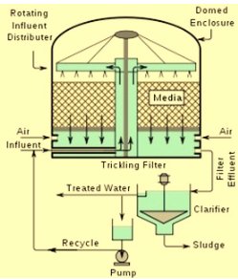
Figure 1 Typical Trickling Filter Process
Membrane Technologies - Membrane technologies are becoming increasingly important in the treatment of industrial wastewater. With the help of these technologies， it is possible to remove particles， colloids and macromolecules， thus allowing disinfection of wastewater. Membrane technologies are usually classified according to the size range of the material being separated.
The main membrane technologies used for industrial wastewater are as follows.
Reverse Osmosis - The reverse osmosis process is used to separate dissolved salts and small organic matter.
Nanofiltration - This process is used for the selective demineralization of water or the concentration of organic solutions. This process is used for the separation of antibiotics.
Ultrafiltration - This process is used for the separation of emulsions， colloids， macromolecules or proteins.
Microfiltration - This process is used for the separation of small particles， large colloids and microbial cells.

