Frequently asked questions related to on-site nitrogen generators and technology

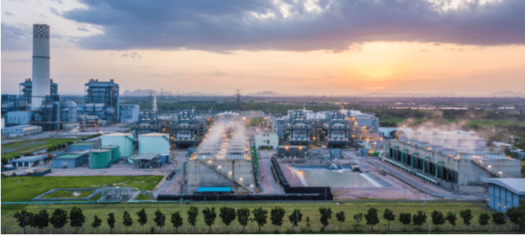
A number of industrial processes such as chemical manufacturing， food and alcoholic beverage processing， pharmaceuticals， and computer chip production require large quantities of nitrogen. As a result， on-demand nitrogen production is often integrated into their equipment set-up. This article will answer some common questions about the use of on-site nitrogen generators and services.

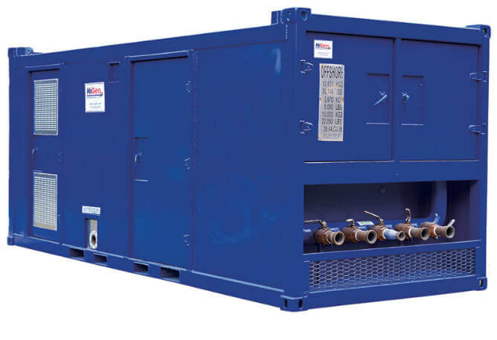
What is SCFM?
Many industrial systems require pressurised air to drive their processes. This is often achieved using air compressor systems and is calibrated to different parameters. Standard cubic feet per minute (SCFM) describes the flow rate of gas through an air compressor at standard pressure and temperature levels.
These are the standard parameters used to measure the SCFM of an air compressor.
Temperature between 60°F and 68°F
Pressure of 14.7 psi
Relative humidity of 36%.
When do I need to perform a nitrogen purge?
The presence of high concentrations of oxygen and moisture has proven to be detrimental to some industrial operations. Oxygen-rich environments increase the risk of spontaneous combustion and encourage oxidation processes that damage sensitive systems and contaminate finished products.
To avoid these undesirable results， nitrogen purging can be used. Industrial systems can be purged by delivering nitrogen. Gaseous nitrogen replaces moisture and oxygen while inerting the environment and preventing oxidative damage.
How does the dryer work?
Compressed air driven through an industrial system needs to be optimised before it can be used. In addition， compressed air often contains high levels of moisture which must be removed to avoid damage to sensitive equipment.
Desiccant air dryers are an effective method of drying compressed air， using hygroscopic materials such as silica， activated carbon and aluminosilicates (zeolites) to draw moisture out of the air.
A typical desiccant dryer consists of two towers， alternating between drying and regeneration phases. Air is passed through desiccant beads in one tower for dehydration， while saturated material in the second tower is regenerated for further cyclic drying.
What is pipe salvage?
With continued use， pipes will gradually accumulate various impurities within their lumen. The build-up of grease， corrosion and other particulate impurities can compromise the integrity of the pipe， leading to reduced efficiency and， in some cases， accidents. Pipeline pigging is a process of cleaning the inside of a pipe to remove unwanted contaminants.
A device known as a pig is introduced into the selected pipe from one end and riveted along its length to remove any obstructive build-up. Pipeline pigs can be made from a variety of materials， including steel and rigid polymers. Smart pigs contain on-board sensors and electronics that collect data on the integrity of the pipes they pass through.
What is pressure vessel welding?
The storage and transmission of high pressure liquids and gases requires extremely high quality vessels. In the USA， the manufacture of pressure vessels is guided by rules set by the American Society of Mechanical Engineers (ASME).
In order to comply with the required standards， vessel manufacturers must follow strict pressure vessel welding procedures. Pressure vessel welding involves placing several feet of weld seam followed by rigorous inspection using ultrasonic and x-ray techniques. Only vessels whose welds pass the stringent inspection criteria can be certified for use with high-pressure fluids.
What is the FPS to GPM calculator used for?
In order to improve overall performance and maximise product transport capacity， industrial pipeline operators must constantly monitor the flow rate of fluids through their pipelines. An example of this is the FPS to GPM calculator.
The FPS (feet per second) to GPM (gallons per minute) calculator is a device or online resource that allows process operators to seamlessly perform the calculations required for system calibration. This can be done by simply entering the pipe ID and the value of the measured fluid flow rate into the calculator's interface.
How do I perform a nitrogen leak test?
Leaks in industrial equipment such as pipelines and pressurised vessels can pose a significant safety risk to operators. Nitrogen leak testing is therefore an important maintenance activity to assess the integrity of process equipment and to ensure safe operating conditions.
Nitrogen leak testing follows a sequential series of steps in which nitrogen is passed through selected test vessels， pipes or vats at increasing pressure levels to detect the presence of leaks， determine their maximum volumetric capacity and establish the reliability of their components.
The data collected from the leak test can be used to correct any anomalies found in the operating channels as well as in newly assembled pipework/closed vessels.

