Customized 150m3/h nitrogen generator for a large chemical company

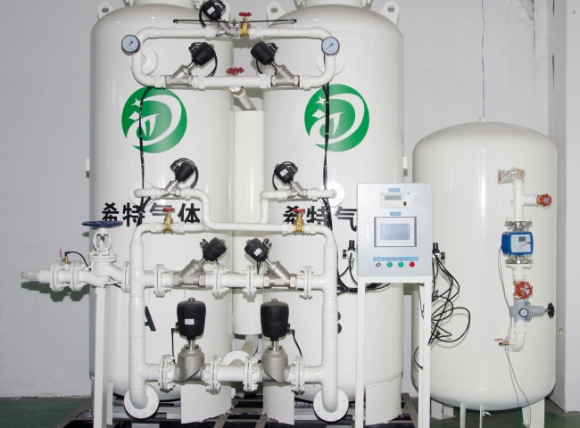

We are pleased to establish business relations with a large company in the chemical industry. We visited this company in 2017， while supplying 2 PSA nitrogen generator plants here in 2020. Since then， we have supplied 7 more PSA plants to this company at different locations. All of these plants are now operating very stably and we are grateful for their continued trust in XITE. We are also proud to be able to give them continued support through our PSA nitrogen plants.
Chemical and resin production processes require large amounts of nitrogen. Nitrogen is a gas with excellent inertness and is used extensively in this industry， including the preservation of chemicals and the prevention of oxidation of raw materials. Many chemical industries handle volatile and flammable chemicals. Removal of oxygen is a key issue， as the absence of oxygen largely mitigates the risk of fire.
This particular XITE nitrogen generator equipment has the following specifications:-
Nitrogen capacity: 150m3/h
Nitrogen purity: 98.5%
Gas delivery pressure: 8 Bar

