Nitrogen making machine for cement companies， nitrogen inert gas equipment

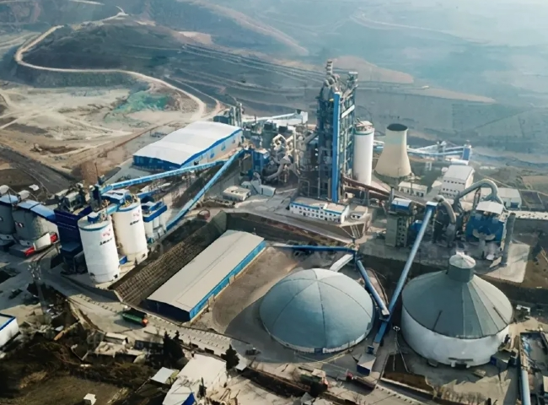
XITE supplied a nitrogen inert gas plant to a large cement manufacturing company in China. They needed nitrogen to clean coal mills， bag filters and coal bunkers to control fires due to spontaneous combustion of pulverized coal.
The customer purchased the following specifications of nitrogen inert gas equipment from XITE.

Technology: Pressure Swing Adsorption (PSA)
Capacity: 150 m3/h
Purity: 99% nitrogen
This complete inert gas plant was completed as a turnkey project， including air compressor， large size nitrogen storage tank， purge nozzle and RTD sensor. In fact， we have many projects where XITE Engineering has also been applied to customers for engineering and design to place purge nozzles and instruments in their equipment.
Applications.
Pulverized coal is used as a fuel in the cement manufacturing process. It has some volatile components and can easily catch fire (spontaneous combustion) in the presence of air. Nitrogen is used as an inert gas for purging coal mills， bag filters and fine coal bins to help prevent fires and for fire mitigation when needed.
Prior to the use of nitrogen， fuel burning inert gas generators were widely used in the cement industry. However， inert gas generators are a dirty process and also tend to incur very high maintenance costs. Nitrogen production， on the other hand， is a very clean process because the nitrogen is produced directly from compressed air.
A similar reference.
Over the past 30 years， we have supplied more than 50 nitrogen generators to most of the large cement manufacturers in China and the Middle East. More and more customers are starting to realize that active fire prevention with nitrogen (by regular purging) is a better way to extinguish and deal with fires than to do so only after combustion has occurred.
About PSA Nitrogen Generators
For customers using nitrogen via cylinders， PSA nitrogen generators offer many benefits， including a significant reduction in the cost of nitrogen.PSA nitrogen generators are low maintenance and allow for 24×7 operation and peace of mind.PSA is a very mature technology and XITE is a professional PSA nitrogen generator manufacturer in China， supplying over 1，200 nitrogen generators worldwide.

