XITE provides high quality medical oxygen generators

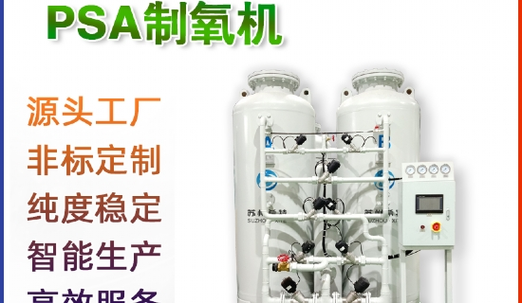
An oxygen concentrator is a useful piece of equipment that provides pure oxygen to patients in hospitals. It is more convenient compared to using oxygen cylinders. Therefore， Suzhou XITE offers on-site oxygen generators that can be installed in any hospital or health clinic. You don't need to worry about the price of medical oxygen generators because XITE offers a reasonable price range for all customers.
The excellent quality of XITE's medical oxygen generators
Since its inception， XITE has been supplying medium and large medical oxygen generators to numerous hospitals throughout China. Due to the availability of all the basic qualities， customers are satisfied. Here are some of these features.
Automatic switch panel
Whenever there is a power outage or any interruption in oxygen production， the oxygen concentrator is automatically transferred to the backup power supply with the help of an automatic switch panel. Thus， the user does not need to switch the plant operation manually when needed.
Fast oxygen production
The oxygen generator supplied by XITE can start its function within just 5 minutes of switching on the plant. It can work 24/7 to produce oxygen continuously for the patient. Since the pressure applied to the oxygen is 4.5-5 bar， this gas is easily transferred to the patient's bed through the tubing.
Easy operation of the device
XITE provides a portable platform on which the oxygen concentrator is mounted. A programmable logic controller (PLC) system was installed to monitor the air and electrical inputs to the machine. A Human Machine Interface (HMI) is also associated with receiving instructions from the user， showing the purity of the resultant gas on the display.

