The difference between liquid nitrogen and nitrogen gas

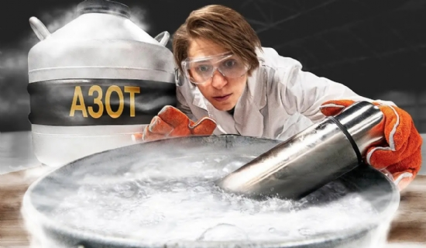
Nitrogen is a naturally occurring non-metallic element. In the periodic table， we use the symbol N to denote it. This element is inert. Moreover， it constitutes 78% of the atmosphere of our planet. However， you must remember that gaseous nitrogen is natural.
Liquid nitrogen is not naturally occurring. We use a low-temperature air separation process to liquefy this non-metallic element. However， chemically speaking， gaseous nitrogen and liquid nitrogen are the same and are both composed of N2 molecules.
However， the essential difference between liquid nitrogen and nitrogen is that the former is man-made， while the latter exists in nature. We will discuss nitrogen and liquid nitrogen in detail later. First， we will go through a short snapshot of them below.
Liquid Nitrogen Vs Nitrogen.
Liquid Nitrogen (LIN)
It is artificially produced
Liquid Nitrogen
Liquid phase
Exposure to liquid nitrogen can make materials brittle
Harmful to living tissue
Applications include preservation of semen， blood samples and other biological samples， frozen food， branding of cattle， skin treatment and cryotherapy.
Nitrogen
Occurs naturally and makes up 78% of the atmosphere.
Nitrogen in the gas phase
Gaseous phase
Usually not dangerous
No effect on materials
Applications include use as a covering agent for protecting food from oxidation， transporting hazardous products， filling tire tubes， making beer kegs， etc.
What is liquid nitrogen?
So we've talked about the difference between liquid nitrogen and nitrogen. Now we will look in more detail at what liquid nitrogen is. Liquid nitrogen is liquefied nitrogen at very low pressure. We refer to the liquefied gas as a cryogenic liquid or simply as a cryogenic gas.
A cryogenic liquid is a liquid gas with a boiling point below -90 degrees Celsius. Similarly， LIN is a cryogenic agent with a boiling point below -195.8 degrees Celsius. In short， we denote it as LIN. typically， it has many properties similar to nitrogen.
It is inert， colorless and odorless. And， you should be careful when handling LIN. Touching liquid nitrogen can be hazardous to bare skin. Industry uses liquid nitrogen plants， which produce liquid nitrogen by fractional distillation.
What is nitrogen?
Nitrogen is a gas that occurs naturally in the earth's atmosphere. It is inert， colorless and inert. In fact， industry values the inert nature of this gas. As one may know， it makes up about 78% of our atmosphere.
Obviously， nitrogen is the industrial gas that is consumed in specialized quantities. We find it in use in all walks of modern life. It is used in the manufacture of ammonia， fertilizers， pharmaceuticals， food packaging and chemical products.

