Application of on-site nitrogen generator (nitrogen generator) in food packaging industry

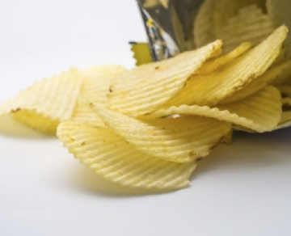
Food companies continue to launch our new products， and what we ultimately need is to keep your food packaging quality and freshness within the shelf life， while maintaining low manufacturing costs， which is meaningful. Food is often damaged during transportation， or the shelf life of traditional packaging is shorter than the necessary shelf life. A simple way to solve these common food packaging problems is to use the nitrogen generator (nitrogen generator) of the on-site gas system.
Whether you are using bags， cans， boxes， bottles， cardboard or plastic， the on-site nitrogen production equipment system provides a cost-effective nitrogen solution， so that you can rest assured that your products are fresh and complete on the store shelves. Many companies are choosing to replace the existing liquid nitrogen supply with on-site nitrogen generator systems to avoid the continuous energy and transportation costs associated with liquid nitrogen or cylinder delivery. In addition， it is also important to understand three reasons for the main use of on-site gas nitrogen generator in the food industry:
Extend shelf life
Bacteria need oxygen to survive， which is a scientific problem. If there is no oxygen in the food package， you don't have to worry about the moldy product. Our on-site nitrogen generator provides a simple， effective and economical way to discharge oxygen from food packaging and replace it with nitrogen. As a result， your product can last longer and therefore waste less.
Maintain quality
Nitrogen can not only prevent mold growth， but also maintain product quality. Because nitrogen fills the extra space of food packaging， water does not enter the space. As you know， water will deteriorate the quality of food faster than anything else. Using the nitrogen generator of the on-site natural gas system， you can save thousands of dollars a year because you don't have to discard so many products.
Prevent damage
Nitrogen used in food packaging can prevent damage. If you put fragile food (such as potato chips or biscuits) into the package and may be crushed during transportation， your product is likely to arrive in the form of fragments. Instead， with our nitrogen generator， you can easily fill the remaining space in food packaging with nitrogen. In doing so， you will ensure that your products reach customers as expected.
For the past 28 years， the field gas system has been providing reliable nitrogen generators made in the United States to food manufacturers around the world. From coffee in the morning to French fries in the afternoon (even wine in the evening!)， On site nitrogen production system can help food packaging keep products fresh and complete， while saving time and money.

