What are the industrial gases used in the steel industry?
Industrial gases used in the steel industry

The term "industrial gases" refers to a group of gases that are used exclusively in various industrial processes (Figure 1). They are distinguished from fuel gases. However， acetylene is sometimes considered to be an industrial gas. Specialty gases， such as neon， krypton， xenon and helium， are sometimes also considered to be industrial gases. Industrial gases are produced and supplied as gases and liquids， and are transported in cylinders， bulk liquids or as gases in pipelines. The industrial gases commonly used in the steel industry are oxygen， nitrogen， argon and hydrogen.

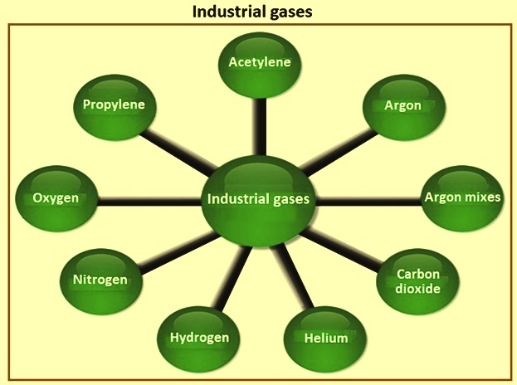
Figure 1 Industrial gases

Industrial gases are supplied in a range of different cylinders， depending on the characteristics of the gas. Some are supplied at high pressure， while others can only be supplied at low pressure. The characteristics of industrial gases determine the way in which they are supplied to customers. Gases such as oxygen， nitrogen， argon and hydrogen can easily be compressed into cylinders at a pressure of 200 bar. Acetylene， due to its characteristics， needs to be stored in a cylinder containing a "porous block" where the gas is kept in a carrier solvent.

Industrial gas cylinders are available in a range of sizes， usually classified by the water capacity of the container. Which size is most appropriate depends on a range of factors， including consumption and flow rate. In addition， each cylinder is fitted with a cylinder valve customized to suit the gas and pressure requirements. Outlet threads are determined by national standards to ensure that only regulators compatible with these requirements can be installed. In addition， for applications requiring higher volumes， industrial gases are supplied in a series of cluster cylinder pallets， which consist of multiple cylinders connected together and shipped on pallets.

The industrial gases commonly used in the steel industry are oxygen， nitrogen， argon， hydrogen and acetylene. The properties of these gases are given in Table 1. A description of these gases is given after the table. In addition， some special gases and gas mixtures are used for instrumental analysis work in steel mill laboratories.

Tab 1 Properties of industrial gases
Gas | Property | Unit | Oxygen | Nitrogen | Argon | Hydrogen | Acetylene
Chemical symbol |  |  | O2 | N2 | Ar | H2 | C2H2
Molecular weight |  | g/mol | 32 | 28.01 | 39.95 | 2.02 | 26.038
Boiling point at 1.033 kg/sq cm | Temperature | deg C | -183 | -195.8 | -185.9 | -252.8
 | Latent heat of vaporization | kcal/kg | 50.91 | 47.586 | 38.791 | 106.597
Gas phase properties at 0 deg C and 1.033 kg/sq cm | Specific gravity | Air = 1 | 1.113 | 0.9737 | 1.39 | 0.06998 | 0.91
 | Specific heat (Cp) | kcal/kg deg C | 0.2197 | 0.2486 | 0.125 | 3.427
 | Density | kg/cum | 1.429 | 1.2506 | 1.7837 | 0.08988 | 1.097
Liquid phase properties at boiling point and 1.033 kg/sq cm | Specific gravity | Water=1 | 1.14 | 0.808 | 1.4 | 0.071
 | Specific heat (Cp) | kcal/kg deg C | 0.3989 | 0.488 | 0.2576 | 2.311
Triple point | Temperature | deg C | -218.8 | -210 | -189.3 | -259.2 | -80.8
 | Pressure | kg/sq cm abs. | 0.0015 | 0.1275 | 0.7026 | 0.0735
Critical point | Temperature | deg C | -188.6 | -146.9 | -122.3 | -239.96
 | Pressure | kg/sq cm abs. | 51.44 | 34.66 | 50.02 | 13.41
 | Density | kg/cum | 436.1 | 314.9 | 535.6 | 30.12
Air is the natural atmosphere of the earth and is a non-flammable， colorless， odorless gas mixture in which nitrogen (78%) and oxygen (21%) predominate. The remaining approximately 1% is made up of the rare gases helium， neon， argon， krypton and xenon. Compressed (pressurized) air is used in a number of applications in steel mills. It is also used to produce oxygen， nitrogen and argon.

Oxygen

Oxygen (O2) is an active component of the atmosphere， accounting for 20.94% by volume and 23% by weight of air. It is a colorless， tasteless and odorless gas. It is highly oxidizing. Oxygen reacts violently with combustible materials， especially in its pure state， releasing heat during the reaction. Many reactions require the presence of water， or are accelerated by a catalyst. Oxygen has a low boiling/freezing point of -183 degrees Celsius. The gas is about 1.11 times heavier than air and is slightly soluble in water and alcohol. Below the boiling point， oxygen is a light blue liquid， slightly heavier than water. The properties of oxygen are given in Table 1.

Oxygen can be produced in large quantities as a high purity gas or liquid by a cryogenic distillation process， or in small quantities (typically around 93%) in low purity by adsorption techniques such as variable pressure adsorption (PSA) or vacuum variable pressure adsorption (VPSA or VSA). Figure 2 shows the cryogenic and non-cryogenic production processes for gases.

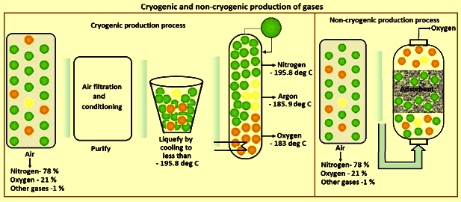
Figure 2 Cryogenic and non-cryogenic production of gases

Oxygen is the second most consumed industrial gas. The largest user of oxygen is the steel industry. In addition to its chemical name O2， oxygen is also known as GOX or GO when produced and transported in gaseous form and LOX or LO when produced in cryogenic liquid form.

The importance of oxygen lies in its reactivity. The reactivity of oxygen is used in steel processing as well as in the welding and cutting of steel. Steel making with basic oxygen furnaces relies heavily on the use of oxygen. It is also used to enrich the air and increase the combustion temperature of the blast furnace， as well as to replace coke with other combustible materials such as pulverized coal， fuel oil or natural gas. In the steelmaking process in a basic oxygen furnace， unwanted carbon combines with oxygen to form carbon oxides， which leave as a gas. The oxygen is fed into the steel bath through a special lance. Oxygen is also used to increase the productivity of the electric arc furnace.

In industrial processes， oxygen enrichment in air increases the reaction rate， which allows for greater throughput in existing equipment or the ability to reduce the physical size of new equipment of the same capacity. Another benefit of oxygen enrichment compared to the use of normal air is energy savings due to the reduced amount of nitrogen and other gases that pass through the furnace or chemical process. Reducing the number of inert gases that must be compressed or heated can reduce energy consumption， either by reducing the gas compression requirements or by reducing the amount of fuel needed to make a given amount of product. Reducing the amount of hot gases emitted to the atmosphere during combustion also reduces the size and purification costs associated with stack gas purification systems.

Oxygen is used along with fuel gases for gas welding， gas cutting， oxygen scarfing， flame cleaning， flame hardening and flame straightening. In gas cutting， oxygen must be of high quality to ensure high cutting speeds and clean cuts.

Oxygen is also used in breathing apparatus. These are used in the steel industry where blast furnace gas or other gases containing carbon monoxide are present at levels above safe values.

Nitrogen

Nitrogen (N2) is a colorless， odorless， tasteless gas that makes up 78.09% of air (by volume). It is non-combustible and does not support combustion. Nitrogen is slightly lighter than air and slightly soluble in water. Nitrogen condenses into a colorless liquid at its boiling point (-195.8 degrees C) and is lighter than water. The properties of nitrogen are given in Table 1.

Nitrogen is usually considered to be an inert gas and is used as such. But nitrogen is not a truly inert gas. It forms nitric oxide and nitrogen dioxide with oxygen， ammonia with hydrogen， and nitrogen sulfide with sulfur. Nitrogen compounds are also formed naturally through biological activity. Compounds are also formed at high temperatures or with the help of catalysts at moderate temperatures.

Nitrogen is the most consumed industrial gas. In addition to the steel industry， it is widely used in the chemical， pharmaceutical， petroleum processing， glass and ceramic manufacturing， metal refining and fabrication processes， pulp and paper manufacturing， and healthcare industries. In addition to its chemical name N2， nitrogen is also referred to as GAN or GN in the gaseous state and LIN or LN in the liquid state.

As shown in Figure 2， nitrogen can be produced in large quantities as a gas or liquid by a low-temperature distillation process， or as a lower purity gas by adsorption techniques such as pressure swing adsorption (PSA) or diffusion separation processes (permeation through specially designed hollow fibers).

The value of gaseous nitrogen lies in its inert nature. It is used to protect potentially reactive materials from contact with oxygen. The value of liquid nitrogen lies in its coldness and inertness. When liquid nitrogen is evaporated and heated to ambient temperature， it absorbs a large amount of heat. The combination of inertness and its extremely cold initial state makes liquid nitrogen an ideal coolant for certain applications. Liquid nitrogen is also used to cool heat-sensitive or typically soft materials to allow machining or fracture.

Nitrogen is used in the steel industry as a gas for pipeline purification， as a coolant for dry quenching of hot coke， as a cooling gas for blast furnace tops， as a carrier gas for conveying pulverized coal， as an inert gas for bottom-blowing converters， and as a protective gas for heat treatment of steel. It is used in different laboratories for testing and also as a process gas， together with other gases， for carbonization and nitriding reduction.

Shrink joints are an interesting alternative to conventional expansion joints. Instead of heating the external metal part， the internal part is cooled with liquid nitrogen so that the metal shrinks and can be inserted. When the metal returns to normal temperature， it expands to its original size， giving a very tight fit.

Argon

Argon (Ar) is a monoatomic， colorless， odorless， tasteless and non-toxic gas with a concentration of 0.934% (by volume) in the atmosphere. Argon is a member of a special group of gases known as rare， noble or inert gases. Other gases in this group include helium， neon， krypton， xenon and radon. These gases are single-atom gases with their outermost electron layers completely filled. The terms noble and inert are used to denote the extremely weak ability of these gases to interact chemically with other materials. All members of this group of gases glow when electrically stimulated. Argon gas produces a light blue violet light.

The normal boiling point of argon gas is -185.9 degrees Celsius. The gas is about 1.39 times heavier than air and is slightly soluble in water. The freezing point is -199.3 degrees Celsius， which is only a few degrees below its normal boiling point. The properties of argon are given in Table 1.

Argon is an important gas， known for its complete inertness， especially at high temperatures. It is the most abundant and cheapest of the truly inert gases. It is usually produced in parallel with the manufacture of high purity oxygen using low temperature distillation of air (Figure 2). Since the boiling point of argon is very close to that of oxygen (a difference of only 2.9 degrees Celsius)， separating pure argon from oxygen and achieving a high recovery of both products requires several stages of distillation.

For decades， the most common argon recovery and purification process has used several steps: (i) a "side pumping" stream from a primary air separation distillation system at the highest argon concentration in a low pressure column， (ii) processing the feed in a crude argon column and returning the nitrogen to the low pressure column to produce a crude argon product. (iii) heating the crude argon to react oxygen impurities in the gas stream (typically about 2%) with controlled amounts of hydrogen to form water， (iv) removing the water vapor by condensation and adsorption， (v) recooling the gas to low temperatures， and (vi) removing the remaining non-argon components (small amounts of nitrogen and unconsumed hydrogen) by further distillation in a pure argon distillation column.

With the development of packed column technology， which allows cryogenic distillation at low pressure drop， most new plants now use a full cryogenic distillation process for argon recovery and purification.

Argon， in addition to its chemical name Ar， is sometimes referred to as PLAR (pure liquid argon) or CLAR (crude liquid argon). Crude argon is usually considered an intermediate product of facilities that make pure argon， but it can also be the end product of some lower capacity air separation plants that distribute it to larger facilities for final purification. Commercial quantities of argon can also be produced in the process of manufacturing ammonia.

Argon is used where a completely inactive gas is required. In steel melting plants， it is used for bottom blowing in the steelmaking co-blowing process. It is used to stir the steel in ladles and as a protective gas for continuous casting of steel. It is also used in AOD converters， where it is blown into the molten metal together with oxygen. The addition of argon reduces the loss of chromium and achieves the desired carbon content at lower temperatures.

Pure argon， as well as argon mixed with various other gases， is used as a shielding gas in TIG welding (tungsten inert gas welding) with non-consumable tungsten electrodes and in MIG (metal inert gas) welding with consumable wire feed electrodes. The function of the shielding gas is to protect the electrode and the weld pool from the oxidizing effect of air.

Hydrogen

Hydrogen (H2) is a colorless， odorless， tasteless， flammable and non-toxic gas at atmospheric temperature and pressure. It is the most abundant element in the universe， but is almost absent in the atmosphere because individual molecules in the upper atmosphere can acquire high velocities when they collide with heavier molecules and are ejected from the atmosphere. It is still quite abundant on Earth， but as part of compounds such as water.

Hydrogen produces a pale blue， almost invisible flame when burned in air. Hydrogen is the lightest of all gases， about one-fifteenth the weight of air. Hydrogen ignites readily and forms explosive gases (hydroxide) with oxygen or air. Hydrogen has the highest combustion energy release per unit weight of any normally occurring material. This property makes it the fuel of choice for the upper stages of multi-stage rockets.

Hydrogen has the lowest boiling point of all elements except helium. When cooled to its boiling point (-252.76 degrees Celsius)， hydrogen becomes a clear， odorless liquid that is only one-fourteenth the weight of water. Liquid hydrogen is not corrosive or particularly reactive. When converted from a liquid to a gas， hydrogen expands about 840 times. Its low boiling point and low density cause liquid hydrogen to dissipate rapidly after spilling. The properties of hydrogen are shown in Table 1.

Hydrogen can be produced by a number of different processes. Thermochemical processes use heat and chemical reactions to release hydrogen from organic materials， such as fossil fuels and biomass. Water (H2O) can be split into hydrogen and oxygen using electrolysis or solar energy. Microorganisms such as bacteria and algae can produce hydrogen through biological processes. Figure 3 shows the production of hydrogen by electrolysis.

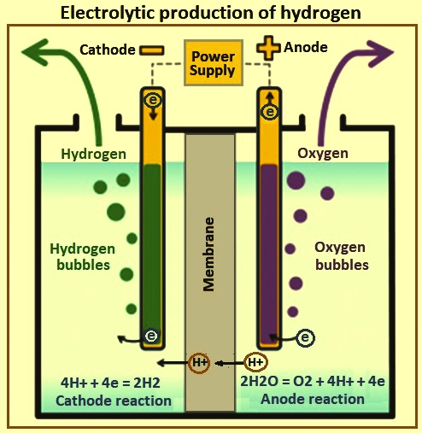
Figure 3 Hydrogen production by electrolysis

Some thermochemical processes use energy from various resources， such as natural gas， coal or biomass， to release hydrogen from its molecular structure. In other processes， thermal energy is combined with a closed chemical cycle to produce hydrogen from a feedstock such as water. Common thermochemical processes to obtain hydrogen are (i) natural gas reforming (also known as steam methane reforming or SMR)， (ii) coal gasification， (iii) biomass gasification， (iv) biomass-derived liquid reforming， and (v) solar thermochemical hydrogen (STCH).

The electrolysis process is carried out in an electrolyzer， which uses electricity to split water into hydrogen and oxygen. This technology is well developed and commercially available， and systems are being developed that can efficiently utilize intermittent renewable energy sources.

Direct solar water separation， or photolysis processes， use light energy to separate water into hydrogen and oxygen. These processes are currently in the early stages of research， but offer long-term potential for sustainable hydrogen production with minimal environmental impact. Two solar water separation processes are (i) photoelectrochemical (PEC) processes and (ii) photobiological processes.

In the biological process， microorganisms are used. Microorganisms such as bacteria and microalgae can produce hydrogen through biological reactions， using either sunlight or organic matter. These technological pathways are in the early stages of research， but have the potential to achieve sustainable， low-carbon hydrogen production in the long term. The two bioprocesses are (i) microbial biomass conversion process， and (ii) photobioprocess.

The most common large-scale process for manufacturing hydrogen is steam reforming of hydrocarbons. Other methods used for hydrogen production include generation by partial oxidation of coal or hydrocarbons， electrolysis of water， recovery of hydrogen as a by-product from electrolytic cells used to produce chlorine and other products， and dissociation of ammonia. Hydrogen can also be recovered for internal use and sale from a variety of refinery and chemical streams， typically purge gas， tail gas， fuel gas， or other contaminated or low-value streams. Purification methods include variable pressure adsorption (PSA)， cryogenic separation and membrane gas separation.

Some industrial processes with relatively small hydrogen requirements have chosen to use compact generators to produce their requirements. In the past， ammonia dissociation was a common technology choice. More recently， improvements in small package electrolysis and hydrocarbon reforming systems have made these avenues for small volume hydrogen production increasingly attractive. Electrolysis production technologies allow the production of high purity hydrogen at high pressures， eliminating the need for supplemental compression. The latest generation of highly packaged hydrocarbon reformers， particularly those employing automated thermal generation processes and operating at relatively low temperatures and pressures， have made on-site hydrocarbon reforming a viable hydrogen production pathway at much lower production rates than was considered commercially viable just a few years ago.

Hydrogen is produced by dissociation of ammonia with the help of a catalyst at a temperature of about 982 degrees Celsius. This results in a mixture of 75% hydrogen and 25% mononuclear nitrogen (N instead of N2). This mixture is used as a protective atmosphere during bright annealing of cold rolled coils and strips. Hydrogen is also used as a reducing agent in the production of direct reduced iron (DRI).

Hydrogen is mixed with an inert gas to obtain a reducing atmosphere， which is required in many applications in the steel industry， such as laboratories， heat treating steel and welding. It is often used to anneal stainless steel alloys and magnetic steel alloys.

Large amounts of hydrogen are used to purify argon containing traces of oxygen， using the catalytic combination of oxygen and hydrogen， and then removing the resulting water.

Acetylene

Acetylene is the chemical compound with the formula C2H2. it is an unsaturated hydrocarbon and is the simplest of the alkynes. An acetylene molecule consists of two carbon atoms and two hydrogen atoms. These two carbon atoms are held together by a so-called three-carbon bond. This bond is useful because it stores a large amount of energy， which can be released as heat during combustion. However， the three-carbon bond is unstable， which makes acetylene gas very sensitive to conditions such as overpressure， overtemperature， electrostatic or mechanical shock.

Acetylene is a colorless and odorless gas. At atmospheric pressure， acetylene cannot exist as a liquid and has no melting point. The adiabatic flame temperature (AFT) in air at atmospheric pressure is 2534 degrees C. The specific gravity at 21 degrees C is 0.91. Today， acetylene is mainly manufactured by partial combustion of methane or occurs as a by-product in the ethylene stream from hydrocarbon cracking.

Due to its unstable nature， acetylene is stored under special conditions. This is achieved by dissolving acetylene in liquid acetone. The liquid acetone is then stored in acetylene bottles， which in turn are filled with a porous (sponge-like) cement material.

Acetylene is used in steel mills for oxyacetylene gas cutting and welding and in continuous casting machines for flame cutting. It is also sometimes used for carburizing steel.

