Hydrogen production equipment for the production of pure hydrogen

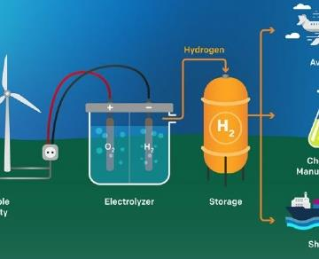
Pure hydrogen cannot be obtained from the atmosphere. It needs to be extracted from some hydrogen-based compounds. XITE has applied the most suitable technology to build a hydrogen generation machine.
This machine breaks down water or hydrocarbons to produce 99% pure hydrogen. Bipolar technology and Proton Exchange Membrane (PEM) technology are applied for hydrogen production.
Comparison of bipolar and proton exchange membrane technologies
● Both electrolyzers produce hydrogen at 99% purity， avoiding all traces of other gases and moisture.
● The bipolar technology usually produces much higher hydrogen from 5 m3/h to 500 m3/h. Depending on the type of electrolyzer， the PEM technology can produce hydrogen streams of only 0.25 m3/h to 500 m3/h.
● The dew point of the hydrogen produced by both electrolyzers is -65°C， which indicates that this resultant gas is dry.
● Hydrogen is delivered at a pressure of 15 bar after it is produced from a hydrogen production plant operated by either technology.
Oxygen is a by-product of the hydrogen production process， as hydrogen is produced from deionized water. In the case of the bipolar technology， this oxygen can be recovered with additional effort， whereas with the PEM technology， oxygen cannot be recovered at all.
Hydrogen production in both technologies requires only electricity， deionized water and cold water for cooling the machine.

