Nitrogen use in the chemical industry

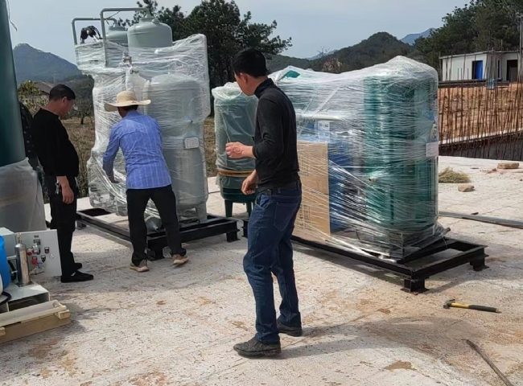
Chemical and resin manufacturing processes require large amounts of nitrogen. Nitrogen is an excellent inert gas and is used extensively in this industry for preserving chemicals， preventing oxidation of raw materials， preventing combustion during chemical storage， and cleaning machinery before and during manufacturing processes. Many chemical industries handle volatile and flammable chemicals. Oxygen removal is a key issue， as the absence of oxygen largely mitigates the risk of fire.
Our customer in Myanmar purchased its first nitrogen production machine from XITE in 2018. Due to the good experience with the quality and reliability of the XITE machines， the customer had confidence in XITE and placed an additional order for 2 more nitrogen production systems， which have recently been put into operation. The actual site photos from the customer's site are a testament to the quality of XITE. We appreciate the customer's support during the installation and commissioning of these 2 new machines. One nitrogen machine is capable of producing 25m3/h of nitrogen with 99.99% purity and the second nitrogen machine is capable of producing 50m3/h of nitrogen， also with 99.99% purity.

