How on-site nitrogen production works - PSA versus membrane technology

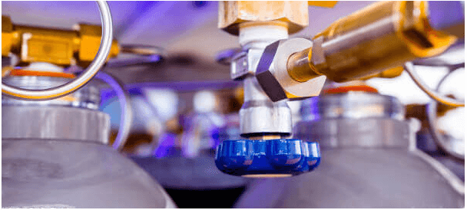
Before nitrogen can be produced on site， the gas must be obtained and transported to different industrial applications via cylinders and tanks. This process can be very cumbersome and problematic. Operators have therefore chosen one of the two available technologies for adequate on-site nitrogen production. This article explores how nitrogen generators (PSA nitrogen generators， nitrogen plants) work and their various benefits to help you discover which system is best suited to your objectives.
How do on-site nitrogen generators work?
The air we breathe is approximately 78% nitrogen， 21% oxygen， and negligible amounts of other gases. Industrial operators have found ways to use this higher percentage of nitrogen to generate nitrogen for a number of applications.
On-site nitrogen generation involves separating the nitrogen from the other air components. It ensures a reliable and economical supply of nitrogen for laser cutting， chemical covering， food packaging and a range of other industrial applications.
Whatever your needs， on-site nitrogen generation units are preferable and more profitable than traditional nitrogen supply methods: purchased from suppliers and transported to site in cylinders and tanks. They rely on membrane or variable pressure adsorption (PSA) technology to achieve the high purity levels suitable for any application. The next sections reveal the differences between these two technologies， while taking a closer look at why a nitrogen generator (PSA nitrogen machine， nitrogen plant) installation may be the best option for your nitrogen supply.
Contact our team today to get a quote for our nitrogen procurement systems.
PSA technology versus membrane technology for on-site nitrogen production
PSA and membrane technologies are the two main production methods widely used for on-site nitrogen generation for a variety of industrial applications. Although both technologies require different amounts of clean， dry compressed air for their operation， they work on different principles.
PSA Nitrogen Generation Systems
A PSA nitrogen generator (PSA nitrogen machine， nitrogen plant) effectively separates nitrogen from the gas stream. It does this safely， reliably and economically with the aid of carbon molecular sieves (CMS).
With a PSA nitrogen generator， the operator fills two containers with CMS which adsorb oxygen molecules from the compressed air passing through them. While one is adsorbing， the other is depressurising， allowing a small amount of nitrogen to flow downwards to release the adsorbed oxygen. This continuous process ensures that the two vessels alternate between adsorption and depressurisation to produce nitrogen gas with a purity of up to 99.9995%.
The benefits of PSA systems
Some of the key benefits of PSA systems for nitrogen production include
Nitrogen purity levels of up to 99.9995%
Highly reliable nitrogen production system
Low maintenance levels due to the use of clean and dry compressed air feed
Highly consistent as it produces large quantities of nitrogen
Membrane nitrogen generators
The separating membrane is the most critical part of the nitrogen membrane system. It consists of thousands of hollow fibres through which compressed air is passed to ensure efficient nitrogen production. Oxygen， carbon dioxide and other gases pass through the hollow fibres more easily than nitrogen. These gases are then released into the atmosphere， leaving a very pure stream of nitrogen at the membrane outlet. The operator only needs to vary the flow rate and pressure of the compressed air to achieve a very high level of purity.
Benefits of hollow fibre membrane systems
The main benefits of using hollow fibre membrane systems for on-site nitrogen production include
Due to its mountability， it is easily applied in confined spaces.
Produces high quality nitrogen with a purity of 95-99.9%.
Its compact and noiseless operation makes the production and supply of nitrogen more environmentally friendly.
Low maintenance requirements due to its low number of moving parts.
High levels of durability and reliability due to limited maintenance requirements.

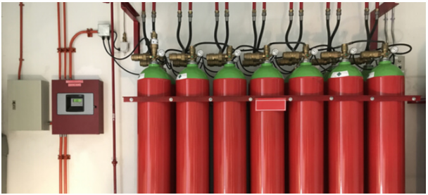
Benefits of purchasing an on-site system from Suzhou XITE Gases
Suzhou XITE Gases nitrogen systems offer the highest quality standards for on-site nitrogen production. Here are some of the main benefits of purchasing these systems.
Cost-effective
Time saving
Very safe and reliable
More environmentally friendly nitrogen supply
Cost-effective
Purchasing nitrogen from a supplier consumes more money than an on-site generator. Some of the additional costs it incurs include the cost of transportation， storage and loss of product during transit. Fortunately， Suzhou XITE Gases offers cost-effective on-site nitrogen generation systems for purchase and procurement.
Time savings
Due to logistical challenges， operators may experience downtime during critical operations. However， with a nitrogen system from Suzhou XITE Gases， you can be assured of a proper nitrogen supply for a variety of processes.
Safety and reliability
A leak from a nitrogen cylinder or tank is toxic to humans. However， this can be avoided by using Suzhou XITE Gas on-site nitrogen generators， as they significantly reduce the need for pressurised nitrogen containers.
You should also note that Seagate Gases Suzhou's Seagate Gases are ASME certified， guaranteeing you reliable and safe operation.
A greener nitrogen supply
Suzhou XITE Gases provides an environmentally friendly nitrogen supply by integrating other systems such as desiccants that prevent all forms of air contamination.
In addition， Suzhou XITE Gas systems are renowned for their high offshore application ratings， revolutionary programmable logic controllers (PLCs)， seamless automatic-manual switching， state-of-the-art remote monitoring， effective dew point monitoring and low and multi-voltage systems. Their safe and reliable systems ensure a continuous supply of nitrogen， making project completion cost effective.
Contact Suzhou XITE Gases for efficient on-site nitrogen production systems
Suzhou XITE Gases offers its customers a unique experience in providing the most suitable nitrogen for their nitrogen production needs. We have established cost-effective on-site nitrogen production technology to meet a number of industrial and customer specifications.
Contact us today to find out more about our reliable on-site nitrogen production systems.

