High purity nitrogen is non-toxic， odourless and non-polluting to the atmosphere.

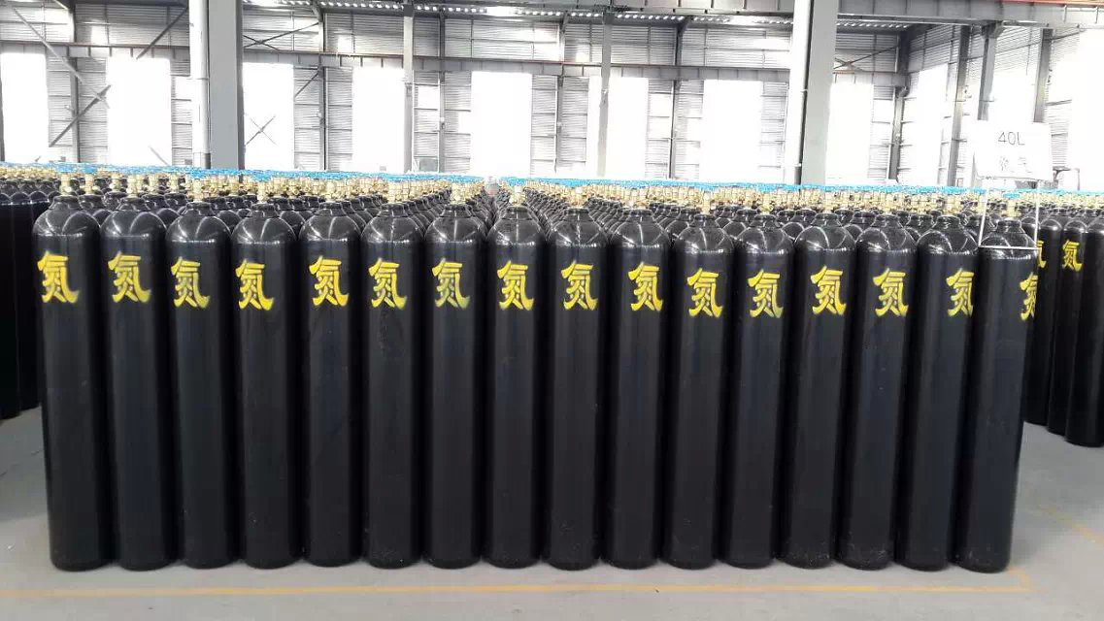
The content of high purity nitrogen in the air is very small， accounting for only about one part in 200，000， easy to find; helium molecules are small， light in mass， easy to diffuse， easy to cross the leakage holes than other gases; helium ion charge-to-mass ratio is small， easy to carry out mass spectrometry; helium is non-toxic， odourless and non-polluting to the atmosphere. Helium is an inert gas， chemically stable， will not corrode and damage equipment; helium is non-toxic， non-condensable， difficult to tolerate in water. Because helium has the above characteristics， helium leak detection has been used from scientific research institutes to industrial enterprises and even to individual enterprises， it can be said that the use of the field end of a wide range.
The supply of helium from the sun is unlimited. We have not confirmed that helium can be produced by nuclear fusion on Earth. But the sun is moving every second， and our sun is a helium factory. It's actually made up of about 25% helium， but it's ejecting helium into space day and night in coronal jets and solar winds. This means that helium is always blowing over our heads， but it doesn't enter our atmosphere because the Earth's atmosphere keeps it from going against our planet. So we have to capture it at the source of the sun - using the idea of a giant structure in space called a Dyson sphere. A Dyson Sphere is basically a giant bubble that traps and collects particles and makes them available for human use. z The original idea was to get unlimited solar energy， which could also be used to trap elements like helium.
High purity helium is used in the use of YQY-12 or 152IN-125 and other pressure reducers to reduce the pressure after use， the use of soapy water before the use of gas pipeline leakage， to ensure that the gas pipeline does not leak. Ensure that the helium gas does not leak， the workplace to maintain ventilation， when the helium content increases resulting in oxygen content of less than 19.5%， the patient first showed accelerated respiration， inattention， ataxia; followed by fatigue and weakness， irritability， nausea， vomiting， fainting， convulsions， and so on， resulting in death. Packaging cylinders are used on the age， where the expiry of the cylinder must be sent to a part of the safety inspection， before continuing to use.

