Using nitrogen generators to fight bacteria

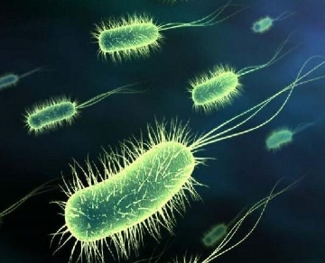

Bacteria are everywhere， as it can survive in a variety of environments. Since it is present in our own bodies， one cannot help but encounter this organism. In fact， these microorganisms are harmless and are even needed for the survival of organisms and ecosystems. However， there are some bacteria that can cause serious infections and diseases. It is also responsible for degrading some specific chemicals. Bacteria can be a source of serious risk to the food， medical and chemical processing industries. The best way to prevent the risk of bacterial growth is through the use of nitrogen produced by on-site nitrogen generators.
The benefits of using nitrogen in a variety of industries include
Preservation of food products
Since bacteria have the ability to replicate in any environment， the food industry must find a solution to protect their products from these organisms. The food industry uses a packaging method called Modified Atmosphere Packaging (MAP) to avoid bacteria by applying nitrogen， which replaces any kind of oxygen inside the package， causing the bacteria to die. The removal of oxygen is also responsible for keeping the food in the package fresh.
Favorable chemical processing
It is vital that no external inference is allowed during chemical processing. Moreover， chemical addition equipment effectively blocks oxygen， which can affect the quality of chemicals and can even cause conditions such as moisture， fires and exposure to deadly pathogens. The use of nitrogen in any chemical process removes oxygen， thereby greatly reducing， and decreasing the chance of any hazards.
Sterilization of medical equipment -
Medical equipment is sterilized using nitrogen to keep it free of bacteria and to ensure patient safety. It is also necessary to keep medical tools sterile inside the package for as long as possible. It goes without saying that the nitrogen inside the package stops bacteria from growing and replicating. This is a mandatory procedure in the medical field to prevent infections and diseases.
What are the benefits of using a nitrogen generator?
In order to prevent the growth of bacteria， you must have access to a reliable source of nitrogen， which can be ensured by installing on-site nitrogen generator equipment. It is the best and cheapest way to generate on-site nitrogen for your specific industry. The generator is able to produce nitrogen by drawing in air and removing oxygen， leaving only the nitrogen behind. Having an on-site nitrogen generator will allow you to produce the nitrogen you need.

