PSA Nitrogen Generator

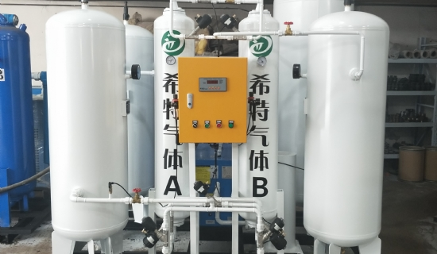
Nitrogen is used in many commercial and industrial applications to improve the quality of products or processes， or as a safety measure to prevent combustion. The delivery and storage of liquid or bottled nitrogen can be expensive， unreliable and a safety hazard. Nitrogen generators enable users to produce nitrogen simply and inexpensively in-house using existing compressed air systems.

XITE recognizes the importance of having a safe， reliable and cost effective supply of high purity nitrogen. We have developed PSA nitrogen generators to meet the growing demand for high quality packaged solutions that save energy and time while being designed to meet their intended application requirements. Typical payback for nitrogen generators is less than 24 months.
Many industries are turning to nano PSA nitrogen generators， some of which include

Food (MAP)
Beverages (bottling)
Plastics (PET)
Pharmaceuticals (product transfer)
Chemicals (overlay)
Laser metal cutting (burr reduction)
Fire protection (avoiding combustion)
Electronics (wave soldering)

