Nitrogen generators for heat treatment processes

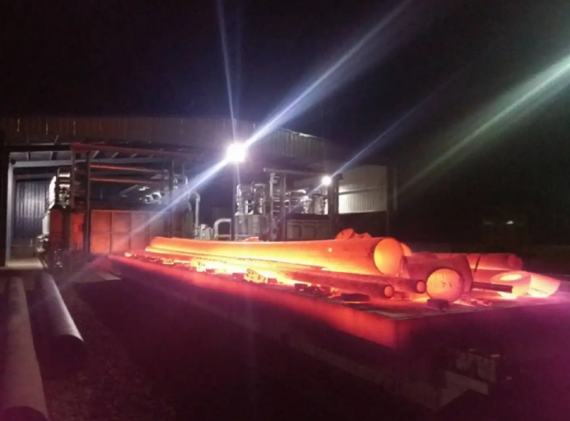
For years， the heat treatment industry has relied on the inert nature of nitrogen to squeeze oxygen out of high-temperature environments， often requiring high flow rates and high purity in short periods of time. Suzhou XITE's nitrogen generators are designed to reliably deliver the consistent purity and flow rates required for your heat treating process.
Nantech's industrial nitrogen generator systems utilize dual adsorption tower PSA technology. PSA (variable pressure adsorption) filtration provides 99.999% pure nitrogen， while the dual adsorption tower design allows for maximum efficiency and minimal maintenance. Combined， the dual adsorption tower design and PSA technology is a robust solution with a system life of 18-24 years， depending on maintenance.
In addition to hassle-free in-house nitrogen production， customers benefit from significant cost savings averaging 50-90% and a fast return on investment， with a typical payback of about one year. Suzhou XITE offers procurement， rental and purchase options - all of which result in savings.
For many years， the heat treatment industry has relied on the inert nature of nitrogen to push oxygen out of high-temperature environments， often requiring high flow rates and high purity in a short period of time. Suzhou XITE's nitrogen generators are designed to reliably deliver the consistent purity and flow rates required for your heat treating process.
Nantech's industrial nitrogen generator systems utilize dual adsorption tower PSA technology. PSA (variable pressure adsorption) filtration provides 99.999% pure nitrogen， while the dual adsorption tower design allows for maximum efficiency and minimal maintenance. Combined， the dual adsorption tower design and PSA technology is a robust solution with a system life of 18-24 years， depending on maintenance.
In addition to hassle-free internal Nitrogen? generation， customers benefit from significant cost savings averaging 50-90% and a quick return on investment， with a typical payback of about one year. Suzhou XITE offers procurement， rental and purchase options - all of which result in savings.

