What is a Vacuum Variable Pressure Adsorption Generator?

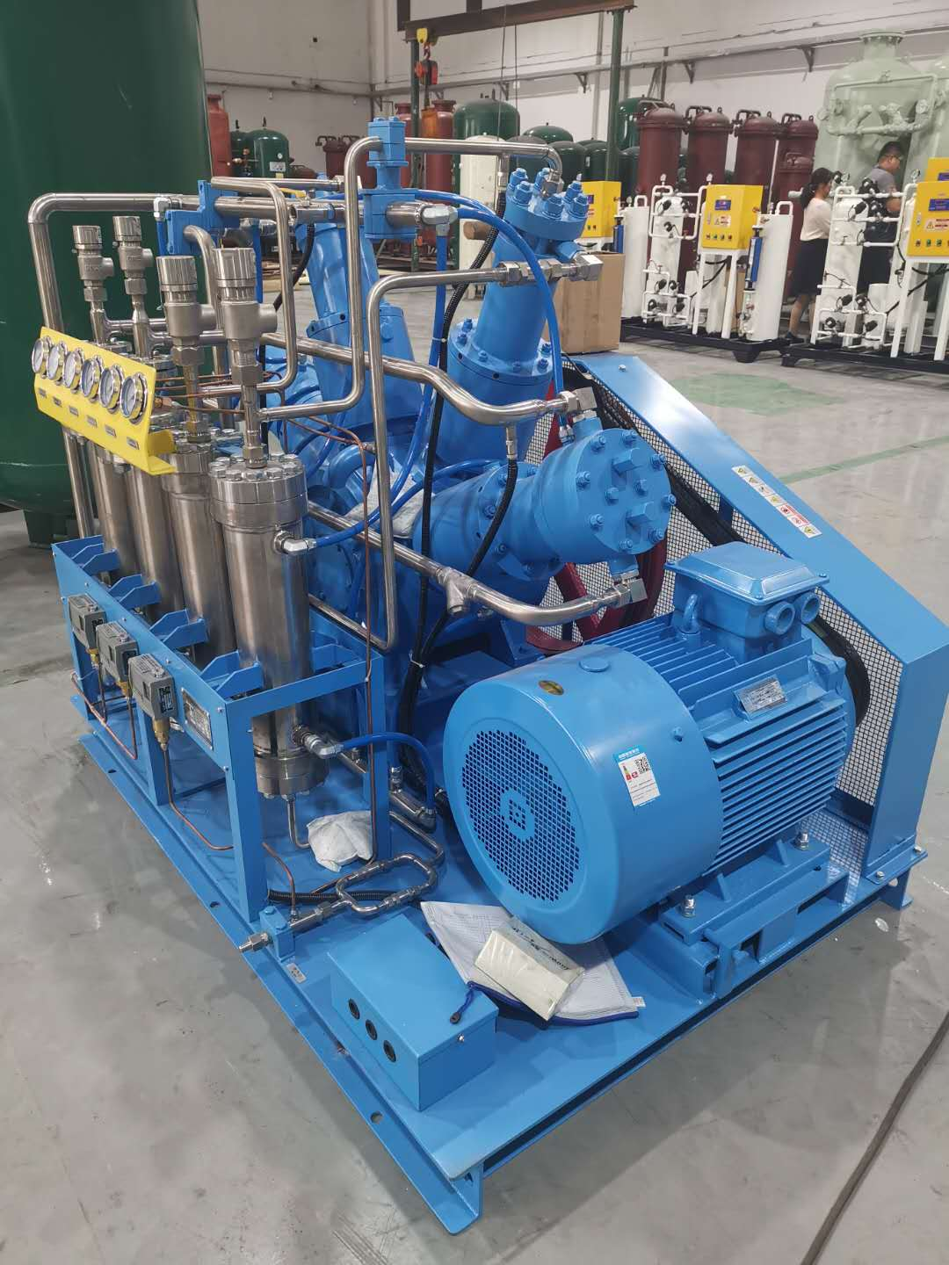
Oxygen is one of the most important gases used in industrial production for various processes. The separation of oxygen by cryogenic processes is then difficult and expensive. Therefore， the VPSA method is used to extract oxygen from gas mixtures. vpsa works at low pressure and is economical. It is an advanced method of separating oxygen in which an adsorbent is used. A special type of adsorbent， selected from a wide range of adsorbents， is used on which the gas is run. Gradually， the gas that is separated is dense with oxygen. This is the simplest method of separating oxygen and VPSA oxygen generators are widely used in industries that require oxygen on a daily basis. Industry owners understand the importance of having a VPSA generator. Therefore， they invest in this technology.
Understanding the process
The air is fed into a cooler to reduce its moisture content. The condensed moisture is then separated with the help of a moisture separator， which is processed by the VPSA oxygen generator (PSA oxygen machine， oxygen generator) using a selected adsorbent. The cooled air is then passed through a tower coated with sorbent. In this process， the cooled air passes through the tower and separation of approximately 93% to 5% of the oxygen takes place. This is the process that takes place in one tower.
The extraction of gases must take place on a large scale. Therefore， for the generation of gases， only one tower is not sufficient. Industry utilises many of these towers to ensure that the cycle of extracting oxygen does not stop. Used towers are also regenerated to obtain continuous oxygen extraction.
Due to the advantages of the VPSA generator it has had a good demand over the years. It is used in many small to large industrial processes.
Let us show you what the advantages and industrial applications of using oxygen are.
Advantages of the VPSA oxygen generator
Improves the combustion process in the kiln or furnace
Oxygen production on site is cost effective and available.
No storage hassles.
The purity of the oxygen generated on site is higher than what you can buy.
Most importantly， it saves time and the hassle of managing inventory.
Applications of oxygen
It is widely used in furnaces or kilns for making steel from iron ore.
Metals such as copper， lead， nickel， zinc， tin and gold are separated by a process that uses oxygen.
It is a major component in the processing of glass tubes and ampoules.
Oxygen is used in wastewater treatment plants to reduce odours and improve aeration.
It is an active ingredient in fermentation， incineration and oxidation reactions.
The ceramics and sanitary ware industries use oxygen.
The paper and pulp industries use oxygen as a bleaching agent.
There are countless industries that use oxygen in their processes. Gases are vital to life and industry. If you are an industry owner who needs oxygen in your production process， then you must look for a reliable VPSA generator.
Translated with www.DeepL.com/Translator (free version)

