The best nitrogen equipment manufacturer

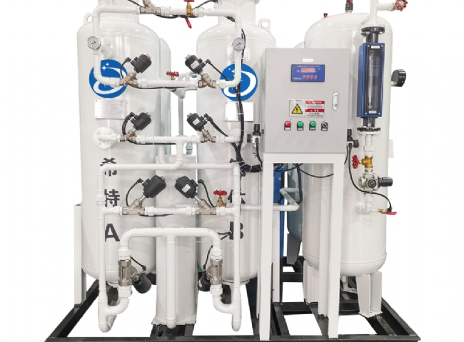
Have you ever thought about the uncountable benefits produced by nitrogen fertilizers to plants in different industries?
Nitrogen is a gaseous substance found in nature. It has different applications， for example， in the formation of nitric acid and explosives.
Suzhou Hite Manufacturing is a very experienced company with our nitrogen plant since 2016. We provide quality equipment for various sectoral industries such as steel， cement， chemical， power， etc.
Suzhou Hite offers nitrogen equipment that has its wide range of applications in many fields such as.
- Laser cutting function
- For the formation of light weight supplies for aerospace and aircraft
- It is used in tires as it does not leak like other gases and makes the tires smooth and last longer.
- It is used as a supervising gas in aerosol systems to prevent them from getting wet and causing corrosion.
- Boiler tubes in power plants are immersed in cooling towers， which can cause them to come into contact with oxygen， which can lead to rusting. At this point， nitrogen can be used to remove the impregnated portion of the boiler to prevent it from corroding.
- It is used to provide safety for airbags
- It is used along with other gases for welding in steel， cement， chemicals， electricity， etc.
- It is also used to push liquids so that they flow smoothly out of pipes.
- It also helps to stop adulteration and make the environment clean of impurities.
- It also has applications in packaging as it helps in removing stains and wastage.
- It contains high cooling power which helps in freezing biological specimens， tissues， etc. It also helps in freezing food and beverages.
Don't you want your business to be the safest， hygienic and have more benefits?

