Consider to build an industrial N2 (nitrogen) filling station

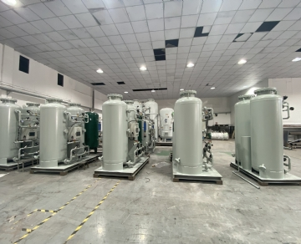
Now is the best time for your company to consider industrial N2 filling station. Our company provides nitrogen cylinder filling station. We can provide your enterprise with a variety of systems of different types and sizes to meet your requirements
N2 filling station allows refilling of cylinders instead of ordering pre filling options from another company. The ability to refill nitrogen cylinders as needed saves your company time and money while improving reliability. You can use on-site and on-demand nitrogen to meet your nitrogen needs without worrying about running out.

Save money on nitrogen cylinders
All companies want to save money， and your company can save a lot of money by refilling the nitrogen cylinder. Purchasing pre filled cylinders from gas suppliers can be expensive and cumbersome: you must rely on timely delivery， and any delay can lead to your running out， thereby reducing or even stopping production. The cost of lost productivity is higher than the price of filling gas cylinders.
Our company provides perfect solutions for your business. Instead of hiring a company to bring full cylinders and exchange empty cylinders， you can fill them yourself. The nitrogen generator system allows you to add a gas station to your facility， which means eliminating the high cost of filling cylinders and alleviating concerns about timely receipt of refills. In addition， refilling the cylinder eliminates the safety problem of storing the filled nitrogen cylinder， and the space occupied by the filling station of the on-site gas system is very small.
Installation of industrial N2 filling station
Most gas stations use booster pumps from the generator system to fill cylinders to 2200 psig. If you need more pressure， help can be provided on site. We have a variety of options to ensure that you get the nitrogen you need for your business when you need it. Having an industrial N2 filling station is an effective way to reduce costs， speed up the production process and ensure that your enterprise will not be idle because there is no nitrogen.

