Application of nitrogen purging system on power transformers

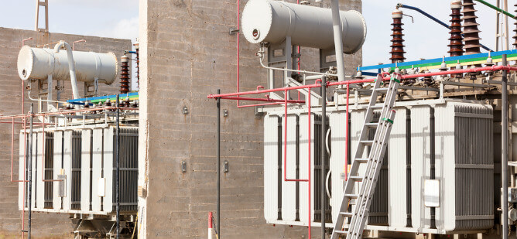
The risk of a fire in a power transformer may be low， but when it occurs， the effects can be severe. If an employee is working near a transformer when an explosion occurs， that person could suffer varying degrees of burns or fatal damage to vital organs.
Knowing the right precautions to take can ensure the safety of people and equipment in electrical facilities. In this article， we will discuss the use of transformer nitrogen purge systems to prevent fire hazards and widespread power outages.
Fire Triangle

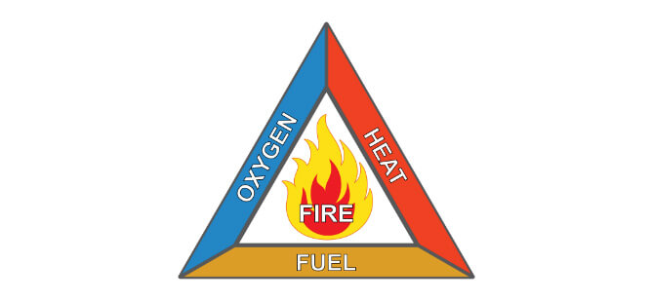
In order to understand how a transformer fire can occur， it is instructive to understand the basic requirements for a fire to occur. Before any fire can occur， certain conditions must be met.
The fire triangle (or combustion triangle) shows the three basic requirements that must be met for a fire to occur.
Source of fuel
Amount of heat
Oxygen
The source of fuel can be any combustible material - in the case of a transformer， cooling oil. Heat is needed to ignite the fuel to ignition temperature， while oxygen provides the chemical oxidation process necessary to keep the fire burning.
Firefighting techniques based on the fire triangle model
A basic principle of firefighting is that eliminating or reducing any element of the fire triangle to a sufficient degree will extinguish the fire.
Removal of fuels
Eliminating fuel sources (also known as starvation) is one way to douse a fire. For example， an important step in extinguishing an electrical fire is to isolate all sources of energy. However， for safety reasons， it may not always be possible to remove the fuel source， especially in a rapidly spreading fire.
Reducing heat
Reducing heat reduces the temperature of the burning medium enough to extinguish the fire. Water is an effective substance for quickly cooling fires that burn with combustible organic and inorganic materials， such as wood and gasoline. However， it is not suitable for extinguishing electrical fires because of the risk of electric shock.
Reducing Oxygen
Reducing the oxygen content at the point of ignition is one of the most effective methods of extinguishing fires. Oxygen replacement using carbon dioxide (CO2) extinguishers is one of the common firefighting techniques. However， its main drawback is the response time to the event.
Since fire extinguishers are operated by people， they pose significant safety issues， which can include slow (human) response to events or incorrect operation. On the other hand， transformer explosion protection and fire suppression systems can provide automated safety for electrical facilities.
What causes a transformer fire?

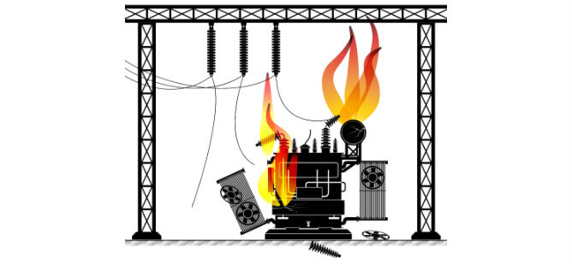
Most transformer fires occur when the main oil tank or oil reservoir ruptures， creating an explosive air-oil mixture due to short circuit conditions. The main oil tank usually contains low-viscosity oil with good dielectric properties， which serves as a cooling medium for the windings and keeps the internal components free from dust and moisture. In transformers rated up to 50 kV， the main oil tank is completely filled with oil.
In the event of an explosion， the high pressure conditions in the tank may cause large amounts of hot liquid to fly several yards away from the unit at high velocity. Personnel working in the vicinity of the unit may suffer burns of varying degrees (which may or may not be fatal)， and leakage of transformer oil may adversely affect the surrounding environment.
Fire protection systems for transformers
Nitrogen fire suppression systems for power transformers use nitrogen as a necessary component to subdue fires by replacing oxygen in the fire source. Due to its inert and lightweight physical properties (lighter and less dense than air)， nitrogen is the best choice for nitrogen purge systems for transformers. In addition， nitrogen is an eco-friendly gas that does not contribute to greenhouse gas emissions like carbon dioxide.
The Nitrogen Injection Fire Protection System (NIFPS) is a dual-action fire safety system that uses a series of electromechanical signals to actuate a valve that opens to drain oil from a transformer tank in the event of a rupture while nitrogen is injected into the tank to replace oxygen.
To extinguish a fire in a transformer， we can reduce the oxygen level by displacing it with nitrogen if a fire occurs. A typical design includes two systems - an explosion-proof system and a fire suppression system.
The explosion protection system consists of a Buchholz (surge) relay and a main relay in parallel with a pressure relief (oil drain) valve. The fire suppression system consists of a fire detection device， a Buchholz relay in parallel with the pressure relief valve， and a main relay.
The nitrogen for injection is stored in a cylinder with a pressure regulator and safety valve， and an electric manometer to monitor the injection pressure.
A transformer filled with nitrogen will have a level of oxygen that is not sufficient to ignite a fire. The nitrogen pressure in the transformer also helps to reduce the top oil pressure and temperature， which is critical to prevent explosions.

