Automation， control and modeling of basic oxygen steelmaking

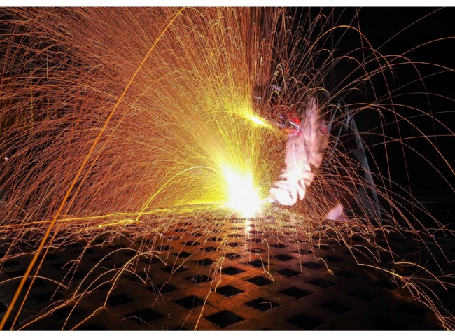
Automation， control and modeling of basic oxygen steelmaking
In basic oxygen steelmaking， the basic oxygen furnace or converter produces liquid steel by reducing the carbon content of the hot metal produced in the blast furnace from about 4.5% to 0.03% to 1.0%. The converter blows large amounts of pure oxygen into the hot metal and refines it into steel in a short period of time. Currently， the basic oxygen steelmaking process uses combined blowing (top blowing and bottom blowing). The bottom blowing is done with inert gas. In the refining process， various materials are used in the converter. Besides hot metal and scrap iron as main raw materials， other materials used in the basic oxygen steelmaking process are calcined lime， calcined dolomite or calcined magnesite for proper slag formation and different coolants in the process (e.g. ore， sponge iron， etc.). The operation of the converter requires a high gas temperature and generates a lot of dust.
The purpose of the basic oxygen steelmaking process is to refine the liquid metal (molten scrap + hot metal) and to adjust the composition and temperature of the molten steel. To achieve this， the steelmaking process uses automation and control systems， usually consisting of a basic automation system and a process control system.
The engineering facilities for basic oxygen steelmaking are actually the design and assembly of various subsystems. The main equipment for basic oxygen steelmaking is a refractory-lined converter (basic oxygen furnace)， in which the steelmaking process takes place. In addition to the converter vessel， the steelmaking process has several subsystems， including (i) converter vessel tilt drive， (ii) oxygen lance system， (iii) inert gas bottom stirring system， (iv) top gas (converter gas) cooling， cleaning， analysis and recovery system， (v) sub lance measurement system， (vi) anti-slip system， and (vii) material handling system. (viii) scrap charging system， (ix) solder and coolant charging system， (x) ferroalloy charging system， (xi) horizontal temperature measurement and sampling system， (xii) automatic steel discharge system， (xiii) slag blocking system， (xiv) secondary dust removal system， (xv) interlock and alarm system， and (xvi) human-machine interface system.
In addition to these subsystems， the oxygen steelmaking will operate in an integrated manner with the upstream and downstream processes. In addition， the steelmaking process will be connected to external systems such as (i) the steel melting plant laboratory， which includes optical emission spectrometers and X-ray fluorescence spectrometers and other analytical equipment， and (ii) the supervisory control and data acquisition (SCADA) system.
Basic oxygen steelmaking is a complex physicochemical process with a large number of influencing factors. There are two methods used to control the blowing gas in the converter. The first method uses indirect measurements of the waste gas， while the second method uses direct measurements of the subgun. In the second method， the temperature of the steel (in degrees Celsius) is measured directly during the blowing process at the same time. This method can also be used for various purposes， such as water bath leveling， slag leveling， measuring oxygen concentration and slag sampling.
In the basic oxygen steelmaking process， the classical process models are still valid and require the operator to know as much as possible about the inputs， process parameters and outputs， which he needs to have free access to in order to make the necessary adjustments to the process to produce medium to large products. In order to achieve this goal， various control and estimation techniques need to be used that function in an organized manner in order to provide the required information for the operator's actions.
Subsystems appropriate to this engineering level are (i) hot metal mass measurement， (ii) hot metal analysis， (iii) inert gas bottom stirring， (iv) oxygen supply， (v) charge temperature and analysis， (vi) melt and coolant charging systems， (vii) ferroalloy charging systems， (viii) process control computers， and (ix) management computers. Measurements required during the steelmaking process are (i) temperature measurements， (ii) melt pool carbon content， (iii) melt pool depth， and (iv) complete chemical analysis. This is usually achieved by stopping the process， tilting the converter， and taking manual temperature and samples.
Process control is an important part of the basic oxygen steelmaking operation， as the heat production time is affected by it. There are several steelmaking process control strategies available， and steel mills use strategies based on their facilities and needs. Process control models can be broadly classified into two categories， i.e. (i) static， and (ii) dynamic.
The simplest form of process control is based on static process models. It consists of a set of heat， oxygen， iron and slag balances combined with equations of state. The latter describes the relationship between the iron content of the slag， the actual content of manganese and carbon in the steel， and the alkalinity of the slag. The static model determines the amount of oxygen blown and the charge of the furnace given initial and final information about the heat， but produces no information about the process variables during the oxygen blowing process. The static model is basically like shooting an arrow. Once the arrow leaves the bow， there is no further control.
In the case of dynamic process control， accurate information about the actual state of the blowing process is needed. Ideally， uninterrupted information on steel， slag and gas composition as well as temperature is available and used online for process supervision. Any deviation from the desired process can be detected and， depending on the model， the oxygen supply can be adjusted or additional flux can be added to the converter. In a basic steelmaking converter， this is only possible under ideal conditions. In practice， the situation is quite different. Especially in a basic oxygen steelmaking process， uninterrupted measurement has strong practical limitations， such as vibrations， dust， high temperatures and liquid metal and slag phases. Dynamic models are adjusted during the oxygen blowing process according to the measurement results in certain blowing gases.
The requirements of the dynamic control process are (i) not to interrupt the process and (ii) to obtain real-time measurements. For this purpose， a sub-gun system capable of handling the process conditions and using disposable sensors on the gun head is used. The different sensors are characterized by their measurement functions， the most important being (i) bath temperature measurement， (ii) bath carbon measurement， and (iii) bath level measurement. Any combination can be used.
The main functions of the basic automation system include oxygen lance control， material control， bottom stirring control， sub-lance detection control， and end point control. The process control system performs production management， control models， process control， and data management. The process control system is used to control the basic automation system. First， it collects information about the melting process and the detection information of the subgun. Then， it determines the status of the melting process based on the results of the model calculation. Finally， it sends signals to the basic automation system to control the adjusted parameters.
The automation and control of basic oxygen steelmaking takes into account not only the specific process functions of the converter， but also the relevant parameters of the charge， including hot metal preparation， scrap yard management and scheduling logistics. Process optimization (Level-2) solutions are based on advanced algorithmic equations that accurately represent complex thermodynamic metallurgical reactions. These solutions are primarily applicable to most operating conditions， such as variable scrap to hot metal ratios， minimal slag practices and varying phosphorus content.
The main objectives of automation and control of the basic oxygen steelmaking process are (1) to meet the requirements of steelmaking， and (2) to provide operational assistance. In addition， automation and control of the steelmaking process is an effective way to (i) provide comprehensive and consistent process information to guide operators， (ii) ensure standardized operations to obtain uniform steel quality， (iii) improve process performance， (iv) improve accuracy of end-point control， (v) shorten thermal cycles， (vi) improve productivity by optimizing steelmaking， (vii) increase productivity by using process models that optimize material use and energy input to reduce production costs. Automation and control rely heavily on computers and are inseparable from the mechanization of the steelmaking process.
The general arcXITEctural structure of automation and control of the basic oxygen steelmaking process consists of (i) the enterprise information system， (ii) the steelmaking plant management information system， (iii) the process control， and (iv) the field instrumentation and equipment.
As can be inferred from the different subsystems and the interfaces that exist between them， it is clear that conventional (analog) circuits cannot achieve the required interconnections. Therefore， it is necessary to make extensive use of digital process control equipment， which offers various advantages such as (i) the ease with which systems can be added and changed， (ii) the ability to handle advanced control strategies， (iii) the ability to program intelligence into the system， (iv) the existence of effective backup facilities， (v) the CRT (cathode ray tube) operator interface that can incorporate a large number of display options， (v) the existence of storage data， (vi) easy access to information and stored data， and (vii) high-level and low-level communication. Figure 1 shows the basic automation and process control system for basic oxygen steelmaking.

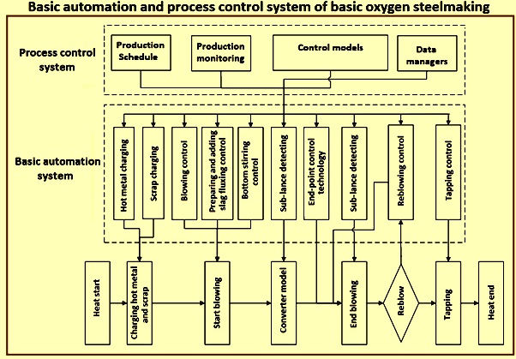
Figure 1 Basic automation and process control system for basic oxygen steelmaking
The increase in computer speed and capacity， the adoption of programmable logic controllers (PLCs) in electrical and control systems， and the conversion from analog to digital instrumentation have led to a significant increase in control accuracy. In addition， the recent application of direct digital control has accelerated the automation of the steelmaking process.
With the advancement of process computers and peripheral measurement technology， the blowdown control of converters has been transformed from static control systems to dynamic or fully automated operational control systems. In addition， as a result of technological advances in electrical and control systems， controllers have shifted from dashboards to CRT displays， allowing operators to monitor and control the steelmaking process on a CRT screen. In addition， with the use of mathematical models and expert systems (using artificial intelligence programs)， the automation and control of the steelmaking process has become more operator-friendly.
The control systems of the different subsystems are often configured as DCS (Distributed Control Systems) and PLC (Programmable Logic Controllers)， which are seamlessly connected to the DCS of the basic oxygen furnace and provide integrated monitoring and control. The unique advantage of this integrated approach is that it covers process stability， product quality， operational flexibility and improved working environment， while safeguarding efficiency and cost effectiveness.
The distributed control instrumentation houses (i) the production operator's console， (ii) field simulation， (iii) instrument display and control， (iv) trending， (v) and logs. The distributed computer on the data highway uses the required I/O (input/output) to handle (i) the water system， (ii) the weighing system， (iii) the bottom mixing system， (iv) the oxygen system， and (v) the communication with the main computer. The management information/control computer is usually a high volume system used mainly for (i) providing information， i.e. shift/day/monthly reports， (ii) handling interactive production， (iii) scheduling between downstream/upstream plants， and (iv) preparing charges (preloading of scrap， etc.). Adaptation to static models， such as heat balance， determining flux (lime/dolomite) and coolant (sponge iron/iron ore)， quantity and when to charge， and oxygen balance (determining rate， duration and blowing pattern)， (vi) adaptation to dynamic models， starting operation after the sub-lance provides real-time information. The system produces an active display that allows the operator to end the process on target， calculate the final result and suggest minor modifications and add final alloys.
The control models are the core part of the automated steelmaking control system. They integrate knowledge of the melting mechanism， mathematical statistics， expert principles and adaptive learning. The control equations are derived using knowledge of the melting mechanism and the key control parameters are defined by mathematical statistics and expert principles. In addition， these control parameters can be modified periodically by adaptive learning. The control models are the static control model， the main material model， the slag formation model， the temperature model， the oxygen consumption model， the dynamic control model， the tilt model， the alloy model and the end point model. In addition， there is an adaptive learning model. The different inspection equipment used are the sub-gun， mass spectrometer， flame spectrometer， microwave rangefinder， oxygen gun vibration monitoring equipment， etc.
In addition， several control models are available， such as mechanism models， statistical models and incremental models. The mechanism model is based on the conservation of heat and mass. It determines the relationship between the variables by mathematical derivation. However， it is not suitable for application due to the complexity of the melting process. The statistical model is based on the black box theory. In this model， physicochemical processes are ignored. It focuses only on the statistical relationships between the input and output parameters. The computational accuracy of this model is not maintained as long as the melting conditions change. With the incremental model， the operating parameters can be refined by comparing them with the recorded productivity data. It can overcome the effects caused by changes in melting conditions. However， the main disadvantage of this model is the low calculation accuracy. Figure 2 shows the functions of the control system and the process model.

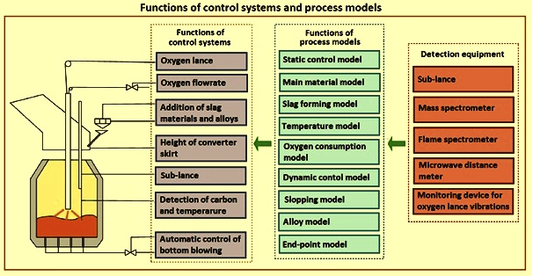
Figure 2 Functions of the control system and process model
Endpoint Carbon Prediction
Endpoint carbon prediction initially relied on the experience and skill of the operator. This method is known to be inefficient and difficult， especially for the melting process of medium and high carbon steels. With the development of computers and information technology， research on computer control of basic oxygen steelmaking has been carried out. Static charge models based on computer calculations were first utilized by Jones & Laughlin Steel to calculate the amount of hot metal， scrap and slag charged and to guide the end carbon control of liquid steel.
With the rapid development of automated detection methods， mathematical models and algorithms， dynamic and intelligent end-point carbon prediction has become available for use in the steelmaking process. Depending on the characteristics of the data collected and used to calculate the endpoint carbon content， endpoint carbon prediction is divided into three stages， such as static prediction， dynamic prediction and intelligent prediction.
Static prediction - Throughout the basic oxygen steelmaking process， the operator is usually assisted by a computer-guided system that proposes process parameters and operator actions based on mass and energy balance calculations and thermodynamic calculations. Static end-point carbon prediction relies mainly on a mathematical model built on the basis of mass and heat balances， which calculates the end-point carbon content in the molten steel based on initial charge parameters (e.g.， charged hot metal and scrap， as well as hot metal composition and temperature). Figure 3 shows a static model for endpoint prediction for basic oxygen steelmaking.

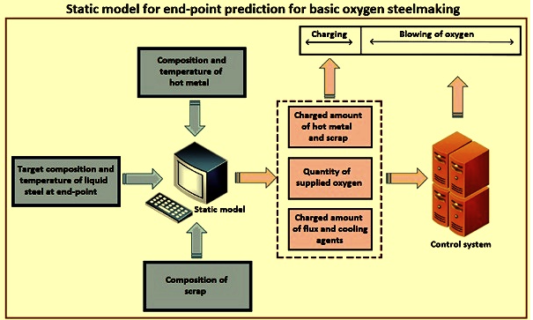
Figure 3 Static model for basic oxygen steelmaking endpoint prediction
The key point of static endpoint carbon prediction is the reasonable establishment of the mathematical model and the acquisition of the initial quantity data. Compared with the randomness and uncertainty of endpoint carbon prediction based on operator's experience and skill， static endpoint carbon prediction can improve the accuracy of endpoint carbon prediction by quantitative calculation of oxygen blowing and endpoint carbon content. The mathematical models usually used for static endpoint carbon prediction mainly include theoretical models and statistical models.
The theoretical model can calculate the oxygen blow and endpoint carbon content based on the calculation of mass and heat balance in the steelmaking process. Due to the complex interactions between various influencing factors in the basic steelmaking process， the calculation of mass and heat balance is usually done with empirical values and is not accurate， therefore， the theoretical model performs relatively poorly in the basic steelmaking converter endpoint carbon prediction.
Statistical models focus only on the relationship between input and output variables， using the collected data for statistical analysis without considering the chemical reaction mechanism in the liquid bath， which is described by the equation X = F(W， S， T， t， Z)， where 'F' is a linear or nonlinear function. 'W' is the charged weight of the hot metal and scrap， 'S' is the target value of the end-point composition in the molten steel， 'T' is the hot metal initial temperature， "t" is the oxygen blowing time and "Z" is other important influencing factors (e.g. top gun height and oxygen pressure).
As a statistical model， back propagation neural networks combined with different algorithms have been widely used in recent years for endpoint prediction in basic oxygen steelmaking. Compared with theoretical models， neural networks are good at analyzing random deviations and avoiding the influence of random factors， which can provide a more reliable reference for endpoint carbon prediction. Figure 4 shows the back propagation neural network for endpoint carbon prediction.

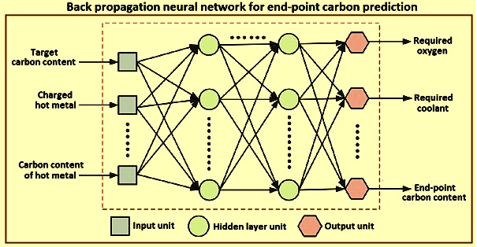
Figure 4 Back propagation neural network for endpoint carbon prediction
However， the theoretical and statistical models described in the previous section are based only on the consideration of initial conditions and static process data (small data sets without time series characteristics are not representative of actual production)， making static endpoint carbon prediction models unsuitable for actual production because of the limited prediction accuracy. A particular challenge for static endpoint carbon prediction is how to reasonably build predictive models based on large production datasets with time series characteristics. Based on these challenges， dynamic endpoint carbon forecasting has been rapidly developed based on static forecasting.
Dynamic prediction - Unlike static control， dynamic endpoint carbon prediction allows predicting the endpoint carbon content in the steel and establishing a dynamic model by calculating time series data collected by monitoring equipment (gun motion， carbon monoxide and carbon dioxide content in the exhaust gas， spectral characteristics of the flame) to enable online adjustment of operating parameters. Currently， the sub-gun system， the exhaust gas analysis system and the flame spectral analysis system are the main methods applied for dynamic end-point carbon prediction in basic oxygen steelmaking. Figure 5 shows the dynamic endpoint carbon prediction with the subgun system.

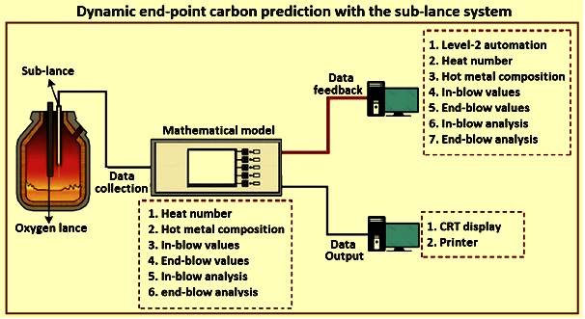
Fig. 5 Dynamic end-point carbon content prediction by sub-lance system
Dynamic end-point prediction by using sub-lance system directly measures the carbon content of the steel at the late stage of the blowing process， and establishes an online prediction model to dynamically predict the carbon content at different blowing times. By applying the sub-gun system， the effect of initial deviation on charged material can be reduced， and the end-point carbon content prediction is more accurate and precise compared with static prediction. Some Japanese steel melting plants have achieved over 90% carbon prediction accuracy with an error tolerance of +/- 0.02%.
By monitoring the exhaust gas information (changes in carbon monoxide and carbon dioxide content during oxygen blowing)， the carbon content of the steel can be dynamically inferred using a mathematical model based on the exhaust gas information， and the end-point carbon content can be predicted and controlled by feedback from the calculation results. Since this is an indirect estimation method， the accuracy of the collected data (e.g.， exhaust gas content and flow rate) and the response time of the mathematical model have a significant impact on the accuracy of the end-point carbon prediction. Therefore， exhaust gas analysis systems are often used in conjunction with subgun systems to control the accuracy of endpoint carbon for several melt shops.
The flame spectral characteristics of the basic oxygen converter port are related to the carbon content of the molten steel and， therefore， change during the basic steelmaking process. Based on the spectral characteristics of flame radiation information， a flame spectral analysis system was developed to predict the end-point carbon content. The online prediction of the carbon content of the molten steel can be accomplished by analyzing the relationship between the flame spectra and the converter water bath state for different blowing times.
Optical sensors have been used to dynamically predict the carbon content of low carbon heat (target end-point carbon content below 0.06%) in basic oxygen steelmaking in the steel melting shop， which has led to significant improvements.
Although dynamic endpoint carbon prediction can yield significant prediction improvements compared to static prediction， the collection of real， full-size， rich data sets that are representative of the overall behavior of the entire steelmaking process， self-learning and self-adaptation of the prediction model are particular challenges for dynamic endpoint carbon prediction. Thus， intelligent endpoint carbon prediction is built on the foundation of dynamic endpoint carbon prediction.
Intelligent prediction - With the development of data collection and intelligent models， intelligent endpoint carbon prediction for basic oxygen steelmaking is now available. It is built on the basis of full-size rich data sets with different characteristics and has a strong self-learning capability to improve the prediction accuracy. Besides the sub-lance system， the basic oxygen steelmaking automation system mainly employs other technologies， namely (i) online slag detection during oxygen blowing to provide guidance for slag operation， (ii) exhaust gas analysis system to dynamically estimate the carbon content and temperature of the molten steel during oxygen blowing， and (iii) intelligent models with strong self-learning and self-adaptive capabilities. Figure 6 shows the establishment of the smart model.

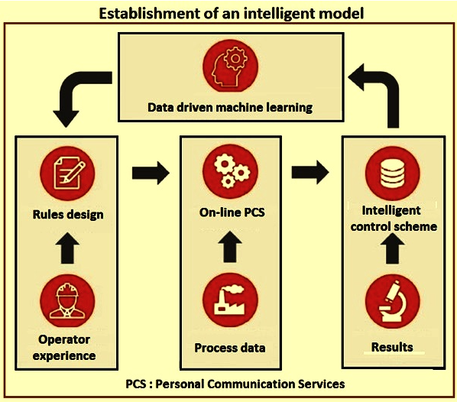
Figure 6 Establishment of intelligent model
With the application of the above technology， intelligent endpoint carbon prediction for basic oxygen steelmaking can be achieved automatically and effectively by computer rather than manually， and the accuracy of endpoint carbon content prediction is greatly improved. With the practical application of intelligent endpoint prediction technology in a steelmaking plant， the reblow rate was reduced from 14% to 1% and the tap-to-tap time was reduced from 37 minutes to 29 minutes， thus greatly improving the efficiency of the basic oxygen steelmaking process.
There is no doubt that intelligent prediction has greatly improved the accuracy of end-point carbon content prediction. Recently， more and more automatic detection technologies have been developed and applied to end-point carbon control in basic oxygen steelmaking， such as robotic sampling and temperature measurement systems and wireless composition measurement systems. Meanwhile， Industrial Internet of Things (IIoT) is rapidly developing along with the fifth generation mobile communication technology (5G) and big data analysis technology， and is gradually applied to smart steel manufacturing. Therefore， intelligent terminal carbon prediction for basic oxygen steelmaking is gaining more and more attention in the future.
From an industrial implementation point of view， highly accurate intelligent endpoint carbon prediction models can be installed on existing process systems to continuously predict process carbon content and provide guidance to operators based on actual and planned events in the basic oxygen steelmaking process.
Expert System
The Expert System is an integrated group of process models that image and optimize the steelmaking process. The Expert System monitors the metallurgical and thermal processes and cycles the actual conditions of the steel and slag. This provides the analysis and temperature of the steel and slag at any given time， and the calculation of the set point models is always based on actual conditions.
The expert system's process models optimize and control the steelmaking process during the entire processing of the converter. the Level-2 system assists the operator based on model calculations based on the stored production scenarios for each steel grade. The expert system constantly informs the operator about the overall status of the heat (i.e. weight， temperature and analysis) during processing.
A large number of setpoint model groups in the expert system determine the expert system's setpoints， which are responsible for determining the raw material supply， gas volume and/or energy required for the different processing steps. Some of the setpoint models are presented here.
The first charge of the expert system is calculated by the different cases for which variable input data (e.g. variable scrap and variable hot metal， variable scrap and fixed hot metal， or fixed scrap and variable hot metal) can be applied. Scrap cost optimization can also be used. The output as a model will provide the optimal charge combination to reach the target for the planned steel grade in the production plan.
The second charge calculation of the expert system is performed immediately after receiving the actual data related to the hot metal and scrap to be charged， including partial weights of the different types of scrap. The second charge calculation model calculates the necessary vessel additions and oxygen quantities to reach the target analysis and the target temperature of the steel at the end of the blowing.
The calculation of corrections in the expert system blowing is done by the sub-lance model. Depending on the data availability (temperature， carbon)， the circulating online model takes over the measured values and applies some corrective measures， since the sub-lance measurement is performed close to the hot spot. The remaining required amount of oxygen， heater or coolant as well as additional slag forming agent are calculated.
If at the end of blowing certain steel properties (e.g. temperature， carbon content or phosphorus content) are not within the specified target range， a re-blow correction calculation of the expert system can be initiated. The actual steel bath analysis and temperature are taken from temperature measurements or actual steel samples. The required amount of oxygen， heater or coolant and additional slag forming agent for reblowing are calculated.
The costing of the alloy type of the expert system is calculated to optimize the necessary alloys and deoxidizing materials to be added to the steel outlet drum. Analysis of alloying agents and their specific losses are taken into account.
The Expert System Predictive Model simulates the entire production process by using the results of supervised and set-point models. It provides a prediction of the progress and final heat level. It also predicts all required additions and actions and serves to optimize the production process. In a typical HMI screen of the predicted model， different parts of the screen show target and input data， model results， calculated analysis of the steel， as well as slag and specific consumptions.
The expert system precomputed model simulates the complete steelmaking process before/after the scrap and hot metal are loaded into the converter. The Expert System Predictive Model determines the optimal blowing and stirring strategy， as well as the stabilization time and fraction of vessel additions. The precomputed model is based on a predefined list of process steps (e.g. charging， main blowing， stirring and discharging) and target values from standard operating practices (SOPs) defined by the process engineer.
The precomputed model consists of five different components， namely (i) calculation of hot metal and scrap inputs， (ii) calculation and distribution of heater and coolant， alloy， scrap and melt to achieve target weight， analysis and basicity. (iii) calculates blow set points to achieve target carbon content and temperature， (iv) calculates ongoing reactions to predict the weight and analysis of steel， slag and scrap after each process step， and (v) provides information and warnings to the operator if target values for a process stage are not achieved.
The Expert System Supervision Model is an online model that cycles through the reactions that are occurring in the steel and slag during the blowing process. This includes oxidation and reduction reactions， the absorption of oxygen， nitrogen and hydrogen， the distribution of sulfur and phosphorus between steel and slag， as well as the late combustion of carbon dioxide and hydrogen. In this way， the effects of different blowing， stirring or material addition modes as well as the dissolution of charged materials are taken into account in the process.
The expert system dynamic control (part of the expert system supervisory model) is a dynamic blowdown end prediction for carbon based on actual exhaust gas data. Based on actual exhaust gas data (e.g. exhaust gas flow， exhaust gas analysis (carbon monoxide， carbon dioxide， oxygen and nitrogen) and actual process data， Expert System Dynamic Control predicts the carbon content at the end of the blowdown process from a typical profile of the exhaust gas data near the end of the blowdown. The result is a prediction of the carbon content at the end of the purge process (typically less than 0.3% carbon) and the purge end requirements to achieve the target carbon content at the end of the purge. In combination with the cyclic online model (expert system supervised model)， a complete prediction (temperature， analysis and weight) of the steel and slag can be made， where the carbon content comes from the expert system dynamic control and all other data is calculated by the expert system supervised model.
In the expert system， the carbon content calculation for the blow-in measurement is based on the raw data from the subgun measurement equipment (i.e. liquid phase temperature Tliq)， instead of the carbon content calculated using the measurement equipment. The carbon content in the blown gas is calculated using the equation Cin-bolw = a0 + a1xTliq + a2x Tliq squared. The adjustment parameters a0， a1， and a2 were kept in the Level-2 database and fitted by using the liquid phase temperature and the carbon content of the blown-in sample.
The carbon content calculated from the blow-in measurements was replaced by the online model， thus correcting the carbon prediction model. To complete the existing automatic blow stop function of the basic oxygen reformer based on dynamic exhaust gas measurement， this function is also used for the subgun system. The automatic blow-stop feature extends or shortens the final blowing phase to achieve the end of blowing for temperature and carbon purposes.
The circulating process model， also known as the saturation model， takes into account the saturation concentration of CaO (lime) and MgO (magnesia) in the complex steelmaking slag. When the corresponding saturation concentration is reached， the dissolution of lime and dolomite is suspended and continues when the slag composition allows further dissolution into slag additions. Therefore， the process model keeps track of the amount and analysis of the liquid slag， as well as the undissolved flux additions. The calculation of the equilibrium phosphorus partition rate is based on the optical alkalinity model. To determine the optical alkalinity， only the composition of the liquid slag phase is used， while the undissolved flux fraction is considered in the calculation of the mass transfer coefficient. As a rule， the saturation model allows to optimize the alkalinity (CaO / SiO2) and the magnesium oxide， with the aim to avoid too much undissolved flux material at the end of the blowing.
The expert system process models take into account the thermal cracking of slag-forming additions that have been loaded prior to the hot metal loading. For these additions， the carbon dioxide and water vapor fractions are completely removed. This prevents overestimation of the cooling effect of pre-charged materials such as limestone or raw dolomite and thus improves the temperature calculation. Furthermore， after hot metal charging， the remaining slag from the previous heating in the converter is partially reduced by silicon in the reaction 2(FeO) + [Si] = 2[Fe] + (SiO2)， 2(Fe2O3) + 3[Si] = 4[Fe] + 3(SiO2)， 2(MnO) + [Si] = 2[Mn] + (SiO2) and to a small extent also by carbon. The reduction of FeO， Fe2O3 and MnO affects the temperature profile in the presence of a large amount of remaining slag.
Although the models are specifically adapted to the specific requirements of the different subsystems， the principle of the expert system is to combine the features of prediction， supervision and setpoint models to achieve perfect quality， which is applied in the whole steelmaking automation.

