Suzhou XITE- the best manufacturer and supplier of oxygen and nitrogen equipment

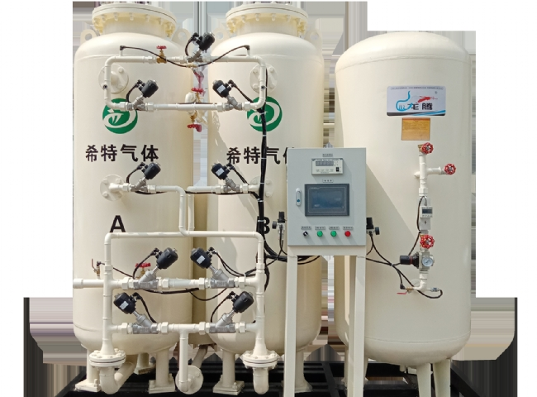
You can never ignore the survival value of oxygen and nitrogen in this world. They both contribute to a better living and working environment. Nitrogen is 78% of the atmosphere， compared to 21% of oxygen.
Nitrogen helps in the formation of many acids， explosives， etc.， and is useful in many other broad areas. Oxygen， in turn， is used to form chemicals and is used in medical， chemical and industrial procedures， among others.
Suzhou Hi-Tech is the most popular company that manufactures the best quality oxygen equipment and also provides the most beneficial nitrogen equipment for all types of your requirements related to your industry or occupation at reasonable prices.
Suzhou XITE manufactures oxygen equipment with the following features.
Offers simple installation and optimal functionality
Includes automation as1w+1s
Provides additional filtration levels
Ready to produce oxygen according to industrial needs
Offers 2 years of free service
Saves your manual effort and time by fully automating the operation
Use of a rotameter to show through arrangements
By using different air dryers， able to reach the required expiration point
Suzhou XITE offers the best nitrogen equipment with the following benefits and applications
Easy elimination of adulteration and waste
Saves boiler tubes by removing them， which are corroded when they come in contact with oxygen in the cooling tower
Provides adequate safety for air pockets
Provides the smoothest pipeline fluid transfer
Can be used as a supervisory gas in sprayer systems to eliminate corrosion
Used to form components for use in aerospace and aircraft
Helps provide a better life cycle and smoother tires by preventing gas leaks in them.
Choose the best manufacturer of nitrogen and oxygen equipment， none other than Suzhou Schieter， and always be safe and efficient.

