Protecting power plant equipment with nitrogen inert gas

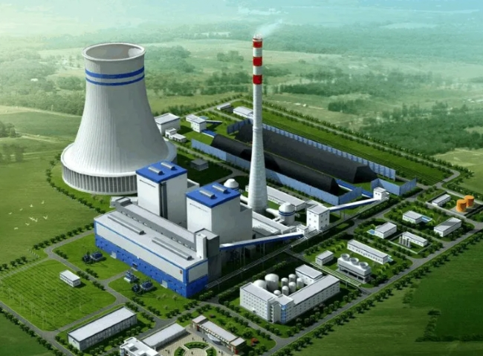
PSA Nitrogen Producer， Nitrogen Producer， Nitrogen
Suzhou XITE is a leading designer， manufacturer and supplier of PSA nitrogen generators. It is well known that corrosion can shorten the life of power plant process equipment. Internal protection of boiler tubes， condensers and wet components in small industrial boilers， HRSG combined cycle power plants and large gas， oil and coal fired power plants is extremely important during short term shutdowns and long term outages. Without some form of protection， corrosion of these wet components can occur at an alarming rate during shutdowns.
Harmful to the environment

If water is able to circulate through these power plant components during a shutdown， one solution is to inject chemical inhibitors into the water stream. However， introducing this chemical into the system has become less desirable because of the environmental problems associated with handling it. If water is drained from the wetted components， the residual water remains inside and， along with the oxygen (air) introduced during the draining process， begins to corrode.

Nitrogen has been used for many years to prevent corrosion in power plant equipment and similar applications. Nitrogen makes up 79% of the air we breathe and is the perfect "green" solution for corrosion prevention in power plant equipment. Nitrogen is inert and by replacing the oxygen in wetted parts with a low pressure， slow flowing nitrogen purge， you end up inhibiting the oxidation/corrosion process.

