Use of oxygen generators in water treatment systems

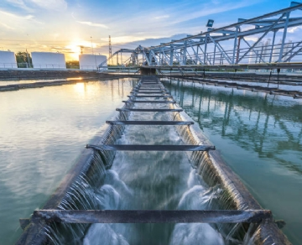
Clean and pure water is a basic necessity for human beings. Whether cooking or sanitation， everyone needs safe water. As our global water use continues to grow， clean water is becoming increasingly difficult to obtain. By injecting oxygen into your water supply system， it can improve the efficiency of removing pollutants and impurities from the water supply.
How does the oxygen generator work?
The oxygen generator allows you to produce your own oxygen at the time and place you need it (instead of relying on liquid oxygen supply or filled cylinders). By using pressure swing adsorption (PSA) to generate oxygen， nitrogen is separated from oxygen in conventional air.
In the field gas system， our oxygen generator has a container for absorbing nitrogen molecules. When oxygen molecules float through the container， they will be collected in the oxygen receiving tank. The oxygen receiving tank is connected to the oxygen generator， then the pressure in the container is released and the nitrogen molecules are discharged back to the atmosphere. This cycle is repeated in the second vessel， providing a consistent flow of air from our oxygen generator.
What are the applications of oxygen concentrators?
The oxygen generator has many applications in water treatment systems， including ozone oxygen generator
The use of ozone concentrators is beneficial in many different situations. It functions as the feed gas of the ozone system. It is environmentally friendly and therefore suitable for the effective treatment of large quantities of water (including ensuring clean drinking water for tap water). Several examples of using oxygen generators to produce ozone include making suitable drinking water for animals， water for cleaning equipment， and replacing chlorides with ozone in swimming pools.
Wastewater oxygen generator: wastewater can come from many different sources - whether from industrial buildings， offices or someone's home， it can come from anywhere. By injecting oxygen into wastewater， it can significantly improve the survival rate and regeneration ability of bacteria. The oxygen generation system can provide independent oxygen generation for many years - which means you don't have to deal with the continuous cost of delivering low-temperature oxygen generation. Oxygen generators for waste water are also very cost-effective and low energy consumption. In the field gas system， we provide custom designed oxygen generator， oxygen container system (purity up to 99%) and oxygen generator (purity up to 95%).

