Improved atmosphere packaging safeguards food freshness

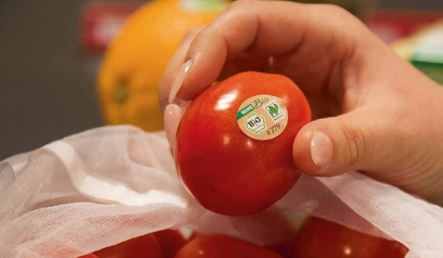
Exposure to oxygen (O2) is one of the reasons for the loss of vitamins contained in fruits and vegetables after harvest. Nitrogen (N2) can minimize this loss of vitamins during storage and transport. This can be produced on site with a generator and introduced into the package as part of the MAP process (modified atmosphere packaging) to replace oxygen in the air. The food has a longer shelf life and does not require any preservatives.
Atmosphere packaging offers fruit and vegetable growers the opportunity to ensure the best quality and freshness of their goods. For this purpose， washed and cut vegetables or fruits are sealed in an artificial atmosphere in a packaging machine (such as a tubular bag or thermoforming machine). During this process， a protective gas is introduced into the package via a lance， completely replacing the existing oxygen.
Shielding gas prevents oxidation
Finally， the individual packages are closed and separated. Each product is now in a sealed， airtight， individual package (e.g.， in a tray or bag)， filled with the packaging gas and ready for shipping. In this way， the protective gas prevents oxidation， which can lead to rancidity and loss of nutrients， especially vitamins. Likewise， the growth of oxygen-dependent microorganisms， such as bacteria and pathogens， as well as molds， is inhibited， thus preventing the development of microbial spoilage processes.
Prevention of browning
In addition， brown discoloration of goods caused by enzymatic reactions is prevented. Nitrogen， a natural component of air， ensures that the natural properties of the produce， such as taste， texture， odor or color， are retained over a longer period of time. By using the natural， odorless packaging gas N2， the product stays fresher longer and reaches the end customer in the best possible condition.
The nitrogen required for the packaging machine can be produced on site with a nitrogen generator from XITE Germany. For this purpose， air from the environment is pressed into two adsorption vessels filled with carbon molecular sieves， which adsorb oxygen and carbon dioxide molecules from the air. In this way， the generator produces the required quantity of food-grade nitrogen with a purity of 99.5%.
Independent of external gas supply
On-site nitrogen production makes the operation independent of the external gas supply and ensures very low production costs thanks to the latest technology. In addition， the environmentally friendly technology reduces CO2 emissions， thus protecting the climate and the environment.

