Principles and operation of PSA on-site oxygen generators

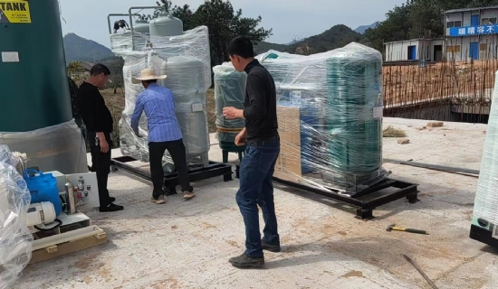
We know that air is a mixture of various gases in different proportions. Nitrogen and oxygen are found in abundance in nature and have various uses. China Suzhou XITE uses high technology process to obtain the purest oxygen for industrial needs.PSA oxygen generator is one of the best ways to obtain the required purity of oxygen for industry.PSA oxygen generator is a great boon to industry and medical field because of its utility and application.
Principle: PSA oxygen generators are one of the typical methods of separating oxygen from an air mixture. In order to obtain abundant oxygen， the method utilizes synthetic zeolite molecular sieves that absorb nitrogen， leaving behind concentrated oxygen. Thus， the end product obtained is oxygen.
Working: The PSA oxygen generator works in a simple and effective way. It consists of being uploaded... Two vessels lined with zeolite molecular sieves to absorb nitrogen from the air mixture. The compressed air mixture passes through these vessels and on one of the absorbers， the sieve adsorbs the nitrogen. The remaining oxygen then passes over the sieve and is collected as the final product. This occurs when the first absorber is almost full. During this time， the inlet valve is opened so that the air mixture can flow through the second absorber. The absorber is regenerated by depressurizing the column to desorb the nitrogen. This process continues between the two vessels for production and regeneration. However， the entire process of the PSA oxygen generator is skillfully controlled by the opening and closing of valves.
The oxygen obtained by this method is used by industry for various purposes. Suzhou XITE， China is a manufacturer and supplier of PSA oxygen generators. For many years， we have been designing to meet the needs of various industries for a variety of applications.
Most industry owners prefer to install PSA oxygen generators for the following reasons
The production process is economical and efficient
It is safe
It reduces inventory work
It is available 24*7 or when needed
Does your industry have a need for a PSA oxygen concentrator? Please contact us to find out your needs.

