Why is the use of oxygen generators for medical use the right choice for hospitals?

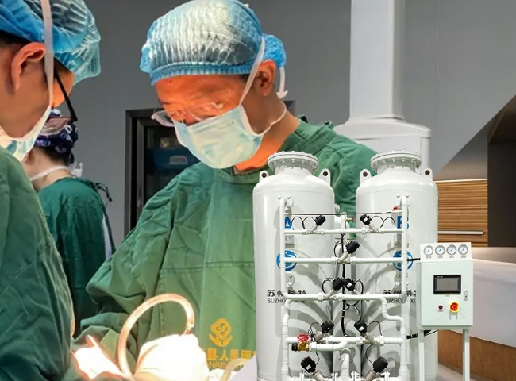
Oxygen is a tasteless， odorless， colorless gas that is highly essential for organisms to burn food molecules. It is essential in medicine and in general. In order to sustain life on earth， the importance of oxygen cannot be ignored. Without breathing， no one can survive. Every mammal can survive for days without water and food， but not without oxygen. Oxygen is a gas that has countless industrial， medical and biological applications. Since we manufacture medical oxygen generators for hospitals using the most medium to large scale materials， we get asked a lot of questions about the significance of investing in medical oxygen generators for hospitals.
In this article， we have compiled some of the most important queries and tried to answer them here in a concise form.
Why is oxygen so important?
In the human body， oxygen has various roles and functions. Oxygen is absorbed by the blood in the lungs and is transported to every cell in the body. The contribution of oxygen to the maintenance of a myriad of biochemical activities cannot be ignored. Oxygen plays a vital role in the respiration and metabolism of living organisms. In addition， oxygen plays an important role in the oxidation of food to release cellular energy.
Assuming that a person is unable to inhale the proper level of oxygen， it may lead to different health conditions such as shock， cyanosis， COPD， aspiration， resuscitation， severe bleeding， carbon monoxide， dyspnea， sleep apnea， respiratory or cardiac arrest， chronic fatigue， etc. To treat patients with these conditions， hospitals require oxygen manufactured specifically for medical applications. Patients who are artificially ventilated also receive oxygen therapy. To meet these needs， the best option for hospitals is to install their own on-site medical oxygen generators.
Since hospitals need the highest standard of quality and purity of oxygen， they must install an oxygen generator plant capable of producing high purity oxygen. By installing an on-site oxygen generator， hospitals are freed from susceptible cylinder delivery delays that can sometimes prove costly， especially in emergency situations.
Is the oxygen produced by the on-site oxygen generators pure and identical to cylinder oxygen?
Our machines produce oxygen using the PSA (Pressure Shifting Adsorption) process. This process has been used to produce medical grade oxygen since the 1970's and is a very mature and well established technology. Zeolite molecular sieves are used to separate the components of air such as nitrogen， oxygen， carbon dioxide， carbon monoxide， etc. Argon and oxygen are not easily separated， so the oxygen from this plant will also contain argon. However， argon is inert and does not affect the human body when rationed with oxygen. This is like breathing nitrogen (78% of the atmosphere is nitrogen). Nitrogen is also inert， like argon. In fact， humans breathe only 20-21% of the oxygen in the atmosphere， and most of the rest is nitrogen.
The oxygen contained in cylinders is 99% pure and it is produced in large quantities by a cryogenic separation process. However， as explained earlier， the oxygen in the cylinder and the oxygen in our machines can be used interchangeably without worry.
Is there any input-output ratio for installing an oxygen machine in a hospital?
In most cases， the simple answer is yes. Aside from the abundance of oxygen cylinder suppliers in major cities， the cost of oxygen cylinders is quite high and a monthly drain on the finances of any hospital or medical facility. In addition， operators usually do not wait for cylinders to become empty before the night shift to avoid them becoming empty in the middle of the night. This means that unused oxygen is returned to the merchant， even if it has been paid for.
Our sales team helps medical facilities with return on investment (ROI) calculations and we have found that in over 80% of cases， a hospital or nursing home will recoup their investment in less than 2 years. Since our oxygen generators have a 10+ year lifespan， this is a remarkable and worthwhile investment for any healthcare facility.
Let's say that the delivery price of an oxygen cylinder is about Rs. 200. Why do we say delivered? Because the final taxed delivery price will also include shipping costs， which is important because shipping costs are not cheap and must be considered. So if the hospital consumes 10 cylinders per day， it will cost them - Rs. 200 x 10 cylinders x 365 days = Rs. 7.3 per year. For this hospital， they will surely easily recover the cost of an equivalent oxygen machine in less than two years.
In addition to the input-output ratio， what are the best configurations a healthcare facility can get from installing an on-site oxygen concentrator?
There are several best configurations， which we describe below.
Safety
Oxygen generators produce gas at very low pressures and keep only a small backup in certified storage tanks. Therefore， the risk of oxygen combustion is minimal.
In contrast， oxygen cylinders have a large amount of oxygen in one bottle that is compressed to very high pressures. Constant handling of cylinders poses a human risk and the risk of repeated pressure failures， leading to very dangerous situations.
With the installation of an on-site oxygen generator， the amount of cylinders handled is greatly reduced and the healthcare facility has improved its safety.
Space
Oxygen concentrators take up a very small amount of space. In many cases， the space used to store cylinders and manifolds is also sufficient to install an oxygen concentrator.
If a larger hospital is a liquid oxygen tank， a significant amount of net space is wasted due to statutory codes. This space can be regained by switching to on-site oxygen generating equipment.
Reduced administrative burden
Cylinders need to be constantly reordered. Once the cylinders are received， they need to be weighed and quantity verified. With our on-site oxygen generators， all of these administrative burdens are avoided.
Peace of mind
The biggest concern of hospital administrators and biomedical engineers is the depletion of oxygen cylinders at critical times. With an on-site oxygen generator， gas can be produced automatically 24×7， and with a carefully designed backup system， hospitals never have to worry about empty cylinders again.
Conclusion
Installing oxygen generators is the right choice for hospitals， because oxygen is a life-saving medicine and every hospital must have it 24 hours a day. There have been several cases where hospitals did not have the required level of oxygen backup on the premises and the consequences of this were extremely serious. The installation of XITE's oxygen generator equipment has freed hospitals from the worry of being without oxygen at all times. Our generators are easy to operate and require little maintenance.

