Application of field nitrogen generator in molding plastics industry

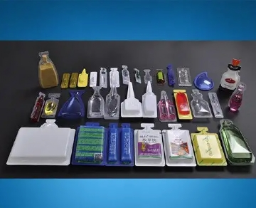
Nitrogen is a key component of plastic manufacturing. Nitrogen helps prevent discoloration and oxidation during manufacturing. In addition， it helps maintain the strength of plastic polymers， which is particularly important when using large molds. The following is a detailed introduction to the use of nitrogen in plastic manufacturing and why nitrogen is used on site to make it more efficient.
Nitrogen dependent plastic manufacturing method
Nitrogen has several different uses， including:
Injection molding - in this method， nitrogen is used as an inert gas to displace any oxygen in the mold. Oxygen retains moisture， so it can cause defects if molded into plastic. By filling the mold with nitrogen， the manufacturer can ensure that no oxygen is present.
Gas assisted injection molding (GAIM) – GAIM is a multi-step process for manufacturing large plastic parts. The problem with larger molds is that the molded plastic shrinks during the drying phase. However， when nitrogen is injected into the mold， the polymer will expand to fill each cavity and ensure that the polymer will not decompose during the cooling phase.
Plastic extrusion - in order to manufacture plastic pipes and pipes， a process called extrusion is used. In this method， the polymer is molded into a long and continuous shape， and nitrogen is used to replace all oxygen. If present， oxygen can cause damage to the equipment and the product being manufactured.

