What is the cost of installing medical oxygen generators in China?

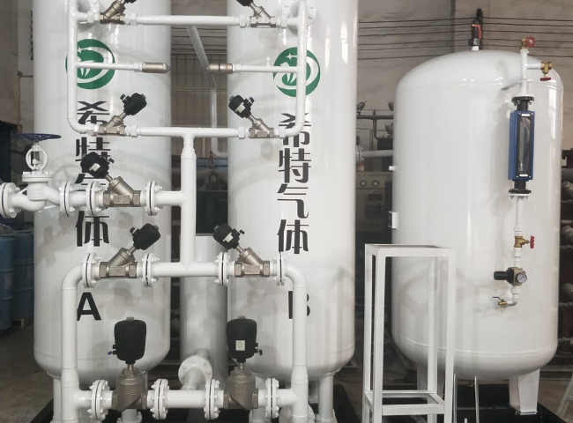
Hospitals and healthcare facilities across the country have noticed a high demand for medical oxygen and are facing severe medical oxygen shortages since the coronavirus outbreak， especially in the second wave of the outbreak in 2021. This shortage has led to increased interest from hospitals to invest in on-site medical oxygen generators to ensure they are equipped with an uninterrupted supply of medical-grade oxygen gas at a low cost.

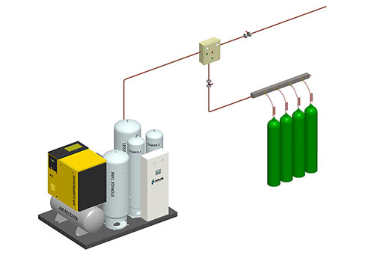

On-site gas generators are not new to the market. These devices have been in the industry for over 25 years， but the two main reasons for the unexpected increase in demand for these devices are.
1. this volatility in the price of medical oxygen cylinders has never been seen in the industry. A huge shortage of cylinders caused hundreds of patients to gasp for air in intensive care units. Now， no one wants to see that horrible time again.
2. Small and medium sized hospitals lack the resources to invest in these oxygen generators.
Here are some common questions related to oxygen machines that everyone seeks answers to before investing.
1. Investment Cost
XITE oxygen generators have the capacity to produce the equivalent of 10 to 300 bottles of gas per day. The investment cost required for these generators starts from 10 to 13 thousand. However， in China， the cost of installing a medical oxygen generator varies depending on the capacity required by the user.
2. Space requirements
If the hospital is currently using gas cylinders， there is no need for any additional space to install the generator. XITE generators are compact and skid-mounted; therefore， no additional space is required. On the other hand， the hospital can save costs associated with the manpower required to handle the cylinders.
3. Operating Costs
The operation of the on-site gas generator consists of two main components， namely electricity and annual maintenance costs.
4. Return on Investment
XITE generators have a good return on investment. The installed cost of a medical oxygen generator in China can be recovered in only two years if utilized to the total capacity.
Outstanding features of XITE medical oxygen generators
We provide qualified engineers to supervise， install and start up all our equipment and train manpower at the customer's site.
Very low power consumption， proven performance and maintenance free machines.
100% reliable quality of oxygen for industrial and hospital use
High oxygen purity for medical and industrial applications.

