Nitrogen generator for Puf panels with a purity of 99.9% and a working pressure of 140 m3/h at 6 KG/CM2

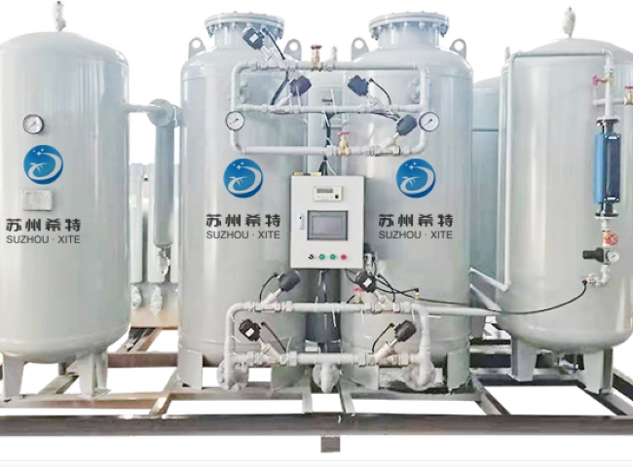
Suzhou Schitt has installed a 140 m3/h nitrogen generator with 99.99% purity and 6 KG/CM2 working pressure for the Puf panel.
XITE PSA nitrogen generators have low capital and operating costs， with start-up times of only 10 to 15 minutes， capacities from 5 m3/h to 500 m3/h， purity from 99% to 99.9998% (2PPM) and discharge pressures ranging from 5 Kg/Cm2 to 7. 5 Kg/cm2， with higher pressures available via BOOSTER up to 30 Kg/cm2 and 150 Kg/cm2. Kg/cm2 XITE has installed equipment for PUF PANEL manufacturing; XITE nitrogen equipment is designed and manufactured according to the process requirements of PUF PANEL manufacturing.
The range of products sold by Suzhou Schitt for PUF PANEL are
Model | Capacity m3/h
XTFD-150 | 140 m3/h

