Nitrogen generator for snack food packaging

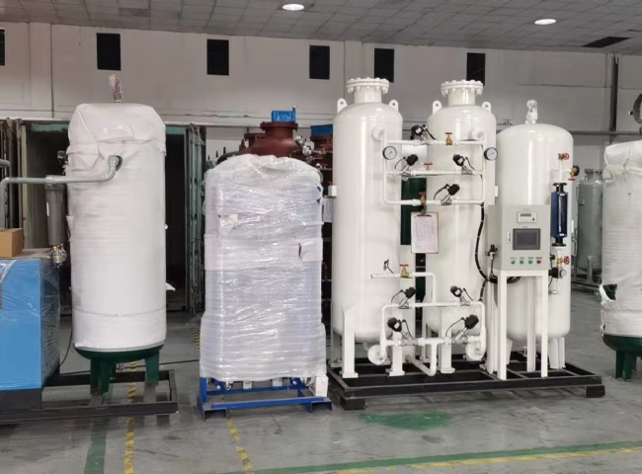
***The company has installed a 50 NM3/HR food packaging nitrogen generator with 99.5% purity and a working pressure of 5 KG/CM2.
Nitrogen has long been used in the food industry to help maintain the freshness， integrity and quality of delivered products. Food manufacturers often use nitrogen purging and nitrogen blanketing to replace oxygen in the atmosphere while processing or storing food products. The presence of oxygen can introduce moisture， which can deteriorate the quality of food products. The use of nitrogen to remove oxygen from food products is a widely used safety practice throughout the food industry.
Another reason nitrogen is often used in the industry is to provide a pressurized atmosphere to prevent package collapse. Using nitrogen in this way helps ensure that finer foods， such as chips and crackers， do not get crushed in the bags in which they are stored.

