Knowledge of high purity gases in the semiconductor manufacturing industry

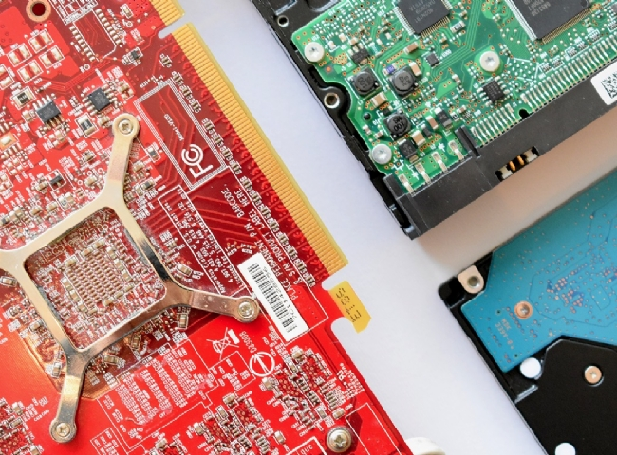
The semiconductor industry is a huge industry worldwide and continues to grow every year， which means that the demand for high-purity gases will grow with it.
Having a reliable supply of high-purity gases is critical to semiconductor manufacturing， especially when it comes to advanced technologies such as smartphones and self-driving cars.
The process of producing integrated circuits is complex， requiring over 30 different gases in the production process， making the number of gases used the largest of any industry.
Gases are an important part of semiconductor manufacturing because they create the chemical reactions needed to shape the electrical properties of semiconductors. Due to their complexity， the gases used need to be precise at each stage of the manufacturing process to configure the semiconductor.
As the semiconductor industry continues to grow and evolve， so does the number of gases used in the process. Some of the core gases used include nitrogen， oxygen， argon and hydrogen， and we will explain in depth their role in the manufacturing process.

Nitrogen
Nitrogen is a core gas used in various steps of the semiconductor manufacturing process due to its availability and inertness， but its primary use is in the cleaning stage. In this stage， nitrogen is used to flush each channel and tube network to remove any oxygen from machines and tools， which will keep them free from other gases that could contaminate the process.
In addition， because nitrogen is used so heavily throughout the process， most semiconductor facilities keep a nitrogen generator on site. Even with the production of high-tech smartphones and other technologies， it has become imperative to keep costs low while trying to meet high demand.
You could say that nitrogen is what keeps tools， spaces and pipes free from any potential moisture， chemical contaminants and particles. It's an essential gas that is used throughout the process from start to finish， and it's no wonder they keep the generator on site.

Oxygen
As you know， oxygen is an oxidizing agent， which makes it essential for creating deposition reactions. It is used to grow silicon oxide layers for various elements in the process， such as diffusion masks.
When using oxygen in semiconductor manufacturing， the gas must be ultra-high purity to prevent any impurities that could cause damage to device production and performance.
Oxygen is also used during the etching process to remove any additional material residue that is generated. It can also be used to make any of these etch patterns permanent.
Finally， oxygen also helps to neutralize reactive gases that may alter product quality through oxidation reactions. Therefore， similar to nitrogen， oxygen also helps to ensure that no contamination occurs.

Argon
Argon is mainly used in the deposition and etching process of UV lithography lasers， which are used to create the smallest patterns on semiconductor chips.
During the fabrication of the desired silicon wafers， argon is used to protect the silicon crystals formed on the wafers from any potential reactions with oxygen and nitrogen during growth at high temperatures.
Because argon is also a very inert gas， it is used to provide a non-reactive environment for the sputtering deposition of metals. Sometimes， nitrogen can be too reactive and can lead to the formation of metal nitrides.
In addition， liquid argon is used in tools to clean the smallest， most delicate chips.
Hydrogen
The use of hydrogen in semiconductor manufacturing is likely to increase due to increased demand. Especially in the lithography stage， hydrogen is used to react with the chemical tin to produce tin hydride. Tin hydride is needed so that it does not accumulate on expensive optical devices.
It is used in the deposition process for the epitaxial deposition of silicon and silicon germanium and also to prepare the surface through the annealing process.
Hydrogen is used to create a new oxide layer to modify the already existing film. This process is performed at high pressures and temperatures， which means that the control of flow rate， temperature and pressure is extremely important.
In addition， hydrogen is also used in the doping phase to help control decomposition， as the gases used for this process are very toxic. So much so that they need to be stored in equipment that can prevent leakage.
Diborane is also a chemical used in the doping process， but it slowly decomposes because it is not temperature stable， so hydrogen is needed to help stabilize it.

Semiconductors in Everyday Life
Semiconductors are used in a variety of everyday devices such as computers， smartphones， and televisions， as well as in advanced technologies such as medical devices， military systems， and many other applications.
They are a part of our daily lives that we don't notice because they are in the devices we use every day. We couldn't do many things without semiconductors， and as semiconductor technology has evolved， they have become more reliable， smarter and more compact.
From communications to transportation to entertainment， these are just a few of the things that semiconductors do for us. They will power future technologies and innovations that will allow us to do things we never imagined possible.

