Compact nitrogen generators: everything you need to know

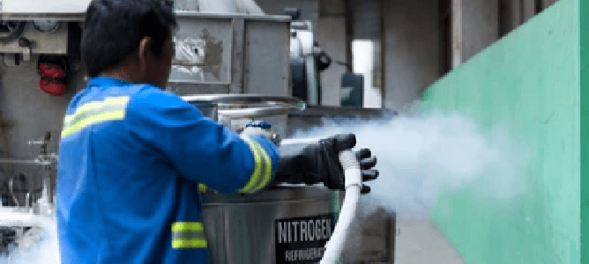
Nitrogen is essential for most industrial and military applications. Operators and staff therefore require a steady supply of gas. Unlike the delivery of nitrogen via cylinders or tanks， on-site nitrogen generators offer several advantages， including low running costs， low maintenance and improved safety.
What is a small nitrogen generator?
Some industrial applications require low flow rates of high purity nitrogen. Small nitrogen generators are ideal for such applications. A small nitrogen generator is therefore a small generator that can produce and supply low flow rates of high purity nitrogen for a variety of working and emergency applications. Some relevant applications for small nitrogen generators include fire suppression and prevention in coal mines， military operations etc. As well as being stationary， operators can also install small nitrogen generators in isolated areas.
Portable nitrogen generators versus small nitrogen generators
Unlike the compact， portable nitrogen generators are much smaller and are essential for defogging and waterproofing night vision goggles for military personnel. In addition， portable nitrogen generators are safe， miniaturised， reliable and can produce nitrogen anywhere and whenever it is needed. Like the portable， the compact nitrogen generator is safe and reliable. However， small generators require specialised and isolated locations for installation and nitrogen generation.
Industries that use small nitrogen generators
Small nitrogen generators remain essential to meet the needs of a number of industrial applications， including food packaging， chemical blankets， electronics， laboratory operations and laser cutting.
Food packaging
As the presence of food oxygen in food packaging significantly reduces the shelf life of food products， it is a good practice to replace oxygen with nitrogen. Food manufacturers can achieve this by using nitrogen generators for food packaging items such as vegetables， fruit， meat and snacks and providing a cushion for them during transport.
Chemical covering
Similarly， nitrogen from high-pressure nitrogen generators is a common component used to chemically cover chemical plants or manufacturing facilities that are prone to fires and explosions. This gas reduces the level of oxygen in these facilities， ensuring the safety of personnel and facilities.
Electronics industry
In electronics applications， nitrogen is an essential component required in the soldering process as it reduces surface tension and achieves a cleaner breakaway from the electrical joints. In addition， with small generators， data centres can maintain ideal temperatures with a constant supply of nitrogen， preventing processors from overheating.
Laboratory operations
Laboratory environments with high oxygen content can easily have error-prone results. However， with a small industrial nitrogen generator， scientists can maintain a sufficient supply of nitrogen to create acceptable oxygen levels for accurate results in highly sensitive laboratory equipment and procedures.
Laser cutting
Finally， the availability of nitrogen is critical for laser cutting applications. With a nitrogen generator for laser cutting， operators can meet their cleaning and quality assurance needs. Nitrogen strengthens stainless steel and aluminised steel and improves their corrosion resistance.
Benefits of small nitrogen generators
Small nitrogen generators offer a number of advantages for industrial and other related applications. Some advantages include avoidance of costs associated with nitrogen tanks/cylinders， no supply restrictions， low maintenance， portability， and increased safety. Unlike nitrogen tank/cylinder manufacturing services that require regular financial commitments， the small nitrogen generator avoids long-term operating costs as the machine ensures a consistent supply of nitrogen for the application in question. Uninterrupted nitrogen production and delivery helps to avoid supply constraints.
In addition， the generator can operate maintenance-free for a long period of time， requiring only constant cleaning and occasional replacement of the pre-filter. The maintenance costs of the nitrogen generator are therefore reduced. In addition， the small size of the compact nitrogen generators makes them easy to move around and allows them to be used in confined spaces. This portability makes them preferable to pre-filled nitrogen tanks or reservoirs. Finally， unlike nitrogen tanks that require specific storage protocols， small generators do not， which greatly increases their safety in industrial applications.

