42 m3/h 95% purity membrane nitrogen generator unit for carrier gas

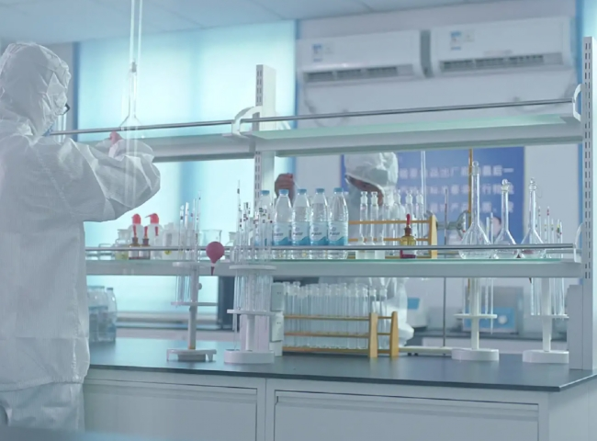
Seagate supplied a membrane nitrogen generator to a laboratory in the Chinese government.
The customer purchased the following specifications of nitrogen equipment from XITE.
Technology: Membrane type (Membrane)
Model: XTDD-Series Membrane Nitrogen Producer
Capacity (nitrogen flow rate): 42 m3/h (700 LPM)
Purity: 95%.
This is a complete supply of equipment for a turnkey project with a dedicated air compressor.
The lab was looking for a large nitrogen generator to centralize their nitrogen supply and to avoid frequent nitrogen purchases， which were required on a large scale for their various labs. Using membranes to produce nitrogen is the most economical solution for producing nitrogen on site. Many processes， such as LCMS lab equipment that requires nitrogen as a carrier gas， do not require a high level of purity. Therefore， this purity (95%) of nitrogen supplied to this laboratory is ideal for membrane nitrogen generators. The customer now receives an uninterrupted supply of nitrogen that is very dry (as required by their process) at (-)70C or better.
This lab is very happy with the equipment provided to them， as they were having daily headaches with nitrogen bottles.

