What is the use of nitrogen in hospitals?

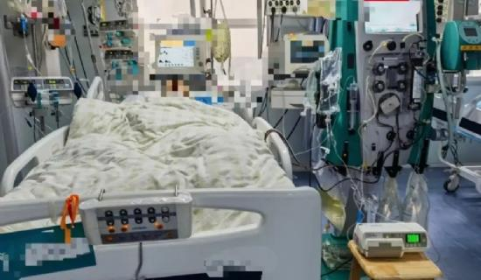
Nitrogen is a common element in the atmosphere， making up approximately 78% of the atmosphere. Nitrogen has proven to be a professional industrial gas. Nitrogen is used in a wide variety of industries， including chemical oxidation， welding， melting， brazing， manufacturing batteries， glass industry， copper smelting， sewage treatment， fish farming， pulp and paper industry， etc. Industries and hospitals use nitrogen generators to produce nitrogen for industrial and medical purposes. Moreover， our generators are produced and manufactured using the latest cryogenic technology.
Use of nitrogen in hospitals:-
Nitrogen has many medical applications， especially in liquid form to provide temperatures down to -196°C. Hospitals use medical nitrogen generators to meet their nitrogen needs. It has the following medical applications.
Use of cryogenic processes to preserve blood， blood components， other cells， body fluids or tissue samples.
It is used in dermatology for various minor procedures using cryosurgery.
It is used as a component of various gas mixtures.
As a replacement medium in sterile equipment， as a non-oxidizing replacement medium in pharmaceutical bottles， and as a propellant in pressurized aerosol dispensers.
To obtain air pressure， nitrogen is used as a power source for gas-operated medical equipment.
It is used to cool CO2 surgical lasers.
How is nitrogen produced?
Hospitals now prefer to use medical nitrogen generators to produce high purity nitrogen for hospital and industrial use. Atmospheric air is introduced into an oxygen generator and then sent to an air separation unit where it is compressed and moved into a purification system where impurities such as moisture and carbon dioxide are avoided. The air is then fed to a heat exchanger where it is cooled to a low temperature. The process air is then introduced into a high-pressure distillation column， where the nitrogen is separated from oxygen and other gases. Next， the air enters a high-pressure distillation column， where it is physically separated into nitrogen in vapor form at the top of the column. It is further distilled to meet medical and industrial specifications.

