PSA nitrogen generators for milk and dairy packaging
Manufacturers and suppliers of milk and dairy products use nitrogen to keep their products safe and fresh. Food and food products are sensitive to oxygen and they are easily oxidised. If oxidation occurs， then milk and dairy products will spoil. Therefore， to avoid this， nitrogen is used to rinse the milk or dairy products to prevent them from going bad.
Why use nitrogen?
The packaging of milk and dairy products requires a different atmosphere. The presence of inert nitrogen will maintain their freshness and increase their shelf life.
Normal atmospheres contain oxygen， which can cause product spoilage. To minimise this process， the nitrogen is flushed so that oxidation can be prevented.
It prevents the physical and chemical properties of the product from being altered. Milk and dairy products are sensitive in nature. This can be prevented by using nitrogen for preservation.
Micro-organisms like food/milk/dairy products and therefore they must be banned completely. Keeping oxygen away from milk/dairy products will eventually lead to a weakening of the microorganisms' growth drive.

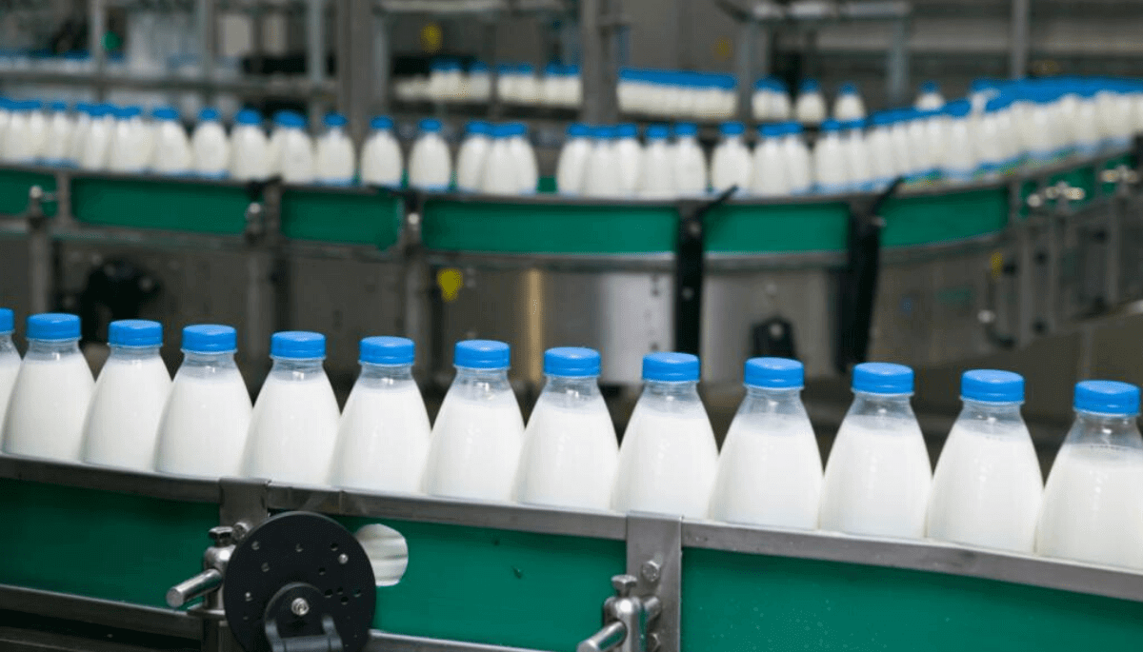
Nitrogen or PSA nitrogen generators
The above points indicate the need to flush food with nitrogen. But what do you think is more convenient? Should you order nitrogen cylinders now or should you go for a PSA nitrogen generator? Let us explain to your readers.
Nitrogen cylinders PSA nitrogen generators
Availability Sometimes you run out of gas cylinders if you don't place your order in time， when you have a nitrogen generator on site then you never run out of gas.
Costs Buying gas cylinders can be expensive. It includes many other costs such as taxes， transport， loading and unloading etc. The initial installation process may seem expensive， but it is worth it as you get what you pay for in many ways.
Inventory It is necessary to file incoming quantities， used and returned cylinders for payment as this is your nitrogen generator equipment and you do not have to worry about payment.
Purity As it is used to package food/milk， it must be pure. Sometimes you may not get the required purity when buying cylinders. When you have your nitrogen generator， you can decide what purity you want. You can produce this quality of nitrogen and make it purposeful.
Safety Sometimes， handling cylinders can become dangerous. There is a chance of injury or other accidents. It is safe. All you need is maintenance of the equipment. You can then stay away from handling problems.
On-site nitrogen generators are a simple and clever solution to provide pure and economical nitrogen for utilities. The generator efficiently produces the grade and quality of nitrogen we need.

