Benefits of oxygen generators over liquid oxygen

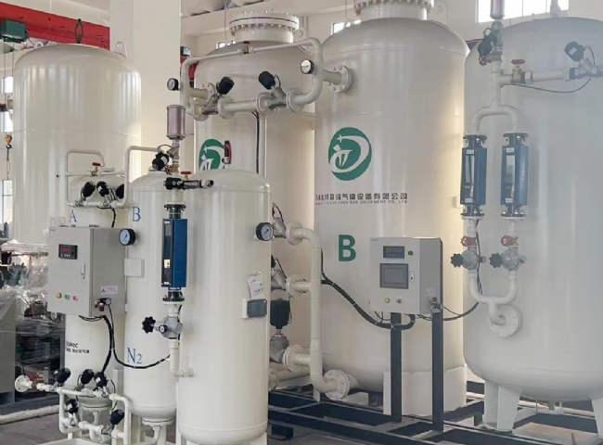
In today's world， there are many industrial processes that require the use of oxygen for different purposes. Earlier， these industries used oxygen tanks or liquid oxygen or liquid oxygen when large quantities were needed for storage. But now， with the dramatic advancement in technology during the last decade， oxygen generation through oxygen generators has become a viable alternative to liquid oxygen storage.
When we discuss oxygen generators， they have a plethora of benefits that are different from liquid oxygen supply systems. The most important and specialized of all the benefits is the safety aspect for the user. Oxygen generators produce gas at a safe pressure. Liquefied oxygen is extremely explosive and therefore requires more care and legal requirements than oxygen in the gaseous form.
Oxygen supplied in liquid form requires a large amount of space and the liquid oxygen supply system must be set up in such a way that it can be accessed by tanker trucks when resupply is required. Liquid oxygen cannot be stored for longer periods of time， as approximately 20% of the stored oxygen is lost through evaporation. This means that it needs to be replenished at uniform intervals. In an oxygen generator， oxygen is only produced when needed and it stores enough gaseous oxygen to meet your process requirements without the problem of evaporation.
With liquid oxygen， the user must rely on the supplier for delivery， but when you use an oxygen generator， you no longer have to worry about price changes from your liquid oxygen supplier. With an oxygen generator installed， the only costs you will have to pay are for electricity， very little maintenance and costs associated with running the air compressor.
Unlike liquid oxygen storage tanks that bleed off 1-4% of their volume， PSA oxygen generators produce oxygen that can be used until the last minute. There is no bleeding of the oxygen generator， which also provides cost savings.

