New technologies for nitrogen production

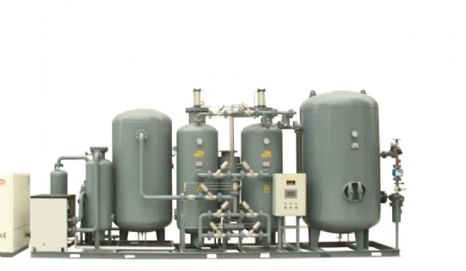
New technology for nitrogen production
On-site self-production is an environmentally friendly and at the same time inexpensive way to supply nitrogen. With new hydrogen and heat recovery technologies， the balance can be further improved.
In the chemical， oil and gas industries， nitrogen (N2) is used as an inert gas and process gas to avoid fires and explosions as well as undesirable oxidation reactions. Nitrogen generators allow companies to produce the gas themselves on site. With the help of variable pressure adsorption (PSA) technology， oxygen and carbon dioxide are adsorbed from the ambient air and ensure the production of uninterrupted N2 in the required quantity and quality.
The compressed air factor is the lever of expertise
The compressed air required for this is produced by a compressor - a process that is energy intensive because a large part of the electricity supplied is converted into heat. This heat can be used decentralized in the waste heat concept of gas-fired power generation to provide heat (and cooling) as an alternative to fossil fuels. By using waste heat， not only can gas be provided economically， but the company's CO2 emissions can also be permanently reduced.
What specific options does a company have to reduce its own CO2 emissions while saving energy and costs when producing its own nitrogen? When using PSA technology to produce nitrogen in-house， the air compressor is the specialist energy consumer that provides the required amount of compressed air. The so-called compressed air factor indicates how much compressed air volume is required to produce the same volume of nitrogen (e.g. 99.999% purity). Thus， the professional lever to reduce CO2 emissions is to reduce the demand for compressed air.
Hydrogen reduces oxygen content
By optimizing the early design of the PSA technology， a significant reduction in the compressed air factor has been achieved since 2017. However， this is only an intermediate step， as the development of the Hitt system and the addition of hydrogen have made further reductions in compressed air coefficients possible. With the help of the Nkat hydrogen catalyst， the "raw" nitrogen (99.5-99.9% purity) obtained through the nitrogen generator is enriched with a very small amount of hydrogen and catalytically converted， which reduces the residual oxygen content and allows for purity levels of 5.0 or higher. In this way， large quantities of high purity nitrogen (compressed air factor of 2.9) can be produced with significantly reduced compressed air requirements， thus saving up to 70% of the energy used in previous PSA technologies.
Can use waste heat
Another way to reduce the carbon footprint of self-produced nitrogen is to use waste heat that can be recovered from the air compressor. Heat recovery technology makes it possible to use the waste heat generated in the form of warm air or hot water to heat rooms and process heating. Both screw compressors and compressed air heating power stations are suitable for this purpose. Using special thermal， electrical and cooling technologies， it is also possible to convert the heat generated by compressed air heating power stations into cooling capacity. For example， excess heat that cannot be used during the summer months can be used to cool rooms and processes. By using waste heat， fossil fuels such as natural gas， LPG or oil can often be replaced in industrial enterprises， which has a positive impact on the direct CO2 footprint.
Public funding creates momentum
The Federal Office of Economics and Export Control (BAFA) supports companies with such initiatives by promoting energy efficiency in the economy and process heat from renewable energy sources. The decisive factor in the calculation is the CO2 savings achieved through investments. Depending on the size of the company， the funding amounts to 500 to 700 euros per ton of CO2 saved per year. For this purpose， the energy consumption of the energy-saving system is compared with a "normal" nitrogen generation system.
An example. If the CO2 savings achieved amount to 154 tons， this will provide the company with a BAFA grant of 107，800 euros. This funding is paid to the company on a non-reimbursable basis. The company described in this example goes on to reduce its costs by 55%， taking the cost of hydrogen into account， resulting in permanent annual savings of €63，000. The use of additional heat recovery technology can also reduce heating costs. In this case， these savings amount to another €18，400 per year. In total， the economic costs can be reduced by 81，400 euros per year. Thus， a modern nitrogen self-production system can contribute to cost reductions and at the same time reduce CO2 emissions.

