High purity nitrogen gas pressure reducing valve use instructions

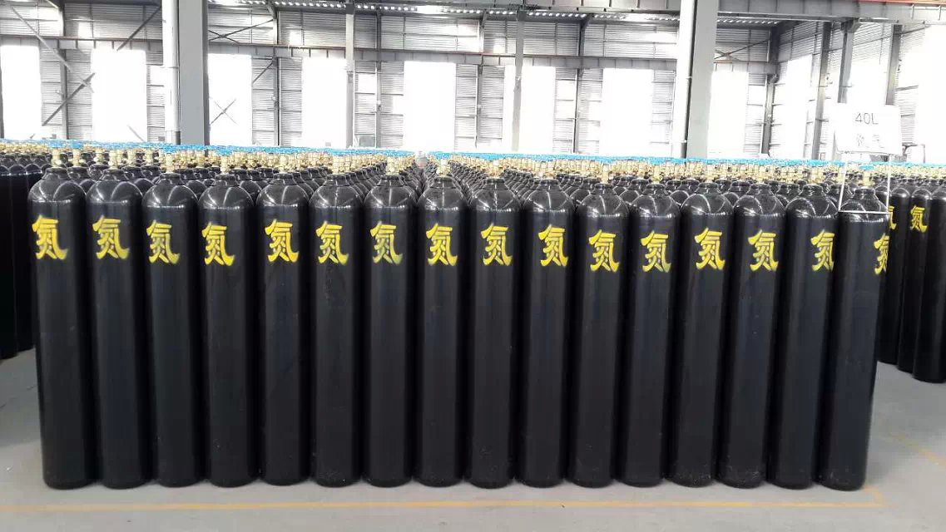
Notes on the use of pressure reducing valves for high-purity nitrogen and other gases:
I. Preparation for use
1、Acknowledge the gas cylinder upright and stable， prohibit the gas cylinder is not any fixed condition when the bottle valve open， at least adhere to the gas cylinder back to the wall or other fixed objects;
2、Check the bottle valve and pressure reducing valve inlet and outlet for oil and dangerous goods; if you find oil or oil stains， please stop using.
3、Acknowledge the use of the pressure reducing valve pressure range and applicable gases. The promised pressure of the regulator is 0.6 times of the gauge pressure;
Hydrogen and other flammable gases cylinder valves and ordinary gas cylinders screw threads in the opposite direction， so the pressure reducing valve is also different， the sign for the articulation of the cylinder end of the middle of the connector has a groove， nitrogen， helium and oxygen regulator is not， the use of the valve should be paid special attention to.
Second， the use of pressure reducing valves
1、Acknowledge that the regulator is in a closed condition， that is， counterclockwise can not be rotated. If it is not in the closed condition， it is necessary to adjust to the closed condition， to avoid damage to the regulator or even the formation of personnel injury;
2， will be installed on the corresponding cylinder pressure reducing valve， and use a spanner to lock. When installing the pressure reducing valve， you should make sure that its connection specifications are consistent with the cylinder and the gas system connector. The pressure reducing valve and the cylinder choose hemispherical connection， tighten the nut to make the two conform;
In the use of the two hemispherical surface should adhere to the bright， in order to ensure a good airtight function. High-pressure gas can be used to blow away dust before installation. If necessary， can also be used for PTFE and other materials as a gasket.
3、Standing on the side of the cylinder outlet， slowly open the valve to the open condition， leak detection. At this time the gas into the high-pressure chamber of the pressure reducing valve;
Open the cylinder valve， do not stand in front of the gas pressure reducer or the reverse side， also for the front and reverse of the pressure gauge head.
4， slowly clockwise rotation of the adjusting handle， adjust the pressure of the low pressure end to the appropriate pressure， and pay attention to ensure that the pressure in the promised range (low-pressure end of the gauge head pressure of 0.6 times);
Third， closed pressure reducing valve
1， closed should first close the cylinder valve， pressure discharge after rolling counterclockwise handle closed regulator， and then unload the regulator;
It is prohibited to dismantle the regulator under pressure at the high pressure end of the regulator. If you do not take down the pressure reducing valve also need to pressure reducing valve in the residual gas discharge， and then loosen the adjusting screw to avoid long-term deformation of the elastic element under pressure.
Fourth， special attention
1、Oxygen pressure reducing valve should be prohibited from touching grease to avoid burning and explosion;
2， the pressure reducing valve should be avoided to touch the vibration， can not touch with corrosive substances.

