About portable nitrogen generators and small nitrogen generators

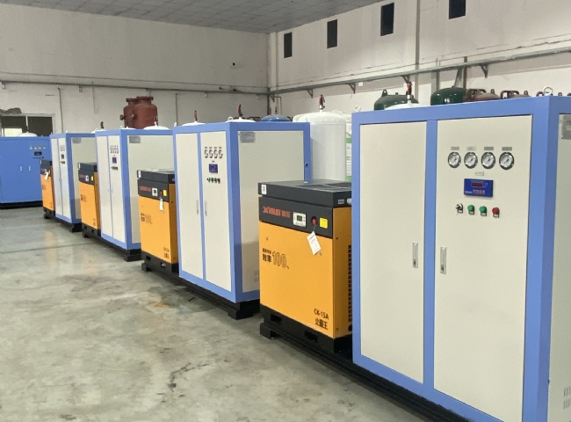
Nitrogen is essential for most industrial and military applications. As a result， operators and staff need a steady supply of gas. Unlike delivering nitrogen through cylinders or tanks， on-site nitrogen generators offer several advantages， including low operating costs， low maintenance and improved safety. This article provides an overview of small nitrogen generators.
What is a small nitrogen generator?
Some industrial applications require low flow rates of high purity nitrogen. Small nitrogen generators are ideal for such applications. As such， a small nitrogen generator is a small generator that can produce and deliver low flow rates of high purity nitrogen for a variety of work and emergency applications. Some relevant applications for small nitrogen generators include fire suppression and prevention in coal mines， military operations， etc. In addition to stationary models， operators can install small nitrogen generators in isolated areas.
Portable nitrogen generators vs. small nitrogen generators
Advantages of on-site nitrogen production
Unlike small， portable nitrogen generators are significantly smaller and are essential for night vision goggle defogging and waterproofing for military personnel. In addition， portable nitrogen generators are safe， miniaturized， reliable， and can produce nitrogen anywhere and whenever needed. Like the portable， the compact nitrogen generator is safe and reliable. However， small generators require dedicated， remote locations for installation and nitrogen generation.
Industries that use small nitrogen generators
Small nitrogen generators remain essential to meet the needs of a number of industrial applications， including food packaging， chemical blankets， electronics， laboratory operations， and laser cutting.
Food Packaging
Since the presence of food oxygen in food packaging greatly reduces the shelf life of food products， it is a good practice to replace oxygen with nitrogen. Food manufacturers can achieve this by using nitrogen generators for food packaging items such as vegetables， fruits， meats and snacks and providing a cushion for them during transportation.
Chemical covering
Similarly， nitrogen from high-pressure nitrogen generators is a common component used to chemically cover chemical plants or manufacturing facilities that are prone to fires and explosions. This gas reduces the level of oxygen in these facilities， ensuring the safety of personnel and facilities.
Electronics Industry
In electronics applications， nitrogen is an important component needed in the soldering process as it reduces surface tension and enables cleaner removal of electrical solder joints. In addition， with a small generator， data centers can maintain ideal temperatures with a constant supply of nitrogen， preventing processors from overheating.
Laboratory Operations
Laboratory environments with high oxygen levels can easily have error-prone results. However， with a small industrial nitrogen generator， scientists can maintain a sufficient supply of nitrogen to create acceptable oxygen levels for accurate results in highly sensitive lab equipment and procedures.
Laser Cutting
Finally， the availability of nitrogen is critical for laser cutting applications. With a nitrogen generator for laser cutting， operators can meet their cleaning and quality assurance needs. Nitrogen can strengthen stainless steel and aluminized steel and improve their corrosion resistance.
Benefits of small nitrogen generators
Small nitrogen generators offer a number of advantages for industrial and other related applications. Some advantages include avoidance of costs associated with nitrogen tanks/cylinders， no supply limitations， low maintenance， portability， and increased safety. Unlike nitrogen tank/cylinder manufacturing services that require periodic financial commitments， the small nitrogen generator avoids long-term operating costs because the machine ensures a steady supply of nitrogen for the application in question. Uninterrupted nitrogen production and delivery helps to avoid supply constraints.
In addition， the generator can operate maintenance-free for a long period of time， requiring only constant cleaning and occasional replacement of the pre-filter. As a result， maintenance costs for the nitrogen generator are reduced. In addition， the small size of the compact nitrogen generators makes them easy to move around and allows them to be used in tight spaces. This portability makes them preferable to pre-filled nitrogen tanks or reservoirs. Finally， unlike nitrogen tanks， which require specific storage protocols， small generators do not， which greatly increases their safety in industrial applications.

