XITE - Durable nitrogen generators for all your industrial needs

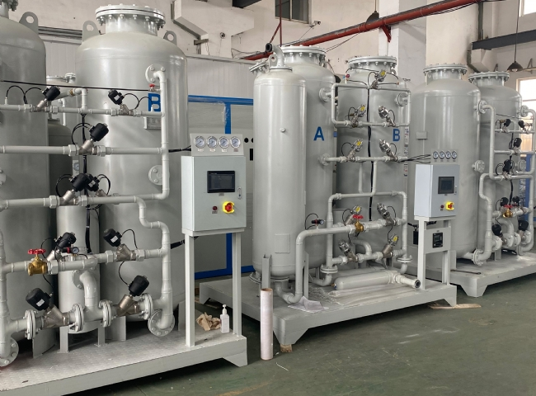
Nitrogen is the most abundant gas in our atmosphere. With over 78% of the entire atmosphere， it is no wonder that we find several industrial applications for this gas. Nitrogen is an essential element in several commercial and industrial processes， hence the need for pure nitrogen generator plants.
XITE is one of the large gas and dry air generators in China. Our goal is to provide high quality generators， using the latest technology， offering innovative and cost effective solutions. With over 45 years of industry experience and satisfied customers in over 56 countries， we take pride in our work.
We are proud to share durable equipment that has a life expectancy of over ten years， making them a profitable investment for our customers. XITE will help you generate nitrogen gas with an impressive purity of 95% to 99.999% and a flow rate range of 1 to 1500 m3/h.

