Advantages of on-site nitrogen generator in coffee production

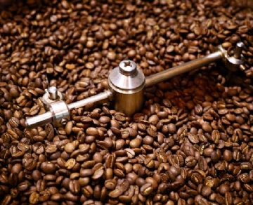
The history of coffee can be traced back to Ethiopia in the 10th century. However， it was not until the 20th century that coffee producers realized the benefits of nitrogen for their products. Nitrogen can maintain the integrity of coffee and greatly extend the shelf life of the product. More and more coffee producers are using on-site nitrogen generators and saving a lot of money by doing so.
Oxygen problem
Oxygen accounts for 21% of the earth's atmosphere. We know it is the gas we need to breathe and sustain life. However， due to its molecular structure， oxygen can easily react with other chemicals in a process called oxidation， and may cause problematic reactions， especially those related to preservation.
Car rust is due to the reaction with oxygen， and similar processes in your body may cause health problems. Even the surface of Mars is known as red because of the rust in the atmosphere.
Oxidation poses a problem for food producers， including those who package and sell coffee. When coffee beans are ground， the oil inside is exposed to the air， and soon it will lose its aroma and taste， leaving a bitter taste.
Why nitrogen?
Nitrogen is an inert gas that does not react with other substances. This makes it an ideal gas for food packaging. By removing oxygen and replacing it with nitrogen， coffee producers can extend the shelf life of their products and maintain the integrity of aroma and flavor. This is because， unlike oxygen， nitrogen does not react with the oil in the coffee beans and therefore does not change.
In addition， nitrogen is not a useful fuel for microorganisms. This means that mold and other things are unlikely to grow on the coffee when it is placed on the shelf， making nitrogen the perfect choice for the food packaging industry.
Coffee packaging process
Coffee packaging enters the vertical molding and filling system. First， the bag is filled with nitrogen to remove oxygen. At this time， the bag is full of ground coffee beans. When the bag is full of coffee beans and still full of nitrogen， the machine will seal the bag. It's just coffee and pure nitrogen.
Using nitrogen sealed coffee bags， coffee producers can expand their sales range without being limited by the short shelf life. They can even pack coffee for vending machines because of the extended shelf life.

