Application of nitrogen gas produced by PSA nitrogen generators in various industrial fields

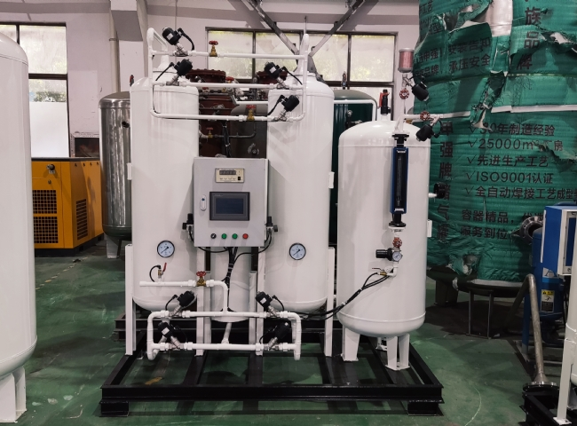
Nitrogen (N2) is a colorless， tasteless， odorless gas that makes up 78.09% (by volume) of the air we breathe. It is non-flammable and it does not support combustion. It is used in a wide variety of industries， including chemical， pharmaceutical， petroleum processing， glass and ceramic manufacturing， steelmaking and other metal refining and manufacturing processes， and healthcare. In addition to N2， nitrogen may be referred to as GAN or GN in the gaseous state and LIN or LN in the liquid state. nitrogen compounds are formed naturally through biological activity. Compounds are also formed at high temperatures or with the help of catalysts at moderate temperatures. At high temperatures， nitrogen combines with reactive metals， such as lithium， magnesium and titanium， to form nitrides. Nitrogen is required for various biological processes and is used as a fertilizer， usually in the form of ammonia or amino compounds. Compounds formed with halogens and certain organic compounds may be explosive.
Applications of Nitrogen
Multi-industrial uses of nitrogen.
The inert nature of nitrogen makes it a good filler gas in many applications. Nitrogen is used to protect flammable or explosive solids and liquids from contact with air. The properties of certain chemicals， solid surfaces and stored foodstuffs must be protected from degradation by atmospheric oxygen and moisture. Protection can be achieved by keeping these items in a nitrogen atmosphere (under)." Inert" or "filled" are other terms used to describe alternatives to air and nitrogen coverage. "Filling" with nitrogen means bubbling a liquid with nitrogen to remove unwanted volatile components， including volatile organic compounds (VOCs)， that may be necessary to meet pollution reduction regulations. Certain substances are difficult to crush or shred because they are hard or the material is degraded by the heat generated by mechanical processes such as grinding. Liquid nitrogen can be used to freeze soft or tough substances before they enter the pulverization process. Cold vaporized nitrogen can be used to keep materials cool (and in an inert atmosphere) during the grinding process. Cryogenic grinding has a variety of applications， including the production of finely ground pharmaceuticals， plastics and pigments; and for shredding tires in recycling plants.
Nitrogen uses in metal manufacturing.
Nitrogen is used to treat melts in the production of steel and other metals， and as a shielding gas in the heat treatment of iron， steel and other metals. It is also used as a process gas， along with other gases， to reduce carbonization and nitriding. Flying edges or fins on cast metal can be removed by cooling them with liquid nitrogen， making them brittle and allowing them to be broken by mechanical action.
Manufacturing and construction applications.
Shrink joints are an interesting alternative to traditional expansion joints. Instead of heating the external metal part， the internal part is cooled with liquid nitrogen so that the metal shrinks and can be inserted. When the metal returns to normal temperature， it expands to its original size， creating a very tight fit.
Liquid nitrogen is used to cool the concrete， which results in better curing properties. Liquid nitrogen can be used to effectively freeze the ground when construction work must be done on soft， water-soaked ground， such as tunneling under waterways. Pipes are driven into the ground and liquid nitrogen is pumped under the surface through the pipes. As the nitrogen enters the soil， it vaporizes， removing heat from the soil and freezing it.
Chemicals， pharmaceuticals and petroleum use. Refineries， petrochemical facilities and marine tankers use nitrogen to remove hazardous vapors and gases from equipment， storage tanks and pipelines (for example， after completing pipeline transfer operations or ending production runs) and to maintain an inert and protective atmosphere in tanks storing flammable liquids. Cooling the reactor (and the materials inside) to low temperatures allows better control of side reactions to complex reactions in the pharmaceutical industry. Liquid nitrogen is often used to provide the necessary refrigeration because it produces rapid temperature reduction and easily maintains the desired low temperature reaction temperature. Reactor cooling and temperature control systems typically use a circulating cryogenic heat transfer fluid to transfer the refrigeration produced by vaporizing liquid nitrogen to the reactor vessel shell. The liquid nitrogen is vaporized in a specially designed heat exchanger that transfers the refrigeration to the circulating heat transfer fluid. Liquid nitrogen is used during well completions to "fracture" natural gas-bearing formations， particularly tight gas formations， including shale gas and natural gas from coal (coalbed methane)， where water-based methods should be avoided. Nitrogen is also used to maintain pressure in oil and gas producing formations. Unlike carbon dioxide， which is also used for pressurization， nitrogen has little affinity for liquid hydrocarbons， so it builds up and stays in the gas cap. Nitrogen is used as an inert gas to push liquids through pipes， to clear pipes， and to push "pigs" through pipes， sweeping up one material before using them to transport another.
Uses in the rubber and plastics industries. Materials become hard and brittle as they cool to very low temperatures. This property allows the removal of flying edges or fins from plastic and rubber castings. The castings are cooled with liquid nitrogen and the flakes are removed by mechanical action.
Food and beverages. The intense low temperatures in liquid nitrogen allow rapid freezing of food products， thus minimizing damage to cells from ice crystals and improving appearance， flavor and texture. Well-designed cryogenic tunnels and spiral freezers efficiently obtain refrigeration from liquid vaporization and the cold nitrogen gas flowing through the freezer. When substances such as vegetable oils and wines are stored， the inertness of nitrogen prevents mass loss (Sparging) by expelling any air entrained in the liquid and protects the liquid in the storage tank by filling the vapor space (Blanketing). Nitrogen (and nitrogen mixed with carbon dioxide and oxygen) is used in transport trucks and in aeration packaging (MAP) to extend the shelf life of packaged foods by preventing oxidation， mold， insect damage and moisture migration.
Health care uses. Nitrogen is used as a shielding gas in the packaging of some pharmaceuticals to prevent degradation due to oxidation or moisture adsorption. Nitrogen is used to freeze blood， as well as viruses used in vaccinations. It has also been used to freeze semen from livestock， which can then be stored for years. The rapid freezing caused by intense cold temperatures minimizes damage to cell walls. Liquid nitrogen is also used in some MRI (magnetic resonance imaging) equipment to pre-cool cryogenic magnets before using more expensive liquid helium for final cooling. Liquid nitrogen is used in cryosurgery to destroy diseased tissue.
Other uses of nitrogen. Nitrogen is used directly as a coolant for rigorous environmental testing for many projects or as a refrigeration source for cooling circulating dry air.
Major Nitrogen Applications
Multiple uses
Waste to energy
For treatment industries
(chemical， pharmaceutical， fabric and leather， food， paper， petrochemical and mining) waste
Solid waste treatment plants
Waste-to-energy plants
Civilian wastewater treatment plants
Agriculture
Milk and derivatives
Bread and confectionery
Meat and poultry
Fish processing
Coffee， wine and oil
Fruits and vegetables
Ready-to-eat food
Catering
Beverages
Ice cream
Precision casting (e.g. lost wax method， microfusion casting)
Cast iron production
Glass container and fiber production
Steelmaking (from scrap - electric arc furnace)
Secondary aluminum production (recycling)
Flat glass production
Aluminum extrusion production
Non-ferrous metal production (copper， lead， gold and bronze)
Steelmaking (from pig iron - in blast furnaces)
Art glass production
Steel forging
Refractory products production， marble
Lime production
Precious metal processing
Cement production
Aviation production
Printed circuit board production
Automotive industry
Third-party heat treatment
Carbon steel processing
Aluminum processing
Stainless steel processing
Woodworking
Non-ferrous metal processing
Tool processing
Pharmaceutical Specialties
Rubber and plastic
Bulk pharmaceuticals
Fine Chemicals
Polymers
Cosmetics and herbal medicine
Basic and organic chemistry， intermediates for synthesis
Off-shore
Extraction
Petroleum refining
Raw material and finished product inventories
Transportation and pipelines
Plant components and equipment
Energy production

