In which industries is nitrogen used?

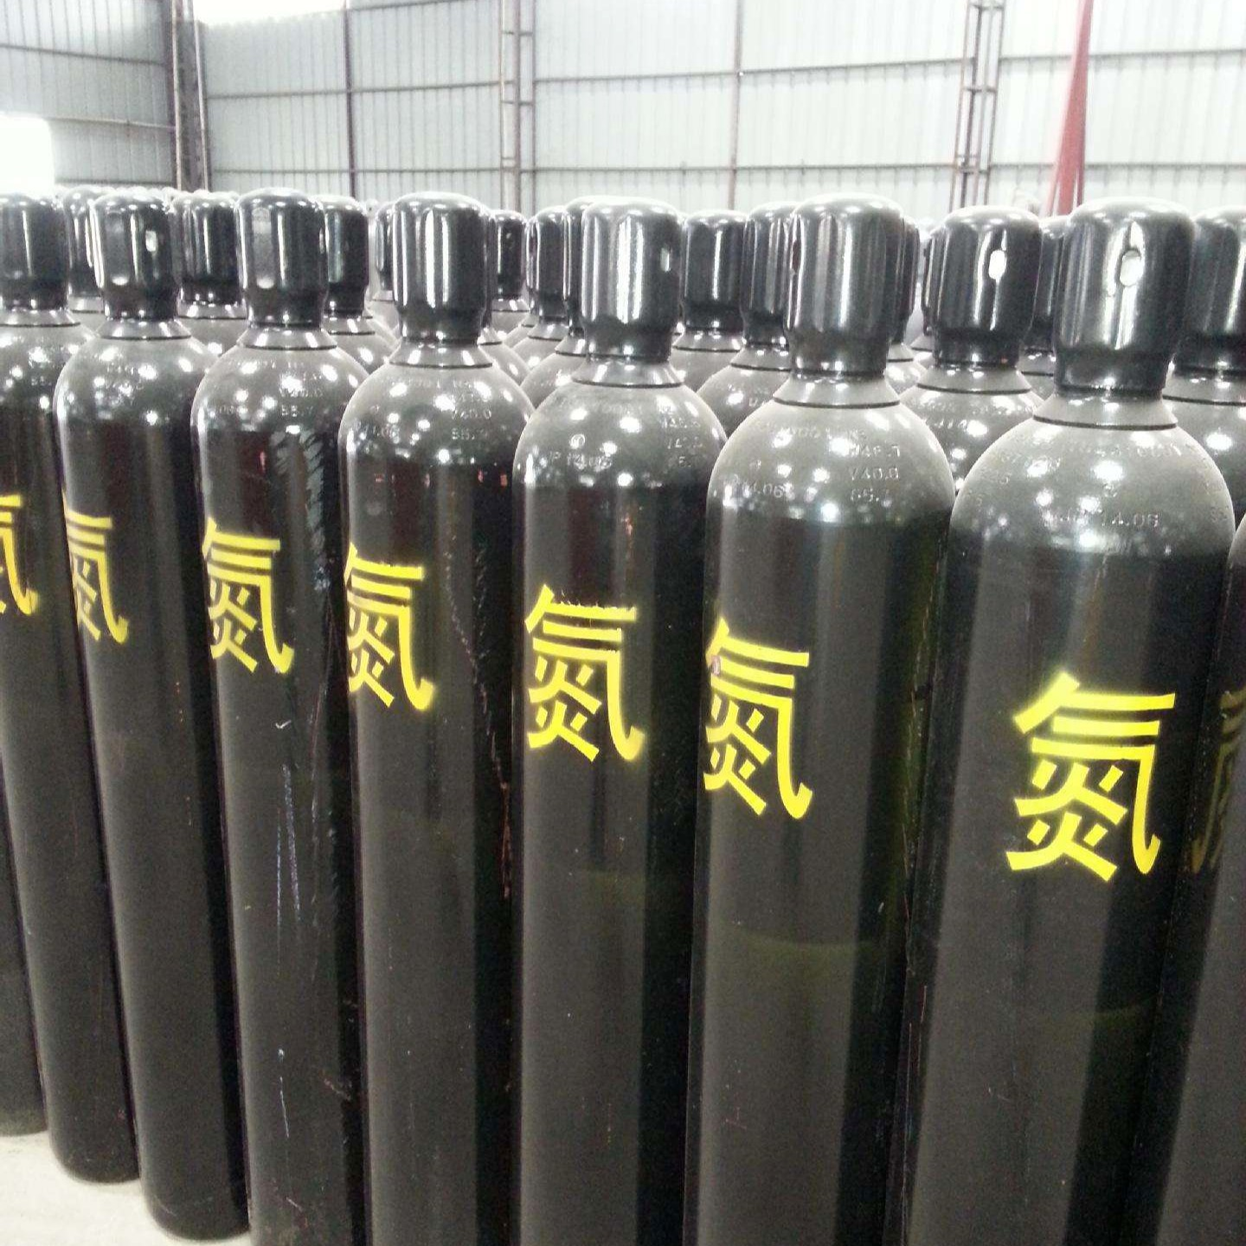
1、Applications in oil， gas and coal mining industries
Nitrogen filling in oil wells can not only improve the pressure in the wells and increase the oil recovery， the nitrogen filling can also be used as a cushion in the measurement of the drill pipe， which completely avoids the possibility of the mud paddle pressure in the wells squashing the lower test pipe column. In addition， nitrogen is also used in downhole operations such as acidising， fracturing， hydraulic perforating and seating of hydraulic packers. Filling natural gas with nitrogen reduces the calorific value. When replacing pipelines in crude oil， liquid nitrogen can be used to burn and inject material at both ends to solidify the seal.
Nitrogen is used for pressure conveying of pulverised coal， which is safe， convenient and economical.
2、Application in chemical industry
Nitrogen is the main raw material for ammonia synthesis. Nitrogen required for ammonia synthesis does not need to be separated and purified， and is directly derived from air. In the production process of ammonia syngas， the oxygen in the air and hydrocarbon raw materials for high temperature catalytic reaction， through the transformation， decarbonisation， methanation and other processes， to generate a mixture of hydrogen-based containing a small amount of methane， trace carbon monoxide and carbon dioxide， the nitrogen and argon in the air does not participate in the reaction， directly into the syngas， so as to obtain the ammonia synthesis of hydrogen and nitrogen-based syngas. Due to ammonia synthesis， oxygen， carbon monoxide， carbon dioxide easy to make the synthesis catalyst in the pigment poison， methane and argon system synthesis of inert substances， a large number of accumulation will reduce the efficiency of synthesis， the use of liquid nitrogen scrubbing process to purify the syngas， you can prolong the life of the catalyst， improve the efficiency of ammonia synthesis.
Nitrogen is also the main raw material for the synthesis of calcium cyanamide， cyanide and silicon nitride.
High purity nitrogen can be used as an auxiliary gas in the production of polyethylene， for example， a polyethylene production line with an annual output of 10 million tonnes needs to provide 4，400 standard cubic metres of pure nitrogen per hour.
Using the chemical inactivity of nitrogen， many flammable liquid substances in the reactor， storage tanks filled with nitrogen， not only to protect the material from oxidation， to maintain the quality of products， but also to ensure safety and prevent combustion and explosion accidents.

